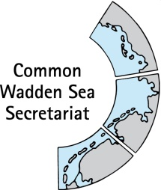
MEETING DOCUMENT
Task Group World Heritage (TG-WH 30)
29 April 2020
Virtual Meeting

Agenda Item: 3
Subject: Announcement Schleswig-Holstein
Document No.: TG-WH 30/3/1
Date: 20 April 2020
Submitted by: Schleswig-Holstein

- From June 15th, 2020 we will have a new head of department in the national park authority: Mr. Michael Kruse. He previously worked in the Schleswig-Holstein Ministry of Environment in the Nature Conservation Department in the area of organic farming / cross compliance

- This year's National Park theme year runs under the motto "Underwater World". The theme year serves to provide the public with targeted information on the current topic. Events are taking place and our national park partners are asked to provide information on the "underwater world" for their guests. Workshops were held for the partners at the beginning of the year to inform them so that they could then work as multipliers. There is also an underwater world brochure with easy-to-understand information (see link). Also various press releases are published during the year (example see link) Underwater world brochure: https://www.nationalpark-wattenmeer.de/sites/default/files/media/pdf/unterwasserwelt_web.pdf (in German only, sorry!)
Press release: https://www.nationalpark-wattenmeer.de/sh/misc/die-sache-mit-dem-eierlegenden-hasen/5752 (in German only, sorry!)

- Unfortunately, due to the current corona situation, all events in the course of the Schleswig-Holstein brent goose days are cancelled (normally the opening event would have been on April 18th, 2020). The Multimar Wattforum in Tönning and the National Park House in Wyk auf Föhr are closed until April 19th inclusive and all public events, such as the natural excursions of our rangers, will also no longer take place until further notice. At the moment it is forbidden to visit the islands and Halligen of Schleswig-Holstein.

