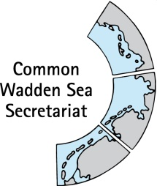
MEETING DOCUMENT
Task Group World Heritage (TG-WH 32)
29 January 2021
Virtual Meeting

Agenda Item: 6
Subject: Status of World Heritage activities in Supplementary Budget 2020/21
Document No.: TG-WH 30/6/1a
Date: 27 January 2021
Submitted by: CWSS

The Supplementary Budget 2021 was approved by the States Parties at the end of 2021.
The status of World Heritage activities and costs distribution regarding the Supplementary Budget 2020 and the plan for 2021 are attached in a separate Excel document TG-WH 30/6/1b (two sheets 2020 and 2021).

Proposal: The meeting is invited to take note respectively to comment on the document in written procedure.

