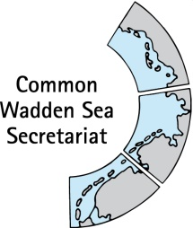
MEETING DOCUMENT
Expert group Climate Change Adaptation (EG-C 5)
12 May 2020
Virtual meeting

Agenda Item: 4. Interreg Building with Nature
Subject: Project update
Document No.: EG-C 5/4
Date: 24 April 20
Submitted by: CWSS

CWSS is partner in the Interreg Building with Nature project (2015-12 to 2020-07). Main role is an exchange of information between project partners (in particular Work Package 3 Resilient Coastal Laboratories) and the trilateral Expert Group Climate Change Adaptation, as well as the establishment of a Climate Change Adaptation Platform.
This document contains an overview on the last reporting period of the Interreg Building with Nature (BwN) project as well as recent information on a cost neutral project prolongation.
In addition, this document contains information on the successful transfer of the BwN Climate Change Adaptation Information Platform to the World Heritage website.

Proposal: The group is invited to note the information

Update Interreg Building with Nature (BwN)

Project management
The INTERREG North Sea Region (NSR) Monitoring Committee has given permission for the Joint Secretariat to extend project timelines by six months (the extension will not have budgetary effects), to account for delays due to the COVID-19 pandemic. One change in project planning includes the final event of the project, originally planned for summer 2020, which will be postponed.
The Interreg BwN project will hand in a request for these additional six months. In addition, BwN will file a cost-neutral prolongation of the project in which in particular further technical investigations in Work Package 3 Resilient Coastal Laboratories are planned. As the financial resources of CWSS will be depleted by the original end of the project, CWSS will probably be a dormant project partner.
WP3 Resilient Coastal Laboratories
Final products in WP 3 are a co-analysis on “coastal laboratories” along the North Sea Coast (mainly sand nourishnments) and the NSR guidelines on nourishment, which will be re-named in practitioners lessons learned. Preliminary conclusions of the co-analysis report include (June 2019):
- The investigated nourishments have achieved the strategic objectives in all labs;
- The chronical coastal retreat in all labs could be stopped while allowing for a certain degree of natural dynamics;
- The nourishments have contributed to the reduction or preservation of flood risks at the labs (dunes remained stable or increased in volume/height);
- When the goal is to minimize dispersion of the nourishments the labs provided evidence that it might be beneficial to design as small as possible nourishments, which render a small perturbation on the coastline. However, when the goal is to feed a larger stretch of coastline with sediments a larger nourishment might be beneficial since it is likely to disperse quicker;
- The shared methodology provides new ways on the exchange of experiences with nourishments as a key BwN solution in the NSR. All labs have their own setting and specifics but due the joint effort and shared insight from the whole NSR, these insights can now be incorporated in each national coastal management strategy and implementation.

Climate Change Adaptation Information Platform
To compile information and documents of relevance for coastal risk management in the Wadden Sea and thereby to support an evidence base for best practices for BwN activities, a Climate Change Adaptation information platform has been established by CWSS and was continuously filled with content on trilateral policy and management, best practices, monitoring and assessment, and communication and education activities (policy reports, scientific reports, projects etc) by EG-C (former TG-C).
The platform has been aligned with the corporate design of the Waddensea Worldheritage and was successfully transferred to the Waddensea Worldheritage website. It is publicly accessible under the topic climate: https://www.waddensea-worldheritage.org/climate-change, with a direct link https://www.waddensea-worldheritage.org/ccap (Figure).
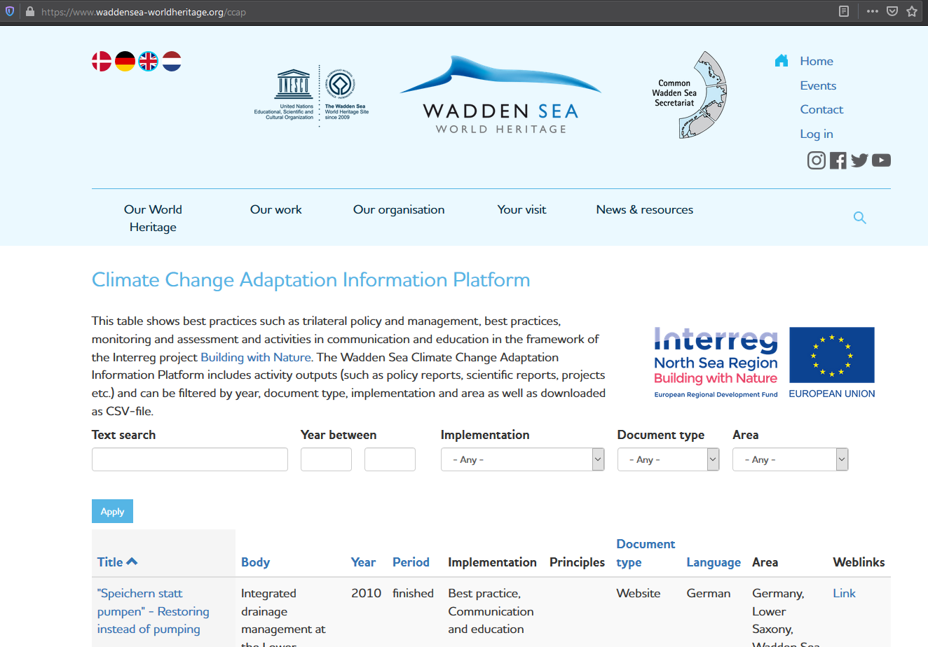
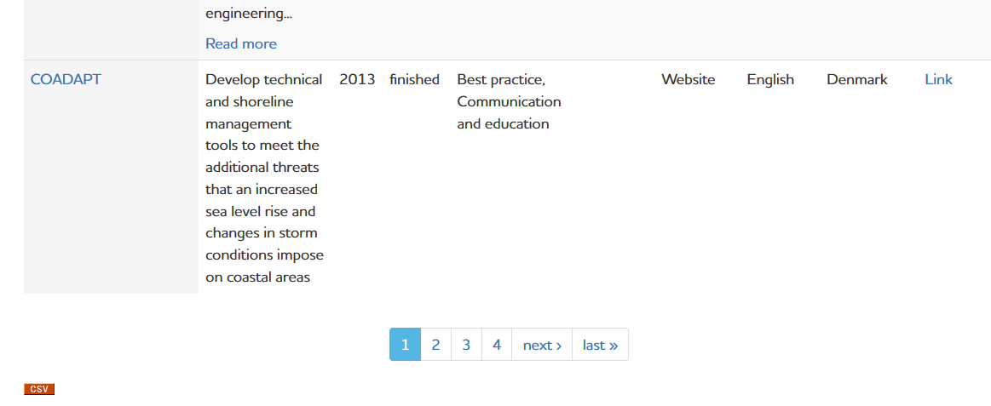

Figure: Climate Change Adaptation Information Platform as developed within the Building with Nature (BwN) Interreg project. The platform contains documents on trilateral policy and management, best practices, monitoring and assessment, and communication and education activities (policy reports, scientific reports, projects etc) as provided by the Expert Group Climate Change Adaptation (EG-C). All information can be filtered by year, document type, implementation and area as well as downloaded as CSV-file (https://www.waddensea-worldheritage.org/ccap).

