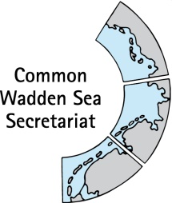MEETING DOCUMENT

**Task Group Management (TG-M 20-2)**

14 May 2020

Virtual meeting

**Agenda Item: 6. Natura2000 Roof Report**

**Subject: Feasibility study**

**Document No.:** TG-M 20-2/6

**Date:** 11 May 20

**Submitted by: Henrik Jørgensen**

Participants will be invited to recall the background of the decision to produce a common N2000 Roof Report (Appendix 1), the outcome of the 2015 workshop in Bonn and the, as it seemed, vain attempts following the workshop to obtain and compile data into the foreseen report, finally followed by a decision at TG-M to commission the University of Aarhus to prepare a feasibility study (FS) aimed at WSB describing the basic obstacles preventing the elaboration of the designated task of a N2000 Roof Report and, if possible, with recommendations and/or conditions for its realization.

At TG-M 19-2 it was decided that an analytical statement on feasibility of the N2000 roof report would be presented from the Danish consultant to TG-M. Based on this, the German position on the need and value of the report would be formulated.

This document contains a first draft of the FS on Roof reporting on Habitats and Species in the Wadden Sea Area by Mr Jesper Fredshavn, University Aarhus, Denmark, including comments by Schleswig-Holstein and Lower Saxony. It further contains the workshop report of the trilateral Workshop N2000 Roof Report, Bonn, 24-25 March 2015 (Annex 1) and information on roof reporting in Denmark (Annex 2), Schleswig-Holstein (Annex 3) and the Netherlands (Annex 4).

Further, DK proposed to have a short section in the FS describing the specific implementation of the N2000 digestives in the three countries respectively. Following this, a paradigm-draft for such a section is attached as well.

**Proposal:** Approve of the proposed structure of the N2000 Roof Report feasibility study, and to further decide on adding an initial section describing the implementation of the N2000 regime in each of the three countries

# Roof reporting on Habitats and Species in the Wadden Sea Area

**A feasibility report**

Jesper Fredshavn, DCE, Aarhus University

The Trilateral Wadden Sea Cooperation (TWSC) between Denmark, Germany and The Netherlands was established in 1978 at the 1st Trilateral Governmental Conference (TGC) on the Protection of the Wadden Sea held in The Hague, Netherlands. The Guiding Principle of the TWSC is to “achieve, as far as possible, a natural and sustainable ecosystem in which natural processes proceed in an undisturbed way”.

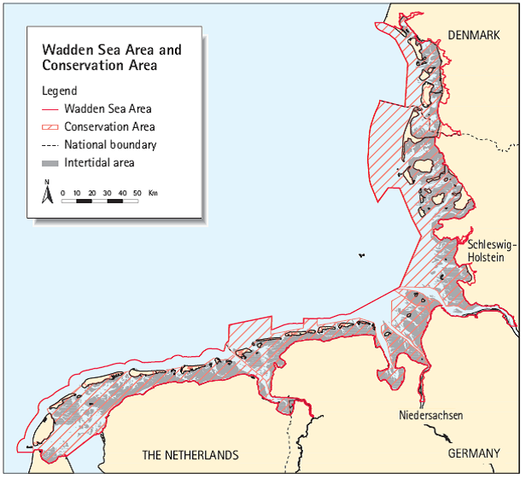Figure 1. Map of the Wadden Sea and conservation area.

The Wadden Sea Area covers approximately 14,700 km²; the Conservation Area about 11,200 km².

Since 1999, the TWSC has produced Quality Status Reports on the current ecological status of the Wadden Sea based on the results from the Trilateral Monitoring and Assessment Programme (TMAP). The TMAP-programme is the common monitoring programme for the Wadden Sea carried out by Denmark, Germany and the Netherlands since 1997.

In 2010 on the 11th Trilateral Government Conference on the Protection of the Wadden Sea the three ministers agreed on a common integrated Natura 2000 Wadden Sea report (a roof report). A Trilateral workshop on the N2000 Roof Report was held in Bonn, 24-25 March 2015, where the output was a desire to produce a comprehensive assessment of selected habitats (20 appointed habitat types) and species (three marine mammals) in the Wadden Sea Cooperation Area. The workshop pointed out that the reporting should be comparable to the comprehensive compilation and assessment that is already made on the bird species in the QSR-report based on the data for the Birds Directive. The intention was that the reporting should be an additional chapter in the QSR-report based on the TMAP data and further national data.

However, the workshop identified several issues to be solved before this reporting could be effected in where Netherlands and Denmark should check differences between national reporting and Natura 2000 management plans and report on which to utilize. Germany was asked to check possibility to extract data from the national reporting. The results of these investigations was three different contributions to a common roof report send to the Wadden Sea secretariat (Appendix 1, 2 and 3).

**Proposed section on implementation of Natur2000 roof report in the three countries**

**Implementation of EU N2000 directives in Denmark with special focus on the Wadden Sea**  
   
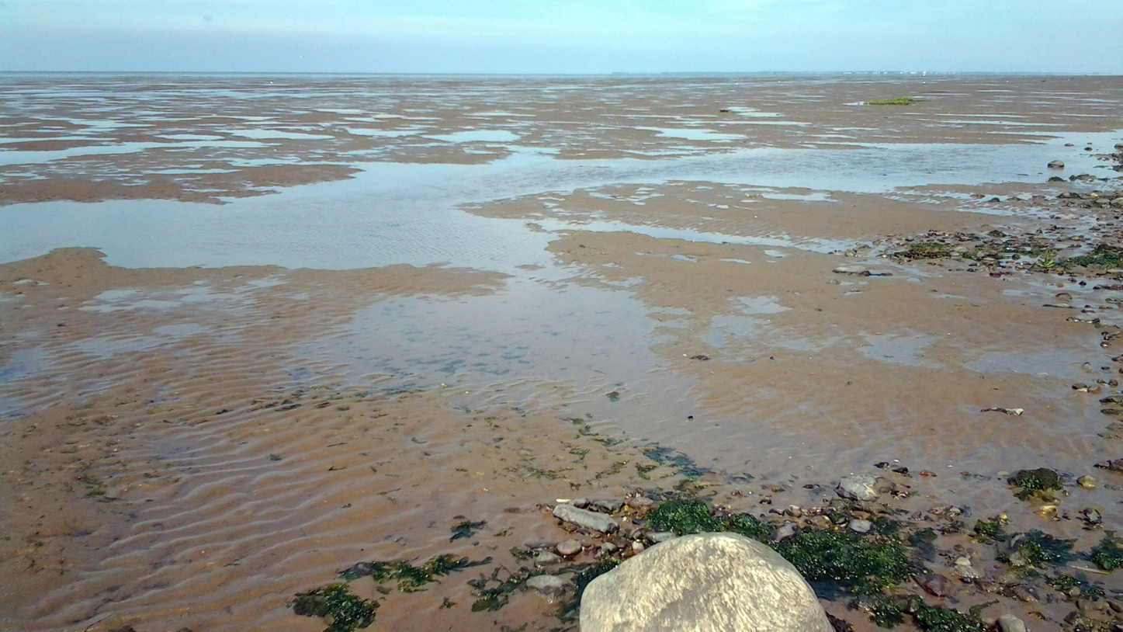

The EU's Natura 2000 directives (Bird Protection Directive and Habitats Directive) oblige European member nations to make the necessary efforts to secure or restore a range of rare, endangered or distinctive habitats and species of European importance, and Denmark has chosen to implement the obligations through a systematic and recurring Natura 2000 planning, which prioritizes the required effort on the basis of the directive commitment and national nature monitoring for 6-year planning periods.  
  
Against this background, Denmark is currently preparing plans for the third generation for the years 2022-2027, re. Annex1. However the specific example below “N*89 Wadden Sea, partial plan for F65 Rømø”* is 1 of 10 plans of the present 2nd generation plan covering the Danish part of the WS.

Of the Danish land area, 8% and of the marine areas 18% are designated as N2000 areas, a total of 252 single areas, of which 10, as mentioned, covers the Wadden Sea area. However, more than 252 habitat and birds areas exist (269 and 124, respectively), but as these may be coincident or be in close proximity to each other, the total number of coherent N2000 areas is 252.  
  
The Natura 2000 plans are prepared after prior discussion with the relevant government, regional and municipal authorities and with the involvement of national park boards, associations, organizations and landowners who have a significant interest in the plans. The cross-cutting, overall discussions take place at national level. At the regional level, the Danish Environmental Protection Agency presents baseline analyzes and a possible plan content is discussed. The baseline analyzes are published at the same time as discussions with the stakeholders are initiated.  
  
In the aquatic area, efforts are to a large extent based on that laid down in the river basin plans, which aim to improve the aquatic environment towards good ecological status. This will at the same time provide improvements in water quality and physical conditions in watercourses (eg removal of barriers), which are necessary to achieve good natural conditions for the water areas also designated as Natura 2000 areas, including i.a. the rare houting in the Wadden Sea area.  
  
Natura 2000 planning is carried out, among other things, in accordance with the rules of [the Environmental Objectives Act](https://www.retsinformation.dk/eli/lta/2015/1531) and related regulations, and the N2000 planning process results in the following 5 sub-elements for each of the [252 individual N2000 areas (links refer to one of the 10 sub-plans for the Wadden Sea sub-plans: *89 Wadden Sea, part plan for F65 Rømø*)](https://mst.dk/natur-vand/natur/natura-2000/natura-2000-planer/natura-2000-planer-2016-21/):

1) [Natura 2000 plan](https://mst.dk/media/130319/n89_f65_n2000plan_2016-21.pdf)  
2) [Consultation report](https://mst.dk/media/130290/n89_hoeringsnotat_n2000plan_2016-2021.pdf)  
3) [Summary statement](https://mst.dk/media/130321/n89_f65_sammenfat_n2000plan_-2016-21.pdf)  
4) [Strategic environmental assessment of the plan proposal](https://mst.dk/media/130322/n89_f65_smv_n2000plan_2016-21.pdf)  
5) [Baseline Analysis - Revised Edition](https://mst.dk/media/130323/n89_f65_basisanalyse16-21_revideret.pdf)  
  
Re. 1) The Natura 2000 plan consists of objectives for the natural state in the Natura 2000 area and an intervention program. The action program for each Natura 2000 site is prepared on the basis of a baseline analysis and available monitoring data.  
  
Re. 2) The consultation report summarizes comments and objections from the public consultation period.  
  
Re. 3) The summary report has been prepared on the basis of the environmental report for proposals for the Natura 2000 plan, and has been used as a basis for (political) decision in connection with the adoption of the Natura 2000 plan, and specifically addresses:  
• The purpose of the Natura 2000 plans and their environmental impact  
• How is the environmental report taken into account?  
• How are opinions received during the consultation phase taken into account?  
• Alternatives that have been included in the environmental assessment  
• Monitoring the effect of the Natura 2000 plan  
  
Re. 4) The strategic environmental assessment is carried out in accordance with Statutory Order No. 939 of 3 July 2013 on environmental assessments of plans and programs  
  
Re. 5) The baseline analysis presents the data and contains the following elements:  
• [Mapping habitat types and habitats for species for which the areas are designated](http://miljoegis.mim.dk/cbkort?&profile=miljoegis-natura2000).  
• Assessment of condition and preliminary assessment of threats.  
• A summary indicating on the map annex the location of the mapped areas and the condition.  
  
Once the N2000 plans have been adopted, municipal councils and other authorities, in exercising their powers under the legislation, are bound by the plans, and specific municipal action plans are drawn up.



**The Danish roof report contribution.**

The Danish contribution on quality assessment of habitat types consists of data from the management plan of SAC H78 (Wadden Sea with Ribe River, Tved River and Varde River). In Denmark, the management plans of the habitat areas are based on data from the National monitoring programme (NOVANA) where all terrestrial habitat type areas within the SAC’s are outlined and a number of structural as well as plant species indicators are recorded on the areas. A structural index is calculated on the structural indicators, including vegetation heights and presence of woody plants, drainage, invasive plants and positive or negative habitat type characteristics among other parameters. Likewise, a species index is calculated on the species composition and species scores reflecting the vulnerability of the species to outside threats. Each areas is assessed separately into five categories from bad to high nature quality and for each habitat type there is a figure showing the distribution of the total area of the habitat type in the SAC in the five different categories.

The mapping and assessment of nature quality of habitat types in the Natura 2000 areas is only used for the Nature 2000 management plans and not meant to be used in the national Article 17 reporting for the Habitat Directive. Another representative, samplewise data set is used for the assessment of conservation status on national level. The data set associated with the mapping of Natura 2000 areas is unique to Denmark and not directly applicable to the other countries.

The report addresses all seven dune habitat types but only the most common salt marsh type (1330).

The Danish marine habitat types has not been mapped in the Wadden Sea area, and therefore only estimates of the habitat type areas are given based on “specific projects”. There are no indication or figures of the habitat quality of the marine habitat types.

The three marine mammals, grey seal, harbour seal and harbour porpoise, listed as habitat species in the Wadden Sea area, are reported as number of counted individuals (the seal species) and density per square kilometre (harbour porpoise). There is no indication of local conservation status or habitat quality in the Danish report.

**The Dutch roof report contribution.**

The Dutch contribution is based on the Dutch input to the Standard Data Format database providing background for the appointment of Natura 2000 sites (SAP and SAC) and for EU selection of the LIFE funds.

The Standard Data Format for habitat types consist of four criteria, relative surface, representativity, conservation and a global criterion that comprise the other criteria. The conservation criterion is very different from the assessment of conservation status in Article 17 reporting, and the SDF conservation is aggregated from part criteria of structure, function and restauration possibilities. The categories of the SDF conservation is A, B and C, where A and B are excellent and good conservation and C is average or reduced conservation. This is opposed to the three categories of the conservation status in the Article 17 reporting, where there are two unfavourable categories, inadequate and bad, and only one favourable category. Although, the SDF categories A, B and C is general for all reporting countries, the assessment is an expert judgement and unique to the reporting country.

The Dutch report consist of an overview of the eight SAC’s involved with two larger sites and six smaller sites. For each of the habitat types the site area and the assessment in the four different SDF criteria and the three different categories are given.

Likewise, for the habitat species, population size in the habitat areas and the site assessment for the three marine mammals are given in a special table. The SDF criteria for species are site population compared to total population, conservation, isolation and a global criterion of the three underlying criteria. Again the purpose of the site assessments are to evaluate the significance of the different sites to the species population.

Table 4 in the Dutch report gives an overview of the national level assessment of conservation status for all the habitat types and the three marine mammals relevant for the Wadden Sea Conservation Area. This assessment is based on all sites in the Netherlands and could deviate considerably from a local assessment of the conservation status in the Wadden Sea area.

**The German roof report contribution.**

The German report is based on the Laender and national reporting on Article 17 reporting on conservation status of habitat types and species to the EU commission. The 2919 national German Natura 2000 Report is available online, including complete data-sets: <https://www.bfn.de/themen/natura-2000/berichte-monitoring/nationaler-ffh-bericht.html> . Exemplary for the German situation, Schleswig-Holstein reported that firstly, there is an overview of the SAC’s relevant for the Wadden Sea Conservation Area and some adjacent areas within the Wadden Sea Area (islands, Halligen, polders etc.). Then follows a large table with the final assessments of conservation status for both the local SH reporting and the entire national German assessment of each relevant habitat type and each of the three marine mammals. Furthermore, the trend of both the local and the national status is reported. This table dates from 2016 and therefore does not comprise the current reporting

An assessment of conservation status of habitats is comprised of four separate status assessments: range, area, structure & function and future prospects. The four together automatically lead to an assessment of the conservation status. There is no indication of the underlying, separate status assessments in the report, neither for the Laender’s assessments nor the national assessments. The assessments for each Land is aggregated over the entire habitat area in all the eleven habitat sites covering the Wadden Sea Area.

As well as the 20 habitat types agreed on in the final report from the Trilateral workshop in Bonn, the German report includes another 12 habitat types also recorded within or partly within the Wadden Sea Area.

**Conclusions**

The three country reports used three completely different approaches for their contributions. The Danish report is a unique dataset used only by Denmark. The Dutch report is based on the common SDF-format, only used to appoint Nature 2000 sites in the member countries and Germany (Schleswig-Holstein) used the common Article 17 reporting format, but on a local scale. The Netherlands and Germany cannot use the Danish approach, as the necessary data is not available. All three countries can use the Dutch approach, but the SDF assessment is not relevant in reporting the actual conservation status of habitat types and species. It is supposed to be a tool for the administrators to point out relevant sites for managing of habitats and species. The German approach is also a common approach that all three countries could report in, but only if there is the necessary local assessments available. This is obviously the case for the Schleswig-Holstein. However, it is not clear if the assessments only covers the relevant areas in the eleven SAC’s in the Wadden Sea Area, or is the full assessment of all 271 SAC’s in Schleswig-Holstein and identical to the Schleswig-Holstein contribution to the national German Article 17 reporting. Anyhow, Denmark and the Netherlands do not necessarily have the same local assessment of the Wadden Sea Area as the Article 17 reporting is a national level reporting.

If the three countries would agree on the common Article 17 reporting format of conservation status assessments, they would face the problem, that there are no common guidelines on which indicators to use, or how to reach an assessment on a specific data set. The EU reporting of Article 17 just use a common set of assessment categories, but without guidelines on how to do the actual assessment. The three different national assessments of the Wadden Sea Area on conservation status would therefore not necessarily reflect a comparable condition.

The final report on the Bonn meeting refers to a much better and more comprehensive compilation and assessment of the habitats and species data as is the case of the birds data for the Birds Directive. However, the birds data are very simple data, primarily bird counts, recorded in similar ways in all three countries, and therefore instantly reportable in a common format. The same is probably the case with data on the three marine mammals. The data collection on the habitat types is in accordance with the national requirements and not readily comparable.

*Based on the three contribution reports received from Denmark, the Netherlands and Schleswig-Holstein, it is not possible to make a common roof reporting. That would require major changes in data collection and agreements on a common reporting format.*

# Appendix 1.

# Report trilateral Workshop N2000 Roof Report, Bonn, 24-25 March 2015

**Background**

In the ministerial declaration of the 11th Trilateral Governmental Conference on the Protection of the Wadden Sea (Sylt Declaration) in 2010 it was agreed by the ministers:

*10. Support the further development of integrated assessments and reporting in the framework of these Directives, including investigating the option of preparing a common integrated Natura 2000 Wadden Sea report.*

In discussing the possibilities for preparing a trilateral roof report there was support for evaluating the way in which at the national level the assessment of habitat types and species is carried out. It was agreed to start work on comparing the assessment methodologies, as soon as the national reports have been finalized and submitted to the EU (end of 2013), with the possible aim of developing a roof report.

This resulted in § 22 and § 23 of the Tønder Declaration 2014:

*22. Acknowledge the activities of the member states in designating and enhancing coherence, as well as the efficiency of the Natura 2000 Network within the Wadden Sea Area.*

*23. Agree therefore to cooperate in evaluating the assessments under the Habitats Directive, also with the aim to prepare a common Natura 2000 roof report for the Wadden Sea.*

A trilateral Workshop on comparative analysis of national Natura 2000 reports with responsible authorities and to discuss the possibilities for preparing a trilateral roof report was organized by Germany on 24-25 March 2015 in Bonn. The workshop was attended by civil servants responsible for national N2000 reporting or the TWSC (List of participants see Appendix 1).

**Outcome of the Workshop**

The Workshop discussed the challenges and opportunities of a Natura 2000 roof report for the Wadden Sea. Amongst others there was the common understanding that the area considered should be the Wadden Sea Cooperation Area and the focus should be on the habitats and species of the Habitats Directive as within the thematic chapters of the QSR a much better and more comprehensive compilation and assessment of the Birds is done that it would be possible with the data for the Birds Directive.

Possible target groups and aims:

* QSR audience
* Can be used as information paper for Natura 2000 groups in each country as well on EU level and within the OSPAR network to raise the profile of the TWSC in these groups
* IUCN and World Heritage Committee – the outcome can be used as input for State of Conservation Report as well as for the Integrated Management Plan for the World Heritage Property

Proposed Format:

* Additional chapter in the QSR on the basis of the TMAP data and further national data.

Proposed next steps:

1. Update 2008 paper of the 2nd Trilateral Workshop “Species and Habitats”

2. Compare spatial overlap of Wadden Sea Cooperation Area and area covered by national management plans

3. NL and DK Check differences between national reporting and Natura 2000 management plans and subsequently propose which to utilize

4. DE check possibility of extraction of data from national reporting and SDF-data

5. Three states report on assessment of habitat types and species relevant to Wadden Sea only

(Habitat Types relevant for Wadden Sea: 1110, 1130, 1140, 1150, 1160, 1170, 1210, 1220, 1310, 1320, 1330, 2110, 2120, 2130, 2140, 2150, 2160, 2170, 2180, 2190; Species relevant for Wadden Sea: 1364, 1365, 1351)

6. Comparative analysis of these national results and discuss differences

7. Explanation of differences (different assessment methods / different status / etc.)

8. Potentially suggest overall assessment for these species and habitats (potentially in a combined matrix)

9. Identification of knowledge gaps (e.g. reefs, monitoring, management measures)

10. Comparison of these results with QSR results analyse similarities and differences between these

11. Aim timeframe: within 1 year (i.e. spring 2016)

[steps 6 – 10 to be done by trilateral N2000 expert group]

Summary:

* Agreed not to include BD within the roof report, because undertaken within thematic reports under QSR
* Choose species and habitats under HD;
* Area: Wadden Sea Cooperation Area
* Installation of trilateral N2000 expert group
* Develop method for combined assessment of shallow water habitats (1110/1160/1170)
* Determine how to deal with 1320
* Based on actions 1-11 agree on necessity of roof report
* Proposal regarding content and format: additional chapter for the QSR
* Next steps: TG-MM discussion; report to Wadden Sea Board

**Appendix 1. Participants N2000 workshop**

|  |  |  |
| --- | --- | --- |
| **Last name** | **First name** | **Email-Address** |
| Adams | Anemiek | a.s.adams@minez.nl |
| Backx | Joost | joost.backx@rws.nl |
| Bauer | Maren | Maren.Bauer@melur.landsh.de |
| Czeck | Richard | Richard.Czeck@nlpv-wattenmeer.niedersachsen.de |
| de Jong | Folkert | dejong@waddensea-secretariat.org |
| Dinesen | Lars | ladin@nst.dk |
| Fleet | David | David.Fleet@lkn.landsh.de |
| Frederking | Wenke | Wenke.Frederking@BfN.de |
| Hedtkamp | Stefanie | Stefanie.Hedtkamp@bmub.bund.de |
| Holzhütter | Thomas | Thomas.Holzhueter@llur.landsh.de |
| Koßmagk-Stephan | Klaus | Klaus.Kossmagk-Stephan@lkn.landsh.de |
| Meyer-Vosgerau | Arndt | Arndt.Meyer-Vosgerau@nlpv-wattenmeer.niedersachsen.de |
| Olischlaeger | Joerg | Joerg.Olischlaeger@lkn.landsh.de |
| Pindt Jörgensen | Henrik | hepgj@nst.dk |
| Schröder | Nina | nina.schroeder@bfn-vilm.de |
| von Drachenfels | Olaf | Olaf.Drachenfels@NLWKN-H.Niedersachsen.de |

# Appendix 2.

1. **Description of boundaries**

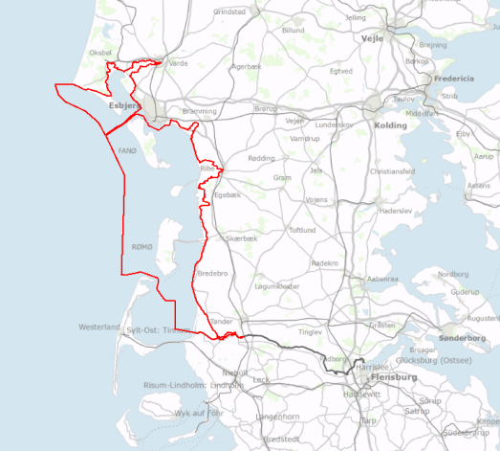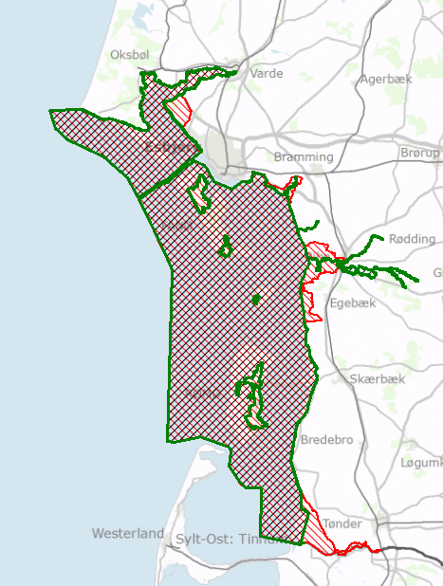

**Figure 1. Boundaries: Left: Wadden Sea cooperation area (red) and habitat area H78 (green) Right -Trilateral Wadden Sea cooperation area.**

Natura 2000 area N89 Wadden Sea covers most of the Wadden Sea corporation area. N89 Wadden Sea consists of a number of habitat- and bird areas and a total of 10 management plans cover all the habitat- and birds areas. In order to describe the Wadden Sea habitat types and species in following sections these management plans including habitat area “H78 Vadden Sea with Ribe River, Tved River and Varde River” are relevant. The management plan for H78 contains mapping and description of the habitat types assessed in the chapters below.

1. **Habitat type quality Assessment**

Assessment of open land habitat type quality in the Wadden Sea as elsewhere in Denmark builds on a system of 5 quality classes where I (high) is the highest quality and V (bad) is the lowest quality. In general, habitat areas in quality classes I and II are assessed to meet the requirements for being in a favorable condition at the local level. Habitat quality classes are estimated using two indexes, a species index and a structural index. The species index is based on plant species recorded on a site covered by a number of circles with a radius of 5 m. The structural index is based on vegetation height and presence of woody plants, drainage, invasive plants and positive and/or negative habitat type characteristics among other parameters.

A high species index combined with a low structural index indicates that the area has potential for higher nature content thus the index can be used in order to locate areas with many and rare species where an effort is required to maintain the high nature content.

V

Bad

IV

Poor

I

High

II

Good

III

Moderate

Favorable condition

Unfavorable condition

Figure 2. Quality classes for habitat types

Terrestrial habitat types in the Danish Natura 2000 areas were systematically mapped for the first time in 2004-2006 and a second mapping took place in 2010-2012.

So far a system has not yet been developed evaluating the quality of marine habitat types.

* 1. **Terrestrial habitat types**
     1. **Atlantic salt meadows (1330)**

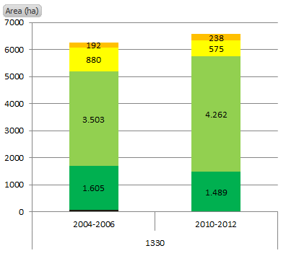The habitat type Atlantic salt meadow (1330) is the most wide spread terrestrial habitat type within the habitat area H78 (see chapter 1). The size of the Atlantic salt meadows mapped in 2010-2012 was 6563 ha. This was 383 ha more than the area of Atlantic salt meadows mapped in 2004-2006.

Figure 3.Habitat quality (based on a species and a structural indices) for Atlantic salt meadows.

Most of the mapped area in 2010-2012, 5750 ha, is in a favorable condition. These areas are characterized by a good composition of species and good structures.

An area of 432 ha has moderate-poor structures. These areas are characterized mainly by overgrowing with high grasses, because of lack of grassing, and/or drainage or presence of coastal protection. For 1246 ha the species index was moderate or poor, meaning that the presence of habitat related plant species was deficient.

* + 1. **Embryonic shifting dunes (2110)**

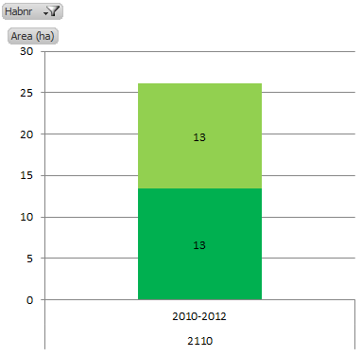Embryonic shifting dunes were mapped for the first time in the period 2010-2012. A total of 26 ha were mapped. The area mapped as Embryonic shifting dunes was in a favorable condition.

Figure 4. Habitat quality based on species and structural indices for Embryonic Shifting Dunes.

Thus the mapped areas are characterized by good structures and species composition.

* + 1. **Shifting dunes along the shoreline with Ammophila arenaria ('white dunes') (2120)**

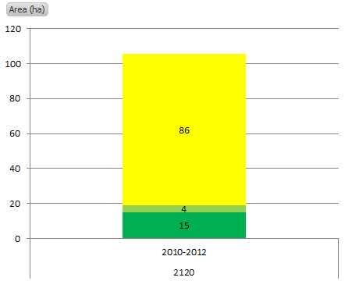White dunes (2120) were mapped for the first time in the period 2010-2012. The area mapped is 105 ha. White dunes are predominantly in an unfavorable condition.

Figure 5 Habitat quality based on species and structural indices for Embryonic shifting dunes.

The structures are in a general good and with little presence of invasive species for example. The area is in unfavorable condition due to a deficient species composition.

* + 1. **Fixed coastal dunes with herbaceous vegetation ('grey dunes') (2130)**

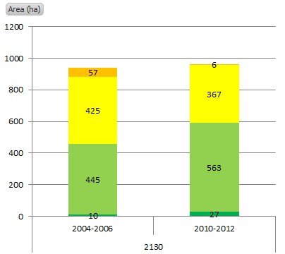Grey dunes (2130) were mapped for the first time in 2004-2006 and again in 2010-2012. In the latter period a total of 963 ha were mapped, whereas in the first period the area was 937 ha. The difference is most proably due to a more detailed mapping in 2010-2012. A total of 590 ha are in a favorable condition and 373 ha are in an unfavorable condition.

Figure 6. Habitat quality based on species and structural indices for Grey dunes.

On 220 ha widespread occurence of woody plants and invasive species cause moderate structures. On 384 ha the species composion is deficient.

* + 1. **Decalcified fixed dunes with Empetrum nigrum (2140)**

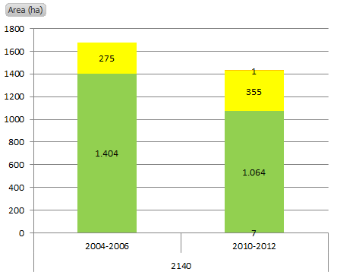A total of 1427 ha was mapped in 2010-2012 as Decalcified fixed dunes with *Empetrum nigrum* (2140). This is 252 ha less than was mapped in the period 2004-2006. The decline is most probably due to a more detailed mapping of the habitat type in 2010-2012.

Figure 7. Habitat quality based on species and structural indices for Decalcified fixed dunes with Empetrum nigrum.

A large occurrence mapped as type 2140 in the first recording period was mapped as mosaics of different habitat types in the second period. For example large areas on the island of Rømø which in first period were mapped as Decalcified fixed dunes with *Empetrum nigrum* (2140), was mapped as Humid dune slacks (2190) in the latter period.

The majority of the mapped area is in a favorable condition (1071 ha) and 356 ha is in unfavorable condition. On 346 ha of the latter there are moderate structures mainly caused by the lack of grazing or other types of extensive land use, which imply that woody plants and invasive species had over growing the vegetation.

The species index is low for approximately 518 ha thus indicating that the presence of species is deficient in these areas.

* + 1. **Dunes with Hippophaë rhamnoides (2160)**

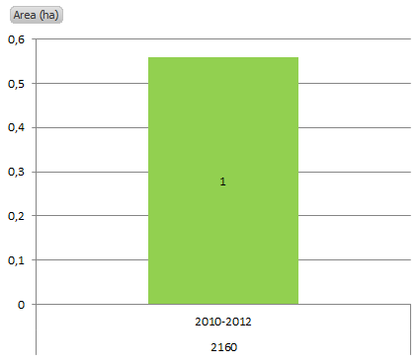Only a very small area is mapped as Dunes with Hippophaë rhamnoides 2160 (approximately 0,6 ha). The habitat type was mapped in 2010-2012.

Figure 8. Habitat quality based on species and structural indices for Dunes with Hippophaë rhamnoides.

The mapped area is in a favorable condition and has well developed structures. A moderate species index indicates that the species composition is somewhat poor.

* + 1. 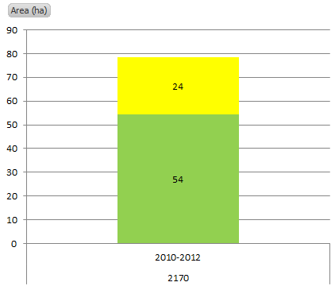**Dunes with Salix repens ssp argentea (Salicion arenariae) (2170)**

Figur 9 Habitat quality based on species and structural indices for Dunes with Salix repens ssp argentea.

Dunes with Salix were mapped for the first time in 2010-2012 covering an area of 78 ha.

An area of 54 ha is in a favorable condition and 24 ha are in an unfavorable condition. For 52 ha the structures are well developed. On the remaining 26 ha structures are moderate.

* + 1. 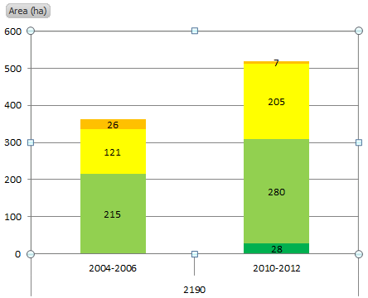**Humid dune slacks (2190)**

Figur 10 Habitat quality based on species and structural indices for Humid dune slacks

The area mapped as Humid dune slacks has increased from 362 ha in 2004-2006 to 520 ha in 2010-2012. The increase is caused by a more detailed mapping in the latter period. For example some areas mapped as 100% decalcified fixed dunes with Empetrum nigrum (2140) in the first period, was in the later period mapped as mosaics of decalcified fixed dunes with Empetrum nigrum (2140) and humid dune slacks.

Humid dune slacks are in a favorable condition on 308 ha and in an unfavorable condition on 212 ha.

The main part of the area in an unfavorable condition is characterized by moderate or poor structures as well as poor species composition. The main reason for the moderate or poor structures in these areas is due to overgrowing by woody plants and occurrence of invasive species.

* 1. **Marine habitat types**

The Danish part of the Wadden Sea has not been mapped in detail by the Danish monitoring program.

Table1. Marine habitat types.

Current mapping of marine habitat type distribution is based on knowledge from specific projects in the period 2004-2011, and numbers in Table 1 should be considered as estimates.

1. **Species**

The three marine mammals (Grey seal, Harbour seal and Harbour porpoise) are monitored in the Danish national programme for monitoring, NOVANA. Monitoring of seals is done from small airplanes flying over breeding and moulting sites counting the number of seals. Also Porpoises are recorded from plane.

* 1. **Marine mammals**
     1. **Grey seal (1364) and harbour seal (1365)**

Number of Grey seals has increased in the Danish part of the Wadden Sea. Thus there were counted 78 individuals in 2012 compared to 14 individuals in 2006. The increase is mainly due to immigration from the German and Dutch part of the Wadden Sea. The reason for the immigration is a result of an increasing population the German and Dutch areas combined with an improved availability of nourishment in the Danish part of the Wadden Sea. The number of counted Harbour seal has increased from approximately 3000 individuals in 2010 to 4000 individuals in 2012.

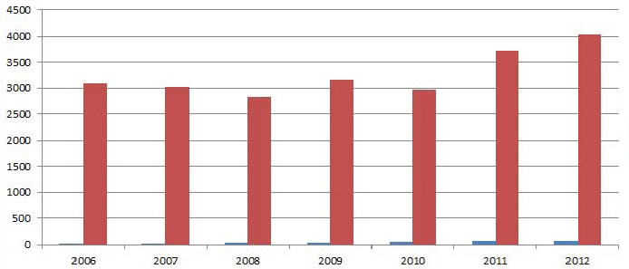

**Figure 11. Number of seals in the period 2006-2012. Blue bar represents Grey seal and red bar represent Harbour seal.**

* + 1. **Harbour porpoise**

Harbour porpoise is monitored by line transect flights from a height of 200 m, where animals within a given distance from the plane are recorded. Overflights were carried out in 2011 and 2012. In both years the density was 0,03 porpoise/km.



# Appendix 3

**Roof Report information from Schleswig-Holstein, Germany**

**(21.06.2016 – D. M. Fleet LKN-SH - Nationalpark Agency)**

Answers to the for SH relevant questions 1, 2, 4 & 5 from the mail from Folkert de Jong 27.01.2016

**1.         Update 2008 paper of the 2nd Trilateral Workshop “Species and Habitats”**

**Chapter 2.2 Status national implementation**

**Proposal for new wording:**

Schleswig-Holstein

In SH area-specific conservation objectives were published by the government in 2006.

The FFH Special Areas of Conservation (SAC), which are relevant for the trilateral cooperation, are listed in the following table:

|  |  |  |
| --- | --- | --- |
| SAC code | SAC | Size (ha) |
| 0916-391 | NTP S-H Wattenmeer und angrenzende Küstengebiete | 452455 |
| 0916-392 | Dünen- und Heidelandschaften Nord-Sylt | 1916 |
| 1016-392 | Dünen- und Heidelandschaften Nord- und Mittel-Sylt | 642 |
| 1115-301 | NSG Rantumbecken | 567 |
| 1115-391 | Dünenlandschaft Süd-Sylt | 741 |
| 1116-391 | Küstenlandschaft Ost-Sylt | 380 |
| 1315-391 | Küsten- und Dünenlandschaften Amrums | 2158 |
| 1316-301 | Godelniederung / Föhr | 149 |
| 1617-301 | Dünen St. Peter | 153 |
| 1719-391 | Untereider | 3606 |
| 2323-392 | Schleswig-Holsteinisches Elbästuar und angrenzende Flächen | 19280 |

The largest SAC in the Wadden Sea Area of Schleswig-Holstein is the "Schleswig-Holstein Wadden Sea National Park and bordering coastal areas" (DE-0916-391). It is divided into three sub-areas - the National Park Area incl. bordering coastal strip, the Halligen (Langeneß, Gröde & Nordstrandischmoor), and the polders (Köge). With regard to the conservation objectives in this SAC a differentiation has been made between overarching and habitat/species-specific objectives. Conservation objectives (Erhaltungsziele) are defined and, where necessary, the restoration (Wiederherstellung) of habitats is proposed. Restoration objectives apply to habitats and species that have been classified as having an “unfavourable bad” conservation status. The overarching objectives are relevant for the whole designated area or sub-area - including all its habitat types and species.

|  |  |  |  |  |  |  |  |  |
| --- | --- | --- | --- | --- | --- | --- | --- | --- |
| **Overview Wadden Sea habitat type and marine mammals evaluation for Schleswig-Holstein and Germany for the period 2007-2012**  Note: Listed are all habitat types within and partly within Wadden Sea Area (WSA) | | | | | |  |  |  |
| **Type** | **Decription** | **SH** | **SH-Evaluation 2007-2012** | **Trend** | **Size (ha)** | **Comment** | **Germany-Evaluation 2007-2012** | **Trend** |
| **Open sea and tidal areas** | |  |  |  |  |  |  |  |
| 1110 | Sandbanks which are slightly covered by sea water all the time | **not recorded in the WSA for 2007-2012** | unknown | unknown | 5000 | Amrumbank | unfavourable bad | stable |
| 1130 | Estuaries | **X** | unfavourable bad | stable | 37000 | Elbe, Godelniederung Föhr, Eider | unfavourable bad | stable |
| 1140 | Mudflats and sandflats not covered by seawater at low tide | **X** | favourable | stable | 163350 | Size includes Elbe estuary | favourable | stable |
| 1150 | Coastal lagoons | **X** | unfavourable inadequate | improving | <70 |  | unfavourable inadequate | unknown |
| 1160 | Large shallow inlets and bays | **X** | unknown | unknown | unknown for WSA |  | unknown | unknown |
| 1170 | Reefs | **X** | unknown | unknown | ? for WSA |  | unfavourable bad | unknown |
| **Sea Cliffs and Beaches** | |  |  |  |  |  |  |  |
| 1210 | Annual vegetation of drift lines | **X** | unfavourable inadequate | deteriorating | 70 |  | unfavourable inadequate | deteriorating |
| 1220 | Perennial vegetation of stony banks | **X** | favourable | stable | 47 |  | unfavourable inadequate | deteriorating |
| 1230 | Vegetated Sea Cliffs of the Atlantic and Baltic Coasts | **X** | favourable | stable | 25 |  | favourable | unknown |
| **Atlantic and continental salt marshes ans salt meadows** | |  |  |  |  |  |  |  |
| 1310 | Salicornia and other annuals colonizing mud and sand | **X** | unfavourable inadequate | deteriorating | 1920 |  | favourable | stable |
| 1320 | Spartina swards (Spartinion maritimae) | **X** | favourable | stable | 1950 |  | favourable | stable |
| 1330 | Atlantic salt meadows (Glauco-Puccinellietalia maritimae) | **X** | unfavourable inadequate | improving | 10656 |  | unfavourable inadequate | stable |
| 1340 | Inland salt meadows |  |  |  |  |  |  |  |
| **Sea dunes of the Atlantic, North Sea and Baltic coasts** | |  |  |  |  |  |  |  |
| 2110 | Embryonic shifting dunes | **X** | unfavourable inadequate | deteriorating | 240 | size includes Helgoland | unfavourable inadequate | deteriorating |
| 2120 | Shifting dunes along the shoreline with Ammophila arenaria (white dunes) | **X** | unfavourable inadequate | stable | 650 | size includes Helgoland & Elbe | favourable | stable |
| 2130 | Fixed coastal dunes with herbaceous vegetation (grey dunes) | **X** | unfavourable inadequate | stable | 1100 | size includes Helgoland | unfavourable inadequate | deteriorating |
| 2140 | Decalcified fixed dunes with Empetrum nigrum | **X** | unfavourable inadequate | deteriorating | 1300 |  | unfavourable inadequate | deteriorating |
| 2150 | Atlantic decalcified fixed dunes (Calluno-Ulicetea) | **X** | unfavourable bad | stable | 230 |  | unfavourable bad | unknown |
| 2160 | Dunes with Hippophae rhamnoides |  | unfavourable bad | deteriorating | 2 | only Helgoland | favourable | stable |
| 2170 | Dunes with Salix repens ssp. argentea (Salicion arenariae) | **X** | unfavourable inadequate | stable | 60 |  | favourable | stable |
| 2180 | Wooded dunes of the Atlantic, Continental and Boreal region | **X** | unfavourable bad | stable | 14 |  | favourable | stable |
| 2190 | Humid dune slacks | **X** | unfavourable inadequate | stable | 300 | size includes Helgoland | unfavourable inadequate | deteriorating |
| **Inland Dunes** | |  |  |  |  |  |  |  |
| 2310 | Dry sand and heath with Calluna and Genista | **WSA?** | unfavourable bad | stable | 500 | size includes areas on mainland | unfavourable bad | deteriorating |
| **Freshwater habitats Standing water** | |  |  |  |  |  |  |  |
| 3150 | Natural eutrophic lakes with Magnopotamion or Hydrocharition - type vegetation | **X** | unfavourable inadequate | improving | 1000 | size includes areas on mainland | unfavourable bad | unknown |
| **Temperate heath and srcub** | |  |  |  |  |  |  |  |
| 4010 | Wet heath with Erica tretralix | **X** | unfavourable bad | deteriorating | 200 | size includes areas on mainland | unfavourable bad | deteriorating |
| 4030 | European dry heaths | **X** | unfavourable bad | stable | 400 | size includes areas on mainland | favourable | deteriorating |
| **Semi-natural dry grassland** | |  |  |  |  |  |  |  |
| 6210 | Semi-natural dry grassland on calcerous substrate | **WSA ?** | unfavourable bad | unknown | 1 |  | unfavourable inadequate | unknown |
| 6230 | Species-rich Nardus grasslands* | **X** | unfavourable bad | stable | 70 | size includes areas on mainland | unfavourable bad | deteriorating |
| **Semi-natural tall-herb humid meadows** | |  |  |  |  |  |  |  |
| 6410 | Semi-natural dry grasslands and scrubland facies on calcareous substrates (Festuco Brometalia)(*important orchid sites) | **WSA ?** | unfavourable bad | stable | 100 | size includes areas on mainland | unfavourable bad | deteriorating |
| 6430 | Hydrophilous tall herb fringe communities of plains and of the montane to alpine levels | **WSA ?** | unfavourable bad | deteriorating | 175 | size includes areas on mainland | unfavourable bad | deteriorating |
| **Mesophile grassland** | |  |  |  |  |  |  |  |
| 6510 | Lowland hay meadows | **x** | unfavourable bad | stable | 1000 | Eider estuary size includes areas on mainland | unfavourable bad | deteriorating |
| **Sphagnum acid bogs** | |  |  |  |  |  |  |  |
| 7140 | Transition mires and quaking bogs | **X** | unfavourable bad | stable | 2260 | size includes other areas on mainland | unfavourable inadequate | unknown |
| **Marine Mammals** | |  |  |  | Population size |  |  |  |
| 1364 | Grey seal | **X** | favourable | improving | Minimum :143 Maximum: 1355 | Federal evaluation | favourable | improving |
| 1365 | Harbour seal | **X** | favourable | stabil | Minimum :16906, Maximum: 21950 | Federal evaluation | favourable | stabil |
| 1351 | Harbour porpoise | **X** | unfavourable inadequate | stabil | Minimum :12413, Maximum: 41395 | Federal evaluation | unfavourable inadequate | stabil |
| ~~1349~~ | ~~Bottlenose Dolphin~~ |  |  |  |  |  |  |  |

**2.         Compare spatial overlap of Wadden Sea Cooperation Area and area covered by national management plans**

In SH management plans are prepared at the SAC level. A published plan for the SAC "Schleswig-Holstein Wadden Sea National Park and bordering coastal areas" (DE-0916-391) is not yet available.

**4.         DE check possibility of extraction of data from national reporting and SDF-data**

See Table for extraction of SH- and German data

**5.         Three states report on assessment of habitat types and species relevant to Wadden Sea only**

See table above for report for SH and Germany.

# Appendix 4

* **Roof Report information from Wadden Sea, the Netherlands:**   
  **Assessment of Natura 2000 habitat types and species**

**Introduction**

At the N2000 workshop, held in Bonn, 24-25 March 2015, it was agreed that the Wadden Sea states report on assessment of Natura 2000-habitat types and -species relevant to the Wadden Sea area (TG-MM, 2016: action point 5). This document describes the assessment of the Netherlands’ part of the Wadden Sea.

The habitat types relevant for the Wadden Sea, as agreed on by the TG-MM (2016), are: 1110, 1130, 1140, 1150, 1160, 1170, 1210, 1220, 1310, 1320, 1330, 2110, 2120, 2130, 2140, 2150, 2160, 2170, 2180, 2190. The species relevant for the Wadden Sea are (TG-MM, 2016): 1364, 1365, 1351. N.b. not all of the mentioned habitat types occur in, or are designated by the Netherlands, such as H1170.

**Method**

This information is based on the assessment of the Natura 2000 sites for habitat types (Janssen et al., 2014) and species (Ottburg & Janssen, 2014) in the Netherlands, describing the information used to evaluate the ecological data for the habitat types and the species listed in Annex II of the Habitats Directive as required for the Standard Data Forms (SDFs). Comprehensive indicators were used to score these data for all sites under the Habitats Directive where a particular habitat type or species occurs. The sites were assessed (scored) using information obtained from a group of experts, as well as from information derived from a large variety of (literature) sources.

The criteria used for the SDFs as described in Janssen et al. (2014) and Ottburg & Janssen (2014) are primarily based on the definitions and guidelines from the European Commission Decision concerning the site information format for Natura 2000 sites (EC, 2011). The following aspects are covered in the Dutch SDFs for:   
Habitat types:

* Cover: the surface in hectares of the habitat type within the Natura 2000 site;
* Representativity: degree of representativity of the habitat type on the site. Described by the EC (2011) as a measure of ‘how typical’ a habitat type is. The Netherlands has interpreted this as how is the habitat type at the site related to the ideal type concerning the biological components of the habitat type. Ranking system used is: A: excellent representativity, B: good representativity, C: significant representativity; D: non-significant presence;
* Relative surface: the surface of the habitat type within the Natura 2000 site related to the surface of the habitat type within the Netherlands, using the following ranking system: A = >15%, B = 2-15%, C = < 2%;
* Conservation status: defined by the EC (2011) as the degree of conservation of the structure and functions of the natural habitat type and restoration possibilities. This criterion comprises three sub-criteria: (i) degree of conservation of the structure, (ii) degree of conservation of the functions, (iii) restoration possibility. The Dutch interpretation is the abiotic quality of the type, covering the structure (horizontal, vertical, scenic embedding), the abiotic and spatial conditions for sustainable conservation of the type and the recoverability. Ranking system used is based on the sub-criteria eventually leading to: A: excellent conservation, B: good conservation, C: average or reduced conservation.
* Global assessment: evaluation based on the scores of the criteria relative surface, representativity and conservation status. Ranking system used is: A: excellent value, B: good value, C: significant value.

Species:

* Size: the numbers of a species (population) within the Natura 2000 site,
* Type: type of species/population, using the following ranking: Permanent (p): to be found throughout the year on the site (non-migratory species or plant, resident population of migratory species); Reproducing (r): uses the site to raise young (e.g. breeding, nesting); Concentration (c): site used for staging or roosting or migration stop/over or for moulting outside the breeding grounds and excluding wintering; Wintering (w): uses the site during the winter.
* Population: the relative size of the population (to other populations in the Netherlands), using the following ranking system (consistent to EC (2011)): A = >15%, B = 2-15%, C = < 2%.
* Conservation: Degree of conservation of the features of the habitat which are important for the species concerned and possibilities for restoration. This criterion comprises two sub-criteria: (i) degree of conservation of the features of the habitat important for the species; (ii) restoration possibilities. Based on these sub-criteria an overall assessment is made: A: excellent conservation, B: good conservation, C: average or reduced conservation.
* Isolation: Degree of isolation of the population present on the site in relation to the natural range of the species. A: population (almost) isolated, B: population not-isolated, but on margins of area of distribution, C: population not-isolated within extended distribution range.
* Global: Global assessment of the value of the site for conservation of the species concerned. A: excellent value, B: good value, C: significant value.

**Dutch Wadden Sea area and Natura 2000**

The Dutch Wadden Sea Area belongs to an ecosystem that continues into Germany (Wattenmeer) and Denmark (Vadehavet), see Figure 1. The area consists of the permanent water and mudflats of the Wadden Sea, the estuary of the Ems (“Eems-Dollard”), the adjacent saltmarshes of Texel, Vlieland, Terschelling, Ameland, and Schiermonnikoog (of which the main dune areas are included in separate N2000 sites of the islands, see list below) and a number of small uninhabited isles and sand flats, see Figure 2. The offshore area to the west and north of the islands is designated as N2000 site “Noordzeekustzone”. The Natura 2000 sites of the Dutch Wadden Sea Area designated as Special Areas of Conservation (SACs) according to the Habitat Directive are listed in Table 1. The biggest area, the “Waddenzee” consists of coastal and intertidal area, barrier islands with dunes and saltmarshes.

**Table 1 SACs of the Dutch Wadden Sea Area**

|  |  |  |
| --- | --- | --- |
| **Site name** | **Site Code Habitat Directive** | **Area (ha)** |
| Waddenzee | NL1000001 | 249,170 |
| Eems-Dollard | NL2007001 | 15,365 |
| Noordzeekustzone | NL9802001 | 123,134 |
| Duinen en Lage Land Texel | NL2003060 | 4,615 |
| Duinen Vlieland | NL2003061 | 1,535 |
| Duinen Terschelling | NL2003059 | 5,017 |
| Duinen Ameland | NL3009005 | 2,012 |
| Duinen Schiermonnikoog | NL3009006 | 1,024 |

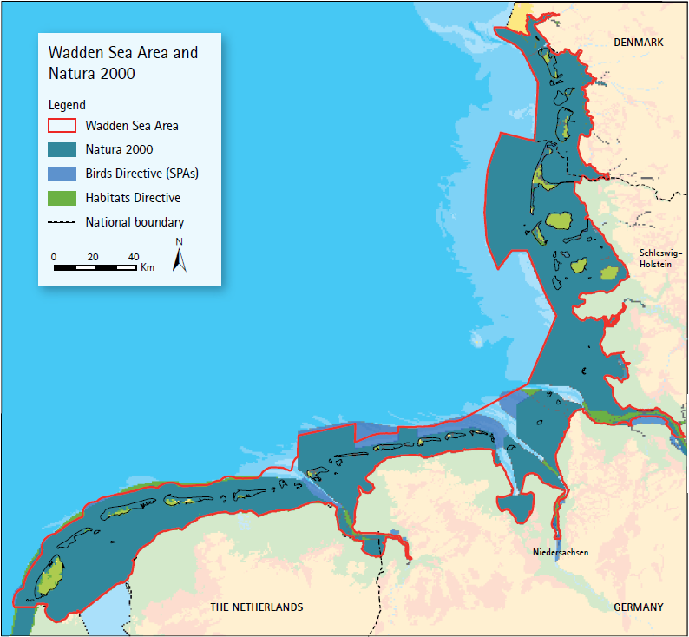

*Figure 1. Wadden Sea Area and Natura 2000 (Common Wadden Sea Secretariat, 2010).*

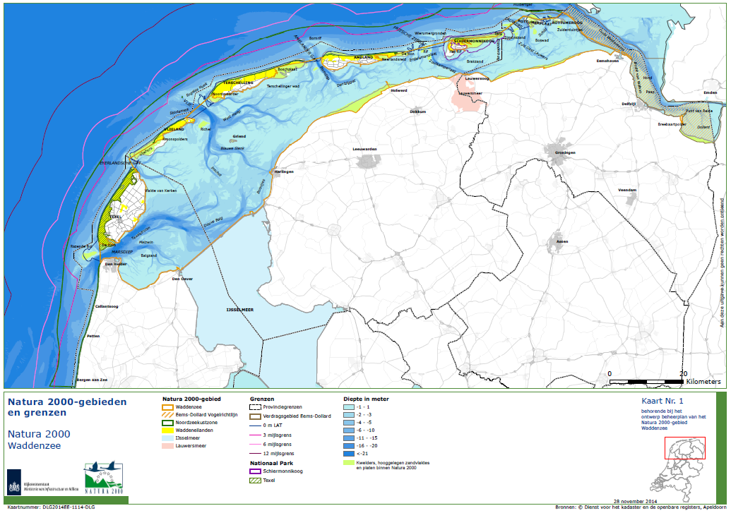

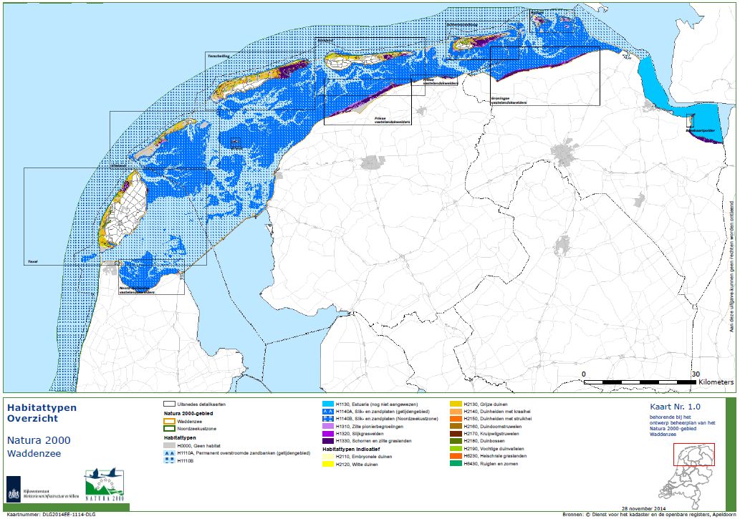

*Figure 2. Natura 2000 sites of the Dutch Wadden Sea (top) and habitat types (bottom) (Ministerie van Infrastructuur en Milieu, 2015).*

**Results**

The results of the Dutch SDF assessment for habitat types and species of the Natura 2000 sites in the Wadden Sea Area are presented in Table 2 and Table 3, respectively. Only the habitat types and species that are listed by the TG-MM (2016), see introduction, are included. The assessment is based on the criteria described in the European Commission Decision concerning the site information format for Natura 2000 sites (EC, 2011), see the section ‘Method’ in this document.

The conservation status of relevant habitat types and species are also assessed on a national scale, i.e. the country assessments of conservation status (2007-2012) of habitat types and species (Habitats Directive, Article 17). These results are available at <http://eunis.eea.europa.eu/externalglobal>. Relevant habitat types and species (see introduction) are provided in Table 4.

*Table 2. The Dutch Evaluation Natura 2000 Wadden Sea habitat types, including the N2000 sites “Waddenzee” (WZ); “Eems-Dollard” (ED) “Noordzeekustzone” (NZKZ); “Duinen en Lage Land Texel” (TX); “Duinen Vlieland” (VL); “Duinen Terschelling”(TS); “Duinen Ameland” (AM) and; “Duinen Schiermonnikoog” (SC). General meaning of ranking: A: excellent; B: good; C: significant/average, as currently registered in the EU Natura 2000 Standard Data Forms database (http://natura2000.eea.europa.eu/Natura2000/).*

| **Habitat types** | | | | **Site Assessment** | | | |
| --- | --- | --- | --- | --- | --- | --- | --- |
| **Type** | **Description** | **Size (ha)** | **Site** | **Relative Surface** | **Represen-tativity** | **Conser-vation** | **Global** |
| **Open sea and tidal areas** | |  |  |  |  |  |  |
| 1110 | Sandbanks which are slightly covered by sea water all the time | 142,568 | WZ | B | B | B | B |
|  | 144,474 | NZKZ | B | C | B | B |
| 1130 | Estuaries | 15,326 | ED | A | B | C | A |
| 1140 | Mudflats and sandflats not covered by seawater at low tide | 129,169 | WZ | A | B | B | A |
|  | 3,053 | NZKZ | C | A | A | A |
|  |  | 9.6 | TX | C | C | A | C |
| 1150 | Coastal lagoons | 0 |  | - | - | - | - |
| 1160 | Large shallow inlets and bays | 0 |  | - | - | - | - |
| 1170 | Reefs | 0 |  | - | - | - | - |
| **Sea Cliffs and Beaches** | |  |  |  |  |  |  |
| 1210 | Annual vegetation of drift lines | 0 |  | - | - | - | - |
| 1220 | Perennial vegetation of stony banks | 0 |  | - | - | - | - |
| **Atlantic and continental salt marshes and salt meadows** | |  |  |  |  |  |  |
| 1310 | Salicornia and other annuals colonizing mud and sand | 1296 | WZ | A | A | A | A |
|  | 75 | NZKZ | B | A | C | B |
|  | 332 | TX | B | A | A | A |
|  | 9.4 | VL | C | B | C | C |
|  |  | 21 | TS | C | A | C | C |
|  |  | 5.4 | SC | C | C | A | C |
| 1320 | Spartina swards (Spartinion maritimae) | 418 | WZ | A | C | A | A |
|  | 2 | TS | C | C | C | C |
| 1330 | Atlantic salt meadows (Glauco-Puccinellietalia maritimae) | 6477 | WZ | A | A | B | A |
|  | 159 | NZKZ | C | C | B | C |
|  | 449 | TX | B | A | A | A |
|  | 40 | VL | C | C | C | C |
|  |  | 165 | TS | C | A | B | B |
|  |  | 35 | SC | C | C | B | C |
| 1340 | Inland salt meadows | 0 |  | - | - | - | - |
| **Sea dunes of the Atlantic, North Sea and Baltic coasts** | |  |  |  |  |  |  |
| 2110 | Embryonic shifting dunes | 118 | WZ | A | A | A | A |
|  |  | 242 | NZKZ | A | A | A | A |
|  |  | 93 | TX | B | A | A | A |
|  |  | 54 | TS | C | A | A | A |
| 2120 | Shifting dunes along the shoreline with Ammophila arenaria (white dunes) | 64 | WZ | B | A | A | A |
|  |  | 139 | TX | B | A | A | A |
|  |  | 116 | VL | B | B | A | B |
|  |  | 380 | TS | A | A | A | A |
|  |  | 97 | AM | B | B | A | B |
|  |  | 12 | SC | C | A | A | A |
| 2130 | Fixed coastal dunes with herbaceous vegetation (grey dunes) | 20* | WZ | C | C | C | C |
|  | 2293 | TX | A | A | A | A |
|  | 327 | VL | B | B | A | B |
|  | 884 | TS | B | A | C | B |
|  |  | 454 | AM | B | B | C | B |
|  |  | 117 | SC | C | B | C | C |
| 2140 | Decalcified fixed dunes with Empetrum nigrum | 597 | TX | A | A | B | A |
|  | 178 | VL | B | B | B | B |
|  |  | 974 | TS | A | A | B | A |
|  |  | 33 | AM | C | B | C | C |
| 2150 | Atlantic decalcified fixed dunes (Calluno-Ulicetea) | 187 | TX | A | B | A | A |
|  | 5.5 | VL | C | B | A | B |
|  |  | 94 | TS | A | B | A | A |
|  |  | 11 | AM | B | B | C | B |
| 2160 | Dunes with Hippophae rhamnoides | 3.3 | WZ | C | C | C | C |
|  | 418 | TX | B | A | A | A |
|  |  | 28 | VL | C | B | B | B |
|  |  | 45 | TS | C | B | B | B |
|  |  | 76 | AM | C | B | A | B |
|  |  | 80 | SC | C | B | A | B |
| 2170 | Dunes with Salix repens ssp. argentea (Salicion arenariae) | 239 | TX | A | A | A | A |
|  | 1.2 | VL | C | A | A | A |
|  | 194 | TS | A | A | A | A |
|  | 104 | AM | B | B | A | B |
|  | 67 | SC | B | A | A | A |
| 2180 | Wooded dunes of the Atlantic, Continental and Boreal region | 399 | TX | B | B | B | B |
|  | 57 | VL | C | C | C | C |
|  | 267 | TS | B | C | B | B |
|  | 35 | AM | C | C | C | C |
|  | 95 | SC | C | C | B | C |
| 2190 | Humid dune slacks | 0.01 | WZ | C | B | B | B |
|  |  | 3 | NZKZ | C | C | A | C |
|  |  | 468 | TX | A | A | A | A |
|  |  | 93 | VL | B | B | A | B |
|  |  | 155 | TS | B | A | A | A |
|  |  | 116 | AM | B | A | C | B |
|  |  | 168 | SC | B | A | A | A |

*Table 3. The Dutch Evaluation Natura 2000 Wadden Sea Habitat Species, including the N2000 sites “Waddenzee” (WZ); “Noordzeekustzone” (NZKZ); “Duinen en Lage Land Texel” (TX); “Duinen Vlieland” (VL); “Duinen Terschelling”(TS); “Duinen Ameland” (AM) and; “Duinen Schiermonnikoog” (SC). General meaning of ranking: A: excellent; B: good; C: significant/average. The information is based on Ottburg & Janssen (2014)*

|  |  |  |  |  |  |  |  |  |
| --- | --- | --- | --- | --- | --- | --- | --- | --- |
| **Species** | | **Population in the site** | | | **Site Assessment** | | | |
| **Type** | **Description** | **Site** | **Size (individuals), min-max** | **Type** | **Pop.** | **Con.** | **Iso.** | **Glo.** |
| **Marine Mammals** | |  |  |  |  |  |  |  |
| 1364 | Grey seal | WZ | 0-3000# | P | A | A | C | A |
|  |  | NZKZ | 0-3000# | P | A | A | C | A |
| 1365 | Harbour seal | WZ | 6500-11600# | P | A | A | C | A |
|  |  | NZKZ | 6500-11600# | P | A | A | C | A |
| 1351 | Harbour porpoise | NZKZ | * | P | C | C | C | C |

# The individuals occurring in the ‘Waddenzee’ (WZ, Wadden Sea) are counted at sandbanks and beaches. These are foraging in the ‘Noordzeekustzone’ (NZKZ, North Sea Coastal Zone) where they are not counted. The species size in the table per site are thus reflecting the same individuals/population.

* Resolution of observations is not sufficient to assess the abundance. This species is indicated as V (very rare).

*Table 4. Conservation status (2007-2012) of habitat types and species (Habitats Directive, Article 17) relevant for the Wadden Sea Area, based on the country-level assessment of the conservation status in the Netherlands (http://eunis.eea.europa.eu/externalglobal)*

|  |  |  |  |
| --- | --- | --- | --- |
| **Habitat type or species** | | **Habitat or population size in Dutch Wadden Sea Area (ha or number)** | **NL country (Art. 17) assessment 2007-2012** |
| **Open sea and tidal areas** | |  |  |
| 1110 | Sandbanks which are slightly covered by sea water all the time | 287,042 * | Unfavourable-Inadequate |
| 1130 | Estuaries | 15,326 | Unfavourable-Bad |
| 1140 | Mudflats and sandflats not covered by seawater at low tide | 132,232 | Unfavourable-Inadequate |
| **Atlantic and continental salt marshes and salt meadows** | |  |  |
| 1310 | Salicornia and other annuals colonizing mud and sand | 1,739 | Unfavourable-Inadequate |
| 1320 | Spartina swards (Spartinion maritimae) | 421 | Unfavourable-Inadequate |
| 1330 | Atlantic salt meadows (Glauco-Puccinellietalia maritimae) | 7,342 | Unfavourable-Inadequate |
| **Sea dunes of the Atlantic, North Sea and Baltic coasts** | |  |  |
| 2110 | Embryonic shifting dunes | 509 | Favourable |
| 2120 | Shifting dunes along the shoreline with Ammophila arenaria (white dunes) | 828 | Unfavourable-Inadequate |
| 2130 | Fixed coastal dunes with herbaceous vegetation (grey dunes) | 4115 | Unfavourable-Bad |
| 2140 | Decalcified fixed dunes with Empetrum nigrum | 1782 | Unfavourable-Inadequate |
| 2150 | Atlantic decalcified fixed dunes (Calluno-Ulicetea) | 298 | Unfavourable-Inadequate |
| 2160 | Dunes with Hippophae rhamnoides | 650 | Favourable |
| 2170 | Dunes with Salix repens ssp. argentea (Salicion arenariae) | 605 | Unfavourable-Inadequate |
| 2180 | Wooded dunes of the Atlantic, Continental and Boreal region | 853 | Unfavourable-Inadequate |
| 2190 | Humid dune slacks | 1003 | Unfavourable-Inadequate |
| **Marine Mammals** | |  |  |
| 1364 | Grey seal | 0-3000 | Unfavourable-Inadequate |
| 1365 | Harbour seal | 6500-11600 | Unfavourable-Inadequate |
| 1351 | Harbour porpoise | 0 (very rare) | Unfavourable-Inadequate |

* This habitat type also includes part of the area along the North Holland coast (see *Figure 2*) and thus overestimates the Wadden Sea area (*Figure 1*).

**Literature**

Common Wadden Sea Secretariat, 2010. Wadden Sea Plan 2010. Eleventh Trilateral Governmental Conference on the Protection of the Wadden Sea. Common Wadden Sea Secretariat, Wilhelmshaven, Germany. Available at: <http://www.waddensea-secretariat.org/sites/default/files/downloads/wsp-v2-11-02-03-final-lowres.pdf>.

European Commission (2011). Commission implementing decision of 11 July 2011 concerning a site information format for Natura 2000 sites (notified under document C(2011) 4892) (2011/484/EU). Official Journal of the European Union L 198/39, 30.7.2011. Available at: <http://eur-lex.europa.eu/LexUriServ/LexUriServ.do?uri=OJ:L:2011:198:0039:0070:EN:PDF>

Janssen, J.A.M., E.J. Weeda, P. Schippers, R.J. Bijlsma, J.H.J. Schaminée, G.H.P. Arts, C.M. Deerenberg, O.G. Bos & R.G. Jak (2014). Habitattypen in Natura 2000-gebieden. Beoordeling van oppervlakte, representativiteit en behoudsstatus in de Standard Data Forms (SDFs). Wageningen, Wettelijke Onderzoekstaken Natuur & Milieu. WOt-technical report 8. 196 blz.; 2 tab.; 33 ref.; 1 Bijlage.

Ministerie van Infrastructuur en Milieu (2015). Kaartenbijlage bij ontwerpplan Natura 2000-beheerplan Waddenzee. Periode 2016-2022. Ministerie van Infrastructuur en Milieu, Rijkswaterstaat Noord-Nederland, November 2015.

Ottburg, F.G.W.A. & J.A.M. Janssen (2014). Habitatrichtlijnsoorten in Natura 2000-gebieden. Beoordeling van populatie, leefgebied en isolatie in de Standard Data Forms (SDFs). Wageningen, Wettelijke Onderzoekstaken Natuur & Milieu. WOt-technical report 9, 106 blz; 6 tab.; 63 ref.

TG-MM (2016): Task group management and monitoring, Sixteenth meeting (TG-MM 16), Bremen 28-29 September 2016. Agenda Item 6, Subject N2000 Roof Report, Document Nr. TG-MM 16-6.1, 6 September 2016.