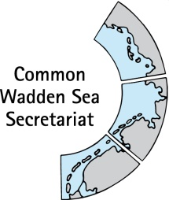MEETING DOCUMENT

**Task Group Management (TG-M 21-2)**

09 March 2021

Online meeting

**Agenda Item: 2. Summary record**

**Subject: Draft summary record TG-M 21-1**

**Document No.:** TG-M 21-2/2

**Date:** 23 February 2021

**Submitted by: CWSS**

This document contains the summary record of TG-M 21-1held on 28 January 2021.

**Proposal:** The group is invited to adopt the document.

**Version Log**

|  |  |  |  |
| --- | --- | --- | --- |
| **Issue Date** | **Version** | **Author** | **Change** |
| 2021-01-29 | v0.1 | CWSS | First draft of the document |
| 2021-02-02 | v0.2 | chair | Amendments and approval by chair |
| 2021-02-09 | v0.2 | MSa, MB (SH) | Minor amendments |
| 2021-02-10 | v0.2 | MSo | Minor amendments, changes to agreements 4.1 & 4.2 |
| 2021-02-22 | v0.3 | CWSS | Integration to version 0.3 |
|  |  |  |  |

Note from CWSS: this version log is for my personal overview and will be omitted.

DRAFT SUMMARY RECORD v0.3

Meeting of the

**Task Group Management (TG-M 21-1)**

28 January 2021

Online meeting

1. **Opening of the Meeting and adoption of the Agenda**

The meeting was opened by the Chairperson, Mr Jørgensen at 13:00 on 28 January 2021. He welcomed Ms Schröder back to the group, and Ms Luna and Ms Perrin (CWSS) as guests to the full meeting. The chair passed apologies from Mr Janke. A list of attendees is at Annex 1. Ms Schröder left the meeting at 13:40

TG-M **adopted** the draft agenda of the meeting (Annex 2) with the addition of a re-opened discussion on the Swimway policy document under agenda item 4.2 by Karst Jaarsma. He further requested the submission of meeting documents in time. Action items are at Annex 3.

1. **Adoption of the draft summary record**

*Document: TG-M21-1-2rev_SR20-4*

TG-M **adopted** the draft summary record of TG-M20-4.

1. **Announcements**

*Documents: TG-M21-1-3-Announcements*

**Denmark**

No announcements

**Germany**

No announcements

**Schleswig-Holstein**

No announcements

**Hamburg**

No announcements

**Lower Saxony**

* New record for Grey Seal Counts: The new year begins with good news from the Lower Saxony Wadden Sea National Park. As part of the annual count of grey seals for the breeding season in December, a maximum of 988 grey seals were counted, 372 of which were pups. For comparison: in the previous year (2019) there were 306 pups and ten years ago only 40 pups were sighted.
* New planning of corridors for grid connection of offshore wind farms: The Office for Regional Development Weser-Ems has now initiated the regional planning procedure for the planning of future corridors for offshore wind power grid connection in Lower Saxony's territorial waters (Seetrassen 2030). The pipeline corridors to be examined run across the islands of Baltrum and Langeoog and end up on the coast in the area of the municipalities of Dornum and Neuharlingersiel.

**Netherlands**

An agreement with Msc Zoe has been closed for the costs made to clean-up after the disaster

**CWSS**

* Upon invitation by Programma Rijke Waddenzee, the TWSC/CWSS took part in a seminar to highlight and reinforce Climate adaptation in the Wadden Sea region on 20 January within the Climate Adaptation Week from 18-25 January 2021 in Groningen (online). Karin Lochte delivered a pitch to highlight the values of the Wadden Sea;
* Kristine Meise started her position at CWSS as successor of Gerld Lüerssen, as new coordinator of the Wadden Sea Flyway Initiative
* Marine Perrin joins CWSS as short-term project assistant until April 2021 to support the development of the single integrated management plan with the development of legal framework databases for Shipping, Fisheries, Energy, Coastal Protection and Tourism.

The group **noted** the information.

Angelique Nielen held a presentation on the Dutch Agenda for the Wadden Sea Region 2050 (Annex 5), which was followed by a round of questions and answers. Ms Nielen offered a presentation for TG-M on the implementation of the Strategy in autumn 2021.

The group **thanked** Ms Nielen and **noted** the information.

1. **Implementation of the Leeuwarden Declaration 13:50**

*Document: TG-M21-1-4-1-TG-M progress report,*

Margrita Sobottka and Karst Jaarsma offered written contributions to the draft TG-M progress report for WSB 32 regarding Partnership Hub activities and general.

The group **noted** the document and agreed to send further input to the document to the chair and CWSS until 4 February 2021. The amended document will be shared with TG-M before submission to the Wadden Sea Board (WSB) 32 before 11 February 2021.

The group **agreed** to formulate a closing remark under the point Light Emission, which will be omitted from the TG-M progress report in future.

The group further **agreed** to update the work plan TG-M 2021.

**4.1** **Paragraph 22 - 23: Marine litter**

*TG-M21-1-4-2Marine litter cover and inventory-rev, TG-M21-1-4-4Marine litter Germany*

The group discussed the inventory marine litter, as well as future involvement and activities of the Trilateral Wadden Sea Cooperation (TWSC) in this topic.

The German members of TG-M pointed out the on-going activities in the frame of the OSPAR convention - all three Wadden Sea states are members of OSPAR. Also, all three states have national action plans (“Programme of measures”, MSFD) with measures regarding marine litter in place. There is the Single-Use Plastics Directive of the European Commission that is implemented in the states. Activities are displayed in the inventory.

The group agreed to submit the combined marine litter document for the Wadden Sea Board 32. The group **agreed** on integrating the German part to the inventory by separating general paragraphs to an additional section.

TG-M further **agreed** to address the WSB with a clear proposal in the future, but that the group needs more time to discuss and focus trilateral activities within the huge amount of what is going on about this issue at different levels already and for the beneficial of the Wadden Sea. Therefore, the specific proposal at the end of the note will be re-written. Mr Jørgensen will prepare a next version of the document which will be discussed first with Ms Sanns and Mr van Bentum and then sent to TG-M.

**4.2 Paragraph 13: Swimway**

*TG-M21-1-4-3-Swimway policy statement_rev*

Henrik Jørgensen inquired, if recent marine spatial planning and the EU Biodiv strategy impacting fish should be added to a cover note for this document. The group pointed out to keep up a clear distinction between fisheries and fish species conservation at working group level, which also would apply here.

The group **agreed** on the policy statement elaborated by the ad hoc WG Swimway, and to submit this to WSB 32 with reference to the Swimway vision’s pillar ‘policy’ and the development process in the cover note, which will be drafted by Marina Sanns and CWSS in consultation with the chair of the WG-Swimway. CWSS will format the document.

Upon request by Karst Jaarsma, the agreement of TG-M 20-4 “*to use the main policy document as valuable background document for internal use only. The document should not be further elaborated”* was discussed. Background is the request by Dutch Swimway colleagues to use the main document for policy comparison and discussion in the Netherlands. CWSS reminded on procedural conflicts, as agreements of the WG-Swimway to further work on this document were “overrun” by this TG-M decision. Marina Sanns responded that there are still mistakes and imbalances at least in the part of the document concerning regulations in Germany and that therefore it should not be published. As the document comprises international regulations, but not national implementations, a direct comparison of the three states is difficult and would need more explanation.

TG-M **reaffirmed** the agreement of TG-M 20-4, yet the Dutch part of the main document may be used for the abovementioned purpose in the Netherlands.

CWSS informed that the amended version of the Terms of Reference for an Expert Group Swimway will be discussed in the WG-Swimway meeting on 3 February 2021.

The group **agreed** to decide on the ToR in an email consultation, with the aim to submit these to the WSB 32 before 11 February 2021.

1. **Shipping**

*Document: TG-M21-1-5-1_MSCZoe, TG-M21-1-5-2-WSF-Round-table*

**MSC Zoe:** TG-M thanked the Netherlands for the report, **noted** the information and **agreed** to include a general update on shipping to the TG-M progress report for WSB32, with the intention to put further work on a statement on the MSC Zoe report, also considering outcomes of the round table, if available and submit these to WSB 33 planned for August 2021.

**WSF Round table**: Margrita Sobottka proposed to point out the round table shipping as partnership hub activity in the cover note. She underlined that the Wadden Sea Forum is in the lead of the round table and has involved multiple partner sectors and is hence a good example of a partnership oriented approach.

Soledad Luna informed that a continuous exchange at working level was started to ensure information exchange on the different activities around shipping issues (round table, partnership hub, SIMP, TG-M).

The group **noted** the round table document and offered to recommend participation to the round table to selected participants if deemed necessary by WSF. CWSS will inquire on status of confirmations of participation to the round table.

1. **Single integrated management plan (SIMP): particularly Sustainable Fisheries and Energy 15:20**

*Document: TG-M21-1-6-1 SIMP, TG-M21-1-6-2 QSR*

Soledad Luna provided an overview on recent developments of the single integrated management plan (SIMP), in alignment with development of respective Quality Status Report (QSR) thematic reports. In December 2o2o, Marine Perrin has submitted legal databases on Fisheries and Shipping & Ports to TG-M members. She is now working on a contract until April 2021 to develop a database on TWSC instruments, and the remaining legal databases for SIMP key topics.

TG-M thanked Marine Perrin for her work on legal databases, **noted** the information and **agreed** to look into procedures for updates, e.g., provide relevant updates of legal databases to CWSS on national level.

Henrik Jørgensen informed about recent developments in the Task Group Monitoring and Assessment (TG-MA), including development of Terms of Reference for the Editorial Board. QSR Thematic Reports for SIMP key topics and ISWSS themes require an update. Therefore, three reports within TG-M responsibility (shipping, fisheries and energy) are included. CWSS added that consultants have started combined work for the QSR reports and SIMP, for the topics shipping and energy. This work includes the impact of the respective sector on the ten key values of the Outstanding Universal Value (OUV) and opportunities. A first draft of the resulting impact matrix will be brought to ad-hoc SIMP drafting-sub-groups and also to other relevant TWSC groups, e.g., Marine Mammals, Alien Species or Birds. For fisheries, an author´s team of Thünen institute (D, lead), WUR (NL) and DTU Aqua (DK) is envisaged.

Floris van Bentum offered input in an ad-hoc SIMP drafting-sub-group shipping.

Henrik Jørgensen noted that extensive collaboration of the three Task Groups (Task Group World Heritage with the SIMP, TG-MA with the QSR), being coordinated by respective CWSS secretaries, is taking place.

Karst Jaarma suggested that TG-M may react on a future summary of the QSR with a policy reply on management recommendations and provide this to the WSB.

TG-M **noted** the information and **agreed** with the proposal to draft an impact matrix by external experts which will be discussed with thematic ad-hoc SIMP drafting sub-groups.

1. **Any other business and next meeting**

**7.1 AOB 1**: Maren Bauer informed about the preparation of a brochure in the frame of the OSPAR ministerial conference planned for 20 June 2021. It shall inform the ministers on threatened or declining habitats and species having been added to the OSPAR list, including the houting. The (very first) draft contains a reference to activities in the Wadden Sea. Therefore she requests if the trilateral group is in favour or not to support actions (and them being named in the brochure). First of all, it would be helpful to get in touch with the respective OSPAR contact persons in DK and NL.

TG-M **welcomed** the initiative and **agreed** to provide Maren Bauer with contacts of national representatives of OSPAR groups, upon an email request by Maren Bauer to Henrik Jørgensen and Karst Jaarsma.

**7.2 AOB 2** Karst Jaarsma had sent questions arising from the Wadden Agenda 2050 to TG-M.

The group **agreed** to discuss these questions either upon a cover note at the upcoming TG-M meeting or by phone/mail to the choice of Mr. Jaarsma.

**7.3 AOB 3** Karst Jaarsma inquired on the situation in Denmark and Germany for new energy cables in the Wadden Sea reference area. Maren Bauer responded that in the German National Parks corridors with the least impact on natural values (animals, habitats) have been identified in spatial planning processes. The power cables must be placed at least 1,50 m deep in the sea floor. Henrik Jørgensen responded that in Denmark a cable to Great Britain is positioned not far north of the WS (“[Viking-link](https://energinet.dk/Anlaeg-og-projekter/Projektliste/Viking-Link)”) and another to The Netherlands goes through the WS to Esbjerg passing the island of Fanø as well [(“Cobra-link](https://en.energinet.dk/Infrastructure-Projects/Projektliste/COBRAcable)”).

TG-M **noted** the information.

1. **Next meeting**

TG-M **agreed** to hold their next meeting as online meeting on Tuesday 9 March 2021 from 13:00 – 16:00. This next meeting will contain a discussion on the work plan TG-M 2021, the N2000 roof report feasibility study, and air traffic regulation which impact flight height of planes above the Wadden Sea.

1. **Closing**

The Chairperson thanked CWSS and participants for productive meeting and closed the meeting at **16:15** on **11 December 2020** and thanked participants for a fruitful discussion.

**ANNEX 1: List of participants**

LIST OF PARTICIPANTS

**Task Group Management (TG-M 21-1)**

28 January 2021

Online meeting

|  |  |
| --- | --- |
| **Denmark** | |
| **Mr Henrik G. Pind Jørgensen (chair)**  Environment Protection Agency  Skovridervej 3, Arnum  DK-6510 Gram  phone: +45 (0) 72 54 34 44  E-Mail: [hepgj@mst.dk](mailto:hepgj@mst.dk) |  |
| **Germany** | |
| **Mr Thomas Borchers**  Federal Ministry for the Environment, Nature Conservation and Nuclear Safety, Germany  Robert-Schuman-Platz 3  D-53175 Bonn  Phone: +49 (0) 228 99 305 2629  Mobile: +49 (0) 173 2843906  E-Mail: [Thomas.Borchers@bmu.bund.de](mailto:Thomas.Borchers@bmu.bund.de) | **Ms Nina Schröder**  Federal Agency for Nature Conservation (BfN)  Außenstelle Insel Vilm  D-18581 Putbus  Phone: +49 (0) 38301 86 161  E-mail: [nina.schroeder@bfn.de](mailto:nina.schroeder@bfn.de) |
| **Ms Maren Bauer**  Ministry of Energy, Agriculture, the Environment, Nature and Digitalization Schleswig-Holstein  Mercatorstr. 3  D - 24106 Kiel  Phone: +49 431 988 7196  E-Mail: Maren.Bauer@melund.landsh.de | **Ms Marina Sanns**  National Park Authority Schleswig-Holstein  Schloßgarten 1  D 25832 Tönning  Phone: +49 (0) 486161645  E-Mail: Marina.Sanns@lkn.landsh.de |
| **Ms Margrita Sobottka**  National Park Authority Lower Saxony  Virchowstr. 1  D-26382 Wilhelmshaven  Phone: +49 (0) 4421 911 277  E-Mail: [Margrita.Sobottka@nlpv-wattenmeer.niedersachsen.de](mailto:Margrita.Sobottka@nlpv-wattenmeer.niedersachsen.de) |  |
| **Netherlands** | |
| **Mr Karst Jaarsma**  Ministry of Agriculture, Nature and Food Quality  Directorate-General Nature, Fisheries and Rural Area  Postbus 20401  NL-2500 EK The Hague  Phone : +31 (0) 64 858  E-Mail: [k.c.a.jaarsma@minlnv.nl](mailto:k.c.a.jaarsma@minlnv.nl) | **Mr Floris van Bentum**  Directorate-General for Public Works and Water Management  Directorate Noord-Nederland  PO Box 2301  NL-8901 JH Leeuwarden  E-Mail: [floris.van.bentum@rws.nl](mailto:floris.van.bentum@rws.nl) |
| **Ms Angelique Nielen**  Ministry of Infrastructure and Water Management  Rijnstraat 8  NL-2515 XP Den Haag  Phone: +31 (0) 6 21689848  E-Mail: [nielen@minienw.nl](mailto:nielen@minienw.nl) |  |
| **Secretary** | |
| **Ms Julia Busch**  Common Wadden Sea Secretariat |  |
| **Invited guests** | |
| **Invited Guest: Ms Soledad Luna & Ms Marine Perrin** Common Wadden Sea Secretariat |  |

**ANNEX 2:** **Final agenda**

FINAL AGENDA

**Task Group Management (TG-M 21-1)**

28 January 2021

Online conference

1. **Opening of the Meeting and adoption of the Agenda**

The meeting will be opened by the chairperson at **13:00** on **28 January 2021**. Participants will be invited to adopt the draft agenda of the meeting.

1. **Summary record**

*Documents:* *TG-M21-1-2rev_SR20-4*

Proposal: Adopt the draft Summary Record of TG-M 20-4.

1. **Announcements**

*Document: TG-M21-1-3-Announcements*

Presentation Angelique Nielen: Dutch Strategy 2050 (10 presentation+10min discussion)

To account for the shortened time for this virtual meeting, meeting participants are invited to hand in their information to the CWSS until **27 January 2021**. Individual announcements will not be repeated during the meeting, but time given for questions.

Proposal: Note the information

1. **Implementation of the Leeuwarden Declaration**

*Documents:* *TG-M21-1-4-1-TG-M progress report, TG-M21-1-4-2Marine litter cover and inventory-rev, TG-M21-1-4-3-Swimway policy statement_rev; TG-M21-1-4-4Marine litter Germany*

Participants will be informed on TG-M relevant tasks of the Leeuwarden Declaration (LD)

Proposal: Note the information and revise document for submission to WSB 32.

**4.1** **Paragraph 22 - 23: Marine litter**

Proposal: Discuss the group´s involvement and activities in marine litter and revise and agree on cover note with inventory for submission to WSB 32

**4.2 Paragraph 13: Swimway**

Proposal: Agree on policy statement and if to submit document to WSB 32. Agree on procedure (email consultation) for Swimway ToR and submit to WSB 32.

1. **Shipping**

*Document:* *TG-M21-1-5-1_MSCZoe, TG-M21-1-5-2-WSF-Round-table*

Inform on parliament discussion regarding MSC Zoe incident. Proposal: Note the document, to discuss the role of TG-M/WSB for implementation of these proposals and to prepare recommendations for the WSB-32 meeting on 4 March 2021.

1. **Single integrated management plan (SIMP) and Quality Status Report (QSR)**

*Document:* *TG-M21-1-6-1 SIMP, TG-M21-1-6-2 QSR*

Discussion of current activities and potential contributions regarding the SIMP process and alignment with the Quality Status Report. Proposal: Note the information and review and add on the databases “Shipping and Ports” and “Fisheries

1. **Any Other Business**

The group will be invited to discuss any other business

AOB 1: Wadden Sea in OSPAR ministerial conference. Proposal: Note the information and discuss next steps.

1. **Next meeting**

Meeting TG-M 21-2 is planned for 9 – 10 March 2021.

1. **Closing**

The meeting will be closed no later than **16:00** on **28 January 2021.**

**ANNEX 3: Action items arising from TG-M 21-1**

ACTION ITEMS

**Task Group Management (TG-M 21-1)**

28 January 2021

Online meeting

|  |  |  |  |  |
| --- | --- | --- | --- | --- |
| **Action #** | **Agenda item** | **Actions agreed upon** | **Person responsible** | **Deadline** |
| 1 | 4 | Provide written amendments to TG-M progress report to chair and CWSS | Margrita, Karst, all | 2021-02-04 |
| 2 | 4 | Update work plan TG-M 2021 | CWSS, chair | 2021-02-23 |
| 3 | 4.1 | Format and prepare cover note for Swimway policy document | CWSS, Marina | 2021-02-01 |
| 4 | 4.1 | Decide on ToR EG-Swimawy in email consultation | all | 2021-02-11 |
| 5 | 5.1 | Include shipping item to TG-M progress report |  | 2021-02-11 |
| 6 | 5.1 | Prepare a statement on MSC Zoe report for the WSB meeting in November | TG-M |  |
| 7 | 5.2 | Inform WSF on offer to support with participants if needed, and inquire information on confirmation of participation to round table | CWSS |  |
| 8 | 6 | Look into procedures for updates, e.g., provide updates of legal databases to CWSS on national level. | TG-M | Next meeting |
| 9 | 4,5 | Submit to WSB 32:  TG-M progress report, including information on shipping; Marine litter note and inventory, ToR Swimway, Policy summary swimway | CWSS | 2021-02-11 |
| **Pending from previous meetings** | | | | |
|  | 20-4/4 | Consider taking up the implementation of the EU single-use plastics directive | TG-M |  |
| 8 | 20-4/7 | Take up N2000 roof report and air traffic regulations |  | 2021-03-09 |
|  | 20-2/5 | Inquire on possible data for wardening workshop | NL (LNV) | Next meeting |
|  | 20-2/5 | Alignment of DK reduced seal count flights with Seal Management Plan | CWSS | Next meeting |
|  | 20-2/6 | Finalise feasibility study and adding section (half pager) on implementation of N2000 in each country | Consultant (study); all (section) | TG-M 21-2 |
|  | 20-2/6 | Share N2000 feasibility study with TG-MA | CWSS | Upon finalisation |

**ANNEX 4: Work Plan**

Table: Work plan 2020 of the Task Group Management (TG-M) with deliverables/products of the group´s responsibility in black, and supervision and coordination activities in grey. Items in brackets are temporary dealt with in TG-M but will need further allocation within the TWSC (e.g., Partnership Hub) (Work Plan as amended at TG-M20-2 2020-05-14) and submitted to the Wadden Sea Board (WSB) at their 31 meeting on 18 June 2020-.

| L**eeuwarden Declaration** | **TG-M role** | **Products 2020 (what)** | **Responsible group/body/person (who)** | **Time schedule incl. milestones (when)** |
| --- | --- | --- | --- | --- |

|  |  |  |  |  |
| --- | --- | --- | --- | --- |
| 3. Single integrated management plan (SIMP) | Support and contribute | First final draft of the complete SIMP | TG-WH, CWSS (SIMP officer) | 2020-11 |
| 3a Tourism | None | Content on chosen SIMP key topic headings | NG-ST leads, Support managers and TG-MA | TBD by NG-ST |
| 3b. Fisheries | Responsible | Proposal working approach | TG-M | 2020-03 (TG-M 20-1) |

|  |  |  |  |  |
| --- | --- | --- | --- | --- |
|  |  | Content on SIMP key topic headings “Inventory” and “Common ground" | TG-M and fisheries specialists (potential Task Group or Round Table) | 2020-03 Basic info  2020-06  2020-09 Revision |
| Content on SIMP key topic headings "Strategies and actions for management" based on "Threats and opportunities" and considering "Climate change" | TG-M and fisheries specialists (potential Task Group or Round Table). | 2020-06 to 2020-09  Workshop or meeting of fisheries specialists (potential Task Group or Round Table)  First Draft and Revision  2020-09-20 Revision |
| Overview on fish monitoring and data | Ad hoc WG SWIMWAY | DONE 2019 |

|  |  |  |  |  |
| --- | --- | --- | --- | --- |
| 3c. Shipping and ports | Responsible/Support | Content on SIMP key topic headings “Inventory”, "Strategies and actions for management" based on "Threats and opportunities" and considering "Climate change" | WSF, with support from TG-M and CWSS. | TBD WSF |
| 3d. Renewable energy, Energy from Oil and Gas, (Coastal flood defence and protection) | Responsible  (Support) | Proposal working approach | TG-M/SH | 2020-03 (TG-M 20-1) |

|  |  |  |  |  |
| --- | --- | --- | --- | --- |
|  |  | Content on SIMP headings “Inventory” and “Common ground | TG-M/SH, CWSS (SIMP officer) (EG-C responsible for coastal flood defence and protection) | 2020-03 Basic info  2020-06  2020-09 Revision |
| Content on SIMP key topic headings "Strategies and actions for management" based on "Threats and opportunities" and considering "Climate change" | TG-M, CWSS (SIMP officer), and depending on working approach proposal. Collaboration with EG-C for climate change as appropriate.  (EG-C responsible for coastal flood defence and protection) | 2020-06 to 2020-09  Workshop or meeting depending on working approach proposal  First Draft and Revision  2020-09-20 Revision |
| Monitoring, data collection and data management | TG-MA | TBD TG-MA |

|  |  |  |  |  |
| --- | --- | --- | --- | --- |
| 5. Wadden Sea Flyway Initiative (WSFI) | Observe | Arctic Cooperation | WSFI SG | 2020-11 |

|  |  |  |  |  |
| --- | --- | --- | --- | --- |
|  | Observe | Monitoring of key sites along Flyway |  | 2020-02, on-going |
| Observe | Capacity Building | On-going |

|  |  |  |  |  |
| --- | --- | --- | --- | --- |
| 12. Breeding Bird Action Plan | Oversee[1] | Breeding bird trend report | EG-MB/BB | 2020-08 |
| 13. SWIMWAY | Observe/  support | Implementation SWIMWAY Vison | TG-M/ad hoc WG SWIMWAY |  |

|  |  |  |  |  |
| --- | --- | --- | --- | --- |
|  | Observe/  support | ToR and work programme for EG Fish |  | 2020-11 |

|  |  |  |  |  |
| --- | --- | --- | --- | --- |
| 14. Management & Wardening | Responsible | (Site) Managers Workshop | TG-M |  |

|  |  |  |  |  |
| --- | --- | --- | --- | --- |
|  | Responsible | Wardening Workshop |  | TBD (to account for COVID 19) |

|  |  |  |  |  |
| --- | --- | --- | --- | --- |
| 15. Seal Management Plan 2018-2022 | Evaluate and support | SMP and Annual Reporting | EG-Seals |  |

|  |  |  |  |  |
| --- | --- | --- | --- | --- |
|  | Oversee | Annual Reporting on harbour seal and grey seal population |  | 2020-07 and -11 |

|  |  |  |  |  |
| --- | --- | --- | --- | --- |
| 16. Harbour porpoises | Observe and evaluate | Inclusion to ToR of EG-Seals | EG-Seals | 2020-11 |
| 17. Alien Species (MAPAS) | Oversee | Implementation MAPAS / Alien Species Platform | EG-AS | 2020-11 (on-going) |
| 20. Quality Status Report | Support | Draft Proposal for next QSR (joint note TG-MA TG-M) | TG-MA | TBD TG-MA |
| 21. Sustainable fisheries | Responsible | Inventory on fishery activities in the Wadden Sea Conservation Area. | TG-M/CWSS | 2020-06  (compare SIMP 3b) |

|  |  |  |  |  |
| --- | --- | --- | --- | --- |
|  |  | Document with status and recommendations for principles of the Framework Sustainable Fishery | TG-M/CWSS | TBD |

|  |  |  |  |  |
| --- | --- | --- | --- | --- |
| 22.-23 Marine litter | Responsible/Support if needed/Ignition phase | Inventory on activities | [TG-M] NL/D/ QSR thematic report authors/ TG-WH | 2020-xx for WSB 32 |
| [24. Light emissions] | Support | Inventory on activities | WSF/Partnership Hub |  |
| 29. Renewable energy and its transportation | Responsible | Overview on concepts for renewable energy transport/sea floor /(Inventory study 2020) | TG-M (DK, D, NL, coordination by ?) | TBD (compare SIMP 3d) |
| [30.-34. Sustainable –Shipping and Ports] | Responsible | Concept on Awareness and Education | TG-M | TBD (compare SIMP 3c) |

|  |  |  |  |  |
| --- | --- | --- | --- | --- |
|  | Support | WSF Round table approach | [WSF in collaboration with TG-M] | TBD (compare SIMP 3c) |

|  |  |  |  |  |
| --- | --- | --- | --- | --- |
| 36. Joint Program on Research | Support | Installation of T Programming Committee on Wadden Sea Research | TRA-RMC | TBD by TRA-RMC/WSB |
| 44. 15th International Scientific Wadden Sea Symposium | Support | Establishment of planning committee and organisation | Schleswig-Holstein | 2021-03-23 to 2021-03-26 |
| Wadden Sea Plan (WSP) | Supervise | Implementation of WSP/Towards technical update of WSP | [TG-M] | On-going |

**ANNEX 5: Presentation Angelique Nielen**

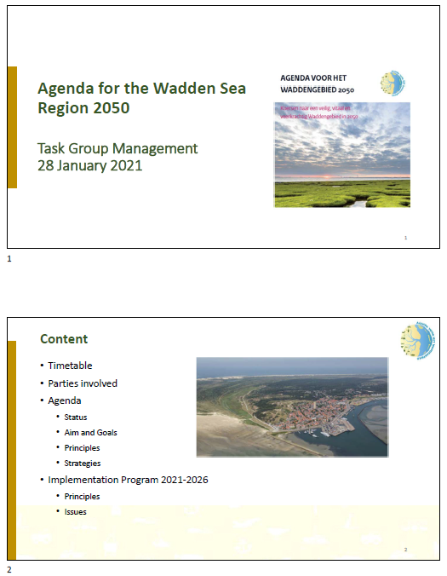

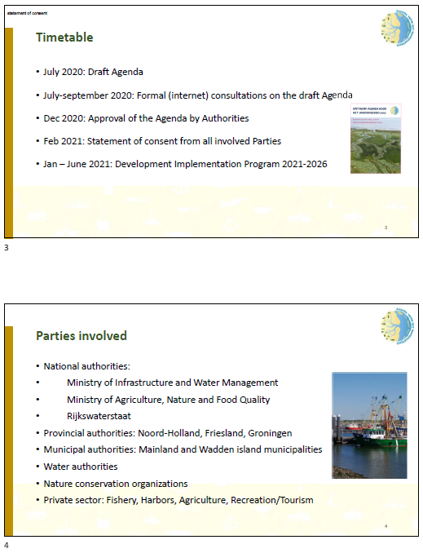

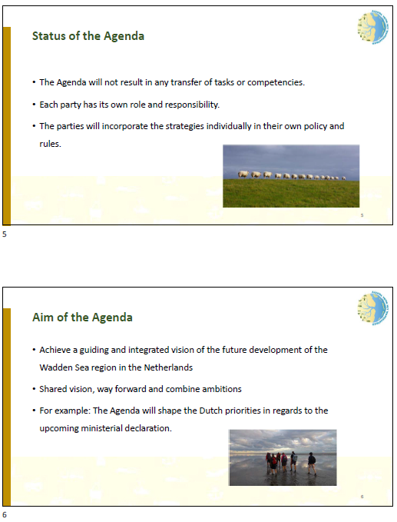

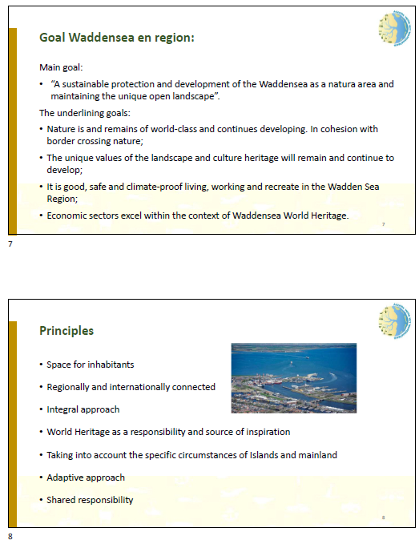

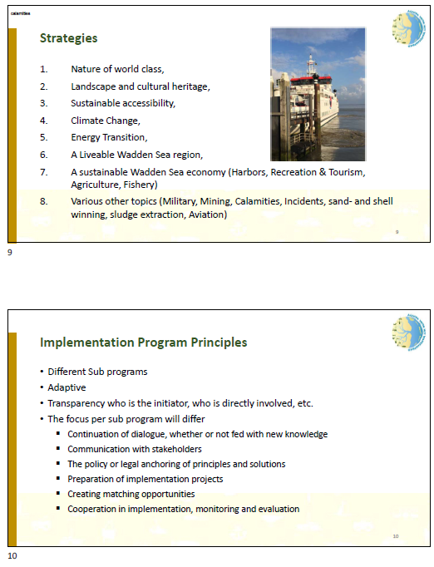

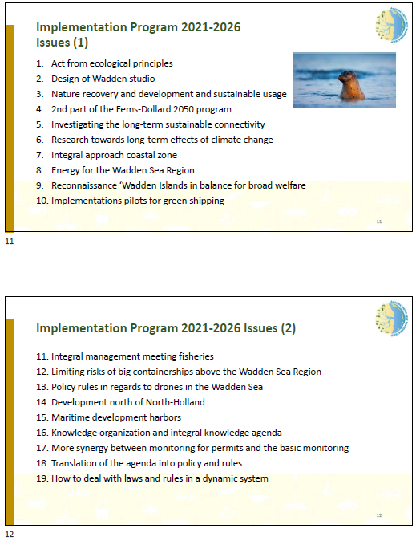

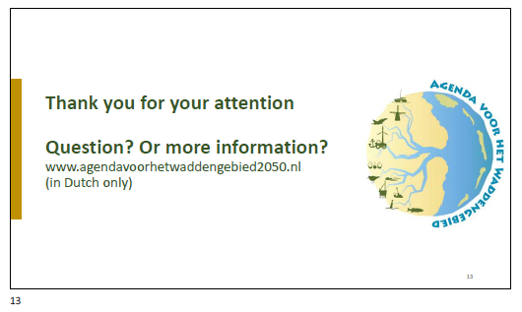

1. Oversee: Processes and products are followed and aligned to trilateral policy and coordinated where necessary