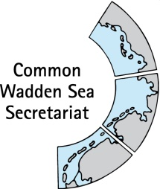
MEETING DOCUMENT
Task Group Management (TG-M 21-3)
25 May2021
Online meeting

Agenda Item: 4. Implementation of the Leeuwarden Declaration
Subject: TG-M progress report and work plan
Document No.: TG-M 21-3/4.1
Date: 19 May 2021
Submitted by: CWSS

This document contains an update on progress on paragraphs of the Ministerial Council Declaration of the13th Trilateral Governmental Conference on the Protection of the Wadden Sea (Leeuwarden Declaration), which are relevant for the Task Group Management (TG-M).
Note work plan in Annex 1 as separate file (TG-M21-3-4-1-Annex1-Work plan 2021-22.xlsx).

Proposal: The group is invited to note the information
update the work plan as appropriate.
agree on a procedure for preparation of recommendations on future trilateral activities marine litter for submission to WSB 33 and start drafting a first contribution on this issue for the Declaration text

Task Group Management (TG-M) progress report and work plan
Since WSB-32 and the corresponding TG-M progress report the following progress was made on paragraphs of the Ministerial Council Declaration of the13th Trilateral Governmental Conference on the Protection of the Wadden Sea (Leeuwarden Declaration), which are relevant for the Task Group Management (TG-M). For the work plan TG-M 2021/22 see Annex 1.

Flyway & Breeding Birds
§5 Agree to continue and further consolidate the work on the Flyway Vision in the framework of the Wadden Sea Flyway Initiative with the relevant governmental and nongovernmental organisations and aim to extend the cooperation in the context of the Wadden Sea Flyway Initiative, especially with regard to the Arctic, to continue monitoring along the entire flyway, to continue specific capacity building and to increase the activation of partners;
The official letter of approval of the concept note ‘Climate Resilience for Critical Sites for Migratory Birds and People along the East Atlantic Flyway’ (Short Title: Climate Resilient East Atlantic Flyway) submitted by the Wadden Sea Flyway Initiative (WSFI) in 2020 was sent out by the International Climate Initiative (IKI) secretariat in February 2021. The IKI project consortium has now entered the first steps of the preparatory phase. After an initial Kick-Off meeting with delegates from the German Ministry for the Environment, Nature Conservation and Nuclear Safety, the IKI secretariat and the project consortium in the middle of April, the project consortium has now entered the next preparatory phase, developing a proposal for the 6-month preparation phase which is going to start at the beginning of 2022. It is foreseen that the actual project will start in the first quarter 2023, given funding is granted.
After the third total count of the East Atlantic Flyway in January 2020 Marc van Roomen is currently compiling and assessing the national dataset from countries along the flyway. The next East Atlantic Flyway Assessment report is expected to be published by the end of 2021.
§12 Instruct the Wadden Sea Board to oversee the further implementation of the Action Plan for Breeding Birds and support an exchange of experiences of national and regional activities, including a potential further development, and to undertake an evaluation in time for the next Trilateral Governmental Conference;
The next progress report on ‘Migratory Birds in the Wadden Sea’ is currently in preparation and will include all count data on migratory birds until summer 2020, providing the most recent baseline information on trends in migratory bird numbers relevant under the framework of the TMAP program. The report is expected to be published after the official publication of the QSR chapters on breeding and migratory birds.
The Breeding Bird Expert Group is planning a joint workshop with the Expert Group Saltmarshes and Dunes in November 2021. After a previous joint workshop between the two groups focusing on the saltmarshes and how their management effects breeding birds, this workshop will focus on the restoration and management of dunes and beaches and their effect on the favourable conservation status of habitats and breeding birds.

A Quality Assessment Workshop is being organized by Schleswig-Holstein for September 2021 to ensure the correct identification of juvenile Arctic waders. Comparative data from successive year on the percentage of juveniles in the population provide useful information to assess changes in the breeding success of Arctic breeding migratory birds which use the Wadden Sea as a Stopover site.

Proposal: TG-M is invited to note the information.

Fish targets / Swimway
13 Instruct the Wadden Sea Board to further develop and contribute to implementing the SWIMWAY Vision (at Annex 3) as an integrated approach to achieving the Trilateral Fish Targets by investigating, monitoring, managing and communicating topics concerning the ecology of fish of the Wadden Sea Area;
The ad hoc Working Group Swimway (WG-Swimway) has been transformed to an Expert Group Swimway (EG-Swimway) with Terms of Reference adopted at WSB 32. Members for EG-Swimway have been nominated by the States and Länder (Annex 2). As announced by the Netherlands at WSB 32, the Dutch representation in this Expert Group and hence for fulfilling the tasks outlined in the ToR can not be specified before discussion of priorities at the next Ministerial Conference in 2022 (now: one person, two days a year). The chairperson of WG-Swimway Mr Adi Kellermann will continue his work in 2021.
- A temporary subgroup of fish monitoring experts is developing a proposal for a common fish monitoring programme in the Wadden Sea regions under the Trilateral Monitoring and Assessment Programme (TMAP), upon request by the Task Group Monitoring and Assessment (TG-MA). An overlap with co-authors of the Quality Status Report thematic report on fish ensures alignment with needs for future QSR assessments;
- A sub-group of Danish, Dutch and German fish scientists is regularly meeting to prepare a trilateral Swimway research proposal. A draft project proposal consisting of work packages has been prepared which may be used fully or partially to fit open calls for third party funds;
- A consortium of German scientists and institutions is finalising a proposal for a national “bottleneck” project to complement the on-going Dutch Waddentools SWIMWAY Waddenzee project.
Proposal: TG-M is invited to note the information

Wardening & management
14. Instruct the Wadden Sea Board to work intensively on cooperation at the operational management level and to secure adequate wardening and management across the whole Wadden Sea Area, in order to strengthen the protection of the Wadden Sea World Heritage
A planned wardening workshop will be postponed, due to the COVID-19 travel- and meeting restrictions (see work plan, Annex 1).
Proposal: TG-M is invited to note the information.

Seal Management Plan
15. Reaffirm the rules on taking and releasing of seals in accordance with Article IV of the Agreement on the Conservation of Seals in the Wadden Sea and adopt the updated Seal Management Plan 2018-2022, which also takes into account the management of grey seals;
Despite Covid-19 regulations, the 2020/21 grey seal aerial counts were successfully conducted. Ms Sophie Brasseur is currently analysing the data and the report will be published on 1 July 2021. The harbour seal count dates have been agreed upon and the first flights of the pupping season will take place at the beginning of June.
Proposal: TG-M is invited to note the information

Harbour porpoises
16. Agree to duly take account of the fact that harbour porpoises are present in the Wadden Sea, thus addressing the conservation of the species;
New Terms of Reference (ToR) of the Expert Group Marine Mammals (formerly: Expert group Seals) have been adopted at WSB 32 and includes now harbour porpoises. Subsequently, the group welcomed additional members with a specific focus on harbour porpoises who are now assessing the existing monitoring schemes within the Wadden Sea regions to develop a common framework for future monitoring efforts of the harbour porpoise.
The postponed harbour porpoise and harbour seal workshop is envisaged to take place as a site event at the ISWSS in Büsum in November 2021.
Proposal: TG-M is invited to note the information

Alien Species
17. Instruct the Wadden Sea Board to undertake further steps towards a Trilateral Management and Action Plan Alien Species (MAPAS) (as described in Annex 4), which should include relevant steps for public awareness and cooperation on early warning and measures, integrating a related monitoring programme, based on the national data underpinning the Trilateral Assessment and Monitoring Programme, including the installation of the network platform at the Common Wadden Sea Secretariat;
The Expert Group Alien Species (EG-AS) is working towards development of operational assessment criteria/targets for non-indigenous species, which can be integrated into the future parameter set and programme array of the Trilateral Monitoring and Assessment Programme (TMAP).
Sascha Klöpper functions as new secretary for this group after retirement of Mr Lüerssen.
Proposal: TG-M is invited to note the information

Sustainable Fisheries
21. Instruct the Wadden Sea Board to further develop steps for the sustainability of fisheries in the Wadden Sea Area on the trilateral level, in order to achieve the conservation objectives of the Trilateral Wadden Sea Cooperation as well as a level playing field. This should be done in close cooperation with responsible authorities and relevant stakeholders and initiatives (e.g. certification procedures), within the Framework for Sustainable Fisheries, taking into account both the importance of the ecosystem service of providing regional seafood in this respect and the integrity of the World Heritage Site.
Separate agenda item on Framework Sustainable Fisheries.

Marine litter
22. Strive to substantially reduce the amount of marine litter in the Wadden Sea by the year 2030;
23. Instruct the Wadden Sea Board to make use of all relevant existing monitoring and action programmes, as well as existing action plans, taking into account local, national and multilateral initiatives to gain and exchange adequate additional knowledge on sources and impacts of marine litter (such as microplastics) on the Wadden Sea ecosystem and stimulate and support appropriate measures.
At TG-M 21-2, the group had agreed to prepare recommendations on future trilateral activities marine litter for submission to WSB 33 and start drafting a first contribution on this issue for the Declaration text.

Proposal TG-M: note the information and agree on next steps

Energy
29. Instruct the Wadden Sea Board to review and monitor the impacts of renewable energy
production and energy transportation on the Wadden Sea ecosystem and to consider measures to avoid or mitigate possible negative impacts by looking for best environmental practices also with the aim of developing, for example, related common principles to evaluate the impact of high-voltage power cables in the Wadden Sea Area in close consultation with the responsible bodies and stakeholders

The review of impacts of renewable energy is being conducted in the frame of the SIMP. For SIMP and QSR see separate agenda item.

Ports and shipping
30. Encourage ports and ferry companies working in the Wadden Sea Area to develop codes of conduct to further demonstrate their willingness to work towards environmentally sound standards in accordance with best available technology;
31. Request the Wadden Sea Board to consider the different approaches of the three countries in order to identify the most sustainable modes of transport for ensuring naturefriendly site-specific connections to the islands in the future;
32. Encourage the competent national shipping and nature conservation authorities to continue their dialogue in order to achieve an even higher level of safety and cooperation, inter alia by raising the general awareness and information level;
At the Wadden Sea Board (WSB) meeting 30 held on 21 November 2019 in Wilhelmshaven, Germany, the establishment of a round table for shipping led by the WSF with the support of the CWSS and in collaboration to TG-M (WSB30/5.8/2 WSF Shipping Group) was approved. The round table was planned for spring 2021, but was set on hold, due to the limited number of participants.
As key topic, shipping and ports is being tackled within the frame of the SIMP. For SIMP and QSR see separate agenda item.

33. Encourage the further development and application of environmentally friendly port concepts through the joint organizations of ports, for example by exchange of best practices;
34. Note the ongoing discussions in the framework of the International Maritime Organization (IMO) on a possible mandatory prewash of cargo tanks having contained paraffins, whereby the prewash residue shall be discharged into a port reception facility;
Proposal TG-M: note the information

Natura 2000 roof report
Still outstanding is 1) Final feasibility evaluation by expert and 2) final processing and approval by TG-M for WSB. Dutch contribution regarding national N2000 implementation has been received (Annex 3).
Proposal TG-M: note the information

QSR
20. Instruct the Wadden Sea Board to produce updates of the online Wadden Sea Quality Status Report and to deliver a comprehensive synthesis report in time for the next Trilateral Governmental Conference;
Authors have started work on thematic reports of TG-M relevant topics fisheries, shipping and energy in the respective thematic reports of the QSR. For SIMP and QSR see separate agenda item.

TG-M Work plan 2021/22
The TG-M work plan 2021/22 is based on the CWSS work plan submitted to WSB 32 (WSB 32/7 Annual workplan by CWSS). Amendments of TG-M at their TG-M 21-2 meeting are included, as well as a first risk assessment by the chair and CWSS, which was shared with TG-M in an email consultation. The work plan is considered a living document and will be regularly updated (Annex 1, separate file).
Proposal: TG-M is invited to note the information and update the work plan as appropriate.

ANNEX 1: Work Plan 2021/22 Task Group Management (TG-M)
See separate file (TG-M21-3-4-1-Annex1-Work plan 2021-22.xlsx).

ANNEX 2: Member nominations of the new Expert Group Swimway (EG-Swimway)

Denmark
Mr Morten Frederiksen  Ministry of Environment and Food  Environmental Protection Agency | Mr Niels Jepsen  DTU Aqua
Ms Xenia Salomonsen
Danish National Park Wadden Sea
Schleswig-Holstein)
Ms Marina Sanns  Schleswig-Holstein Agency for Coastal Defense, National Park and Marine Conservation  National Park Authority | NN  Schleswig-Holstein
Lower Saxony
Mr Christian Abel  National Park Authority Lower Saxony | Mr Oliver-David Finch  NLWKN Aurich
Netherlands
Ms Ingrid Tulp
Wageningen, University & Research (WUR)
Dept. Wageningen Marine Research
Participants from advisors to WSB and external experts
Ms Eva Lages  WWF, Wadden Sea Office | Mr Wouter van der Heij  Waddenvereniging
Ms Aline Kühl-Stenzel
NABU-Bundesverband
Coordination and Secretary
Mr Adi Kellermann (chair)  Kellermann-Consulting | Ms Julia A. Busch (Secretary)  Common Wadden Sea Secretariat

ANNEX 3: Implementation of EU N2000 directives in the Netherlands with special focus on the Wadden Sea
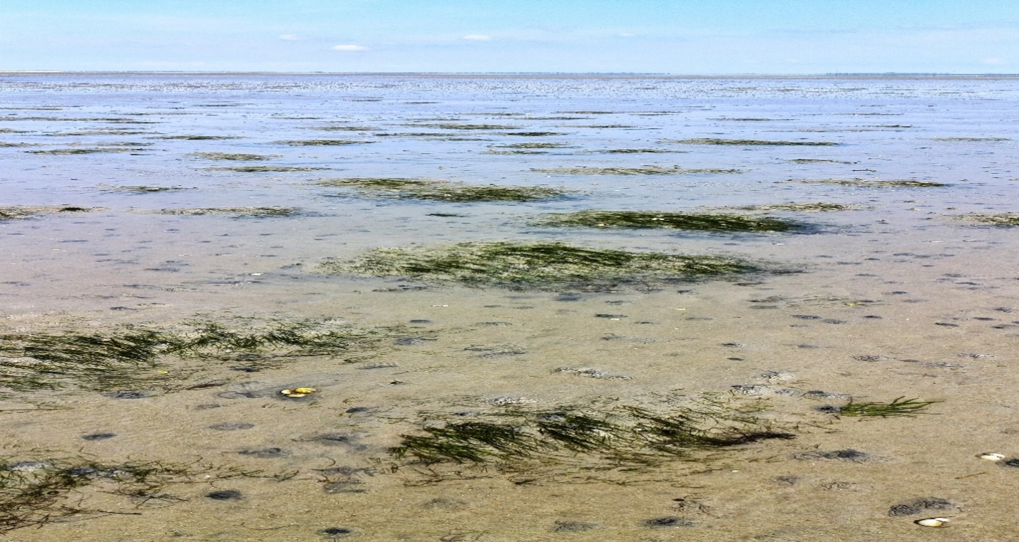
The EU's Natura 2000 directives (Bird Protection Directive and Habitats Directive) oblige European member nations to make the necessary efforts to secure or restore a range of rare, endangered or distinctive habitats and species of European importance, and the Netherlands have chosen to implement the obligations through a systematic and recurring Natura 2000 planning, which prioritizes the required effort on the basis of the directive commitment and national nature monitoring for 6-year planning periods.
There are 166 single Natura2000 areas in total in the Netherlands with a total surface of 1.1 million ha of which 271.771ha covers the Wadden Sea area and 144.475ha the coastal North Sea area.
The Natura 2000 plans are prepared after prior discussion with the relevant government, regional and municipal authorities and with the involvement of national park boards, associations, organizations and landowners who have a significant interest in the plans. For the bigger water areas (the so called Rijkswateren) Rijkswaterstaat is responsible for drawing up the plans.
The Ministry of LNV is responsible for the N2000-policy, the pointing out of the N2000 areas and N2000-targets at the national and regional level. More elaborate information in regards to procedures is available in Dutch.
The actual N2000 Management plan for the Waddensea will be prolonged until 2023.This plan covers the Dutch Waddensea area including the Ems-Dollard. For the Ems-Dollard this plan only counts for the Bird Directive. Also 5 plans for the Wadden islands exists and there is one for the adjacent coastal in place.
Against this background, the Netherlands is currently preparing a supplementary plan for the Ems-Dollard for the years 2022-2027. This has to do with the postponed implementation of the Habitat directive in this area. So the Ems-Dollard supplement will only focus on the goals of this directive.
Since the Ems-Dollard is partly at the same time both Dutch as German territory, the NEA (analysis on effects of use?) will be discussed with Germany as well.
Natura 2000 planning is carried out, among other things, in accordance with the rules of the Wet Natuurbescherming and related regulations. The N2000 planning process results in the following sub-elements for each of the individual N2000 areas.

