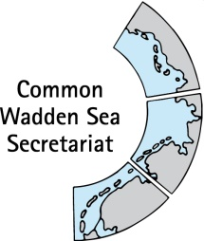

TASK GROUP
World Heritage
TG-WH 26

31 January – 1 February 2019
Bremen

__________________________________________________________________________________

Agenda Item: 4

Subject: SoC request cargo vessel MSC Zoe

Document No. TG-WH 26/4/1

Date: 18 January 2019

Submitted by: Secretariat

__________________________________________________________________________________

Attached is a request by the World Heritage Centre on further information concerning spill of containers from the cargo vessel “MSC Zoe” near the Dutch and Lower-Saxon Wadden Sea islands (see attached letter of 11 January 2019).

As done in previous cases, the States Parties have agreed to involve each other in preparing official responses to WHC request, in order to further strengthen the joint management of the Wadden Sea World Heritage property as one entity.

Proposal

The meeting is proposed to discuss how to proceed in preparing of a joint respond to be forwarded as answer to the World Heritage Centre.

