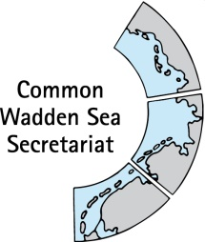
MEETING DOCUMENT
Task Group World Heritage (TG-WH 30)
29 April 2020
Virtual Meeting

Agenda Item: 3
Subject: Announcement Denmark
Document No.: TG-WH 30/3/2
Date: 20 April 2020
Submitted by: Denmark

- Potential extension to the harbour of Esbjerg – follow-up The environmental impact assessment has been concluded and the World Heritage Center and IUCN has been invited to participate in the pre-hearing. The information has been shared with the members of TG-WH Aril 3rd (email from the secretariat). Deadline for comments from the World Heritage Centre and IUCN is May 15th.
- New district heating plants at the port of Esbjerg DIN Forsyning wants to establish 50 MW seawater pumping plant and 60 MW wood chip boiler plant located at Esbjerg harbor. Currently, a memo of information is being prepared for the World Heritage Center, the IUCN and the Trilateral Wadden Sea Cooperation in accordance with the IUCN World Heritage advice note: Environmental Assessment. Esbjerg Municipality's case handling in relation to the Danish environmental legislation is still ongoing, and DIN Forsyning's analyses of the impact on seawater temperatures and currents have not yet been finalized. However, the consultants find that so many sensitivity analyses have been prepared that conclusions and screening in relation to the Natura 2000 site and assessment in relation to the UNESCO World Heritage site can be prepared. We will share the information with TG-WH once we receive it.
- The National park plan 2019-25 is now available in an English pixi version that might be of interest for our partners also in TG-WH (see separate PDF file). The National Park Plan 2019-25 is covers concrete goals that the National park must deliver in the next 6 years. It is the fulfillment of our obligations following the National Park law and the Statutory Order for the National Park Wadden Sea in Denmark. The Plan has been subject to an extensive public phase engaging our regional communities. The plan is widely spread at the political level also at the ministerial level.

