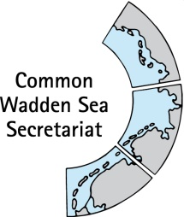

TASK GROUP
World Heritage
TG-WH 33

8 – 9 June 2021
Virtual Meeting

_________________________________________________________________________

Agenda Item: 3

Subject: Announcements

Document No. TG-WH 32/3/1

Date: 07 June 2021

Submitted by: Lower Saxony

_________________________________________________________________________

Attached are announcements received from Lower Saxony by 2 June 2021.

Proposal

The meeting is proposed to note the announcements.

Announcements Lower Saxony

Logo-Use Pilot; Coffeepot
At the end of last year, the National Park Administration ordered a new Lower Saxony National Park merchandizing product, a "World Heritage Wadden Sea Pot", as a pilot in a small number of pieces (500). After delivery problems caused by Corona, it now is on sale via the national park facilities, to test the marketability. The pot is produced by the company "Gute Pötte" from Hamburg. If there is a positive customer feedback, the NPA will encourage the "Gute Pötte" company to apply for an official licence to CWSS and to sell the pot via the company itself in the whole Wadden Sea region, in the best case also in Danish and Dutch. Der Gute Wattenmeer Pott by Nationalparkverwaltung "Niedersächsisches Wattenmeer" - Gute Pötte (gute-poette.de)

Checklist for sustainable events
When organising events - be it group tours in nature, regular market days or one-off concerts with thousands of spectators - a wide variety of aspects influence the degree of sustainability: from the choice of venue to purchasing, the travel of visitors, catering and energy supply to waste management. The checklist, which is now available (German only, sorry) and was developed within the framework of the German-Dutch project "Wadden Agenda 2.0", offers numerous tips on how to organise events in a more resource- and environmental-friendly way. Nachhaltig Veranstalten in der Wattenmeer-Region - Nationalpark Wattenmeer (nationalpark-wattenmeer.de)

