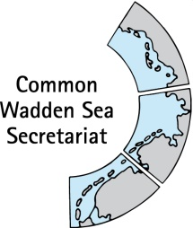
MEETING DOCUMENT
Ad hoc Working Group SWIMWAY (WG-SWIMWAY 20-2)
22 June 2020
Virtual meeting

Agenda Item: 4. SWIMWAY projects
Subject: Connected projects
Document No.: WG-SWIMWAY 20-2/4
Date: 16 June 2020
Submitted by: Martha Buitenkamp

This document contains a short status information on possible connections of projects and SWMWAY Wadden Sea by J.B.J. Huisman (ANNEX 1).

Proposal: The group is invited to note the information

Possible cooperation between projects & SWIMWAY Wadden Sea
Ir. J.B.J. Huisman, Van Hall Larenstein, 2020-06-05

This proposal describes three practical possibilities in joining efforts between projects and Wadden Sea countries.
Tracking fish migration
In the Ems-river and estuary several Dutch and German organizations and Universities are working together to research fish migration, the current separate projects will be active for the next 4 years. Create umbrella (Emsfisch im Fokus/Eemsvissen in Beeld) for the Ems-projects including some finances aimed at working together. Facilitate cooperation with Danish project.
Measures improving fish migration
Wadden Sea countries are working together and sharing knowledge with regards to dikes, sea level rise and measures involved on an official basis. To our knowledge no ecological group is present. At the moment a trilateral working group estuarine fish passes is working together in sharing knowledge on tidal fish passes. Field visits are an essential part of this working group. We propose to officially acknowledging this working group as a Trilateral working group by the Secretariat and the Wadden Sea countries.

Involving citizens/education
Within the project Ruim Baan voor Vissen 2 citizens/volunteers will be monitoring arrival of glass eels and other small diadromous fish at several tidal locations using cross nets. We have been working together with a sister-project in Niedersachsen. We propose to create a joint Trilateral project in which citizens/students will be monitoring diadromous fish. If we could add 2 or 3 locations in Schleswig-Holstein en Denmark we could create a Trilateral citizens science project for the coming three years. People will communicate about their catches in an international app group.
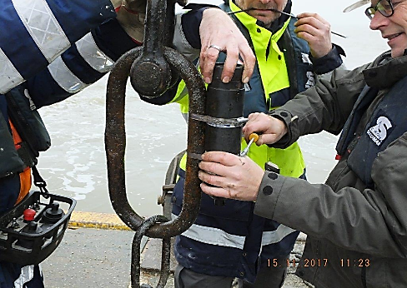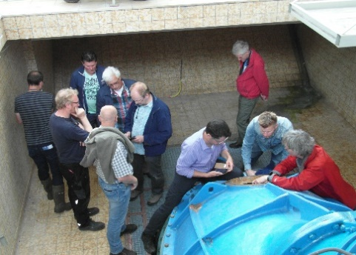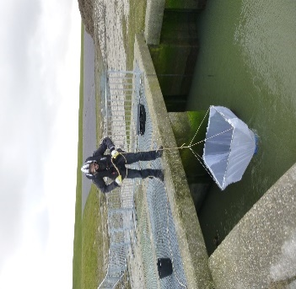
Figure 1 Pilot receiver network in the Ems estuary (left), International field visit Harlesiel (middle), cross net monitoring (right)
Proposal and time frame
The proposed examples can be effectuated quite easily as all three possibilities are based on current projects and would facilitate cooperation and joints projects at the end of 2020 early 2021, starting with the first glass eels arriving in 2021?

