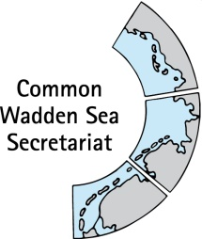
MEETING DOCUMENT
Ad hoc Working Group SWIMWAY (WG-SWIMWAY 20-2)
22 June 2020
Virtual meeting

Agenda Item: 7. Roadmap, Terms of Reference and future constituency
Subject: Roadmap 2020
Document No.: WG-SWIMWAY 20-2/7/1
Date: 08 June 2020
Submitted by: all

This document contains a roadmap for WG- SWIMWAY 2020.

Proposal: The group is invited to note the information.

Roadmap SWIMWAY 2020
V0.4, 2020-06-08

