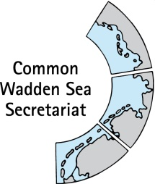
MEETING DOCUMENT
Ad hoc Working Group SWIMWAY (WG-Swimway 20-3)
07 September 2020
Online meeting

Agenda Item: 5. SWIMWAY pillar: Policies
Subject: SWIMWAY policy paper
Document No.: WG-SWIMWAY 20-3/6/1
Date: 23 September 2020
Submitted by: Martha Buitenkamp, Paddy Walker

At WG-SWIMWAY 19-1, group members presented short outlines for initiation projects for SWIMWAY. Amongst these, Ms Buitenkamp presented a short outline of a Policy analysis SWIMWAY Wadden Sea. At WG-SWIMWAY 19-3, a first draft policy review for SWIMWAY, compiled by Mr Koolstra (NL), Mr Nick Probst (D) and Ms Vestergaard (DK) has been shared with WG-SWIMWAY and was since then subsequently updated. This report summarises existing legislation relevant to the realisation of the fish targets at the European level and the associating implementation in the national law in Denmark, Germany and the Netherlands.
This document contains the version as of 22 September 2020.
Proposal: The group is invited to agree on finalisation of the main document once the correct information on fisheries has been included and to agree on status of the document.

Trilateral policy review Swimway Wadden Sea

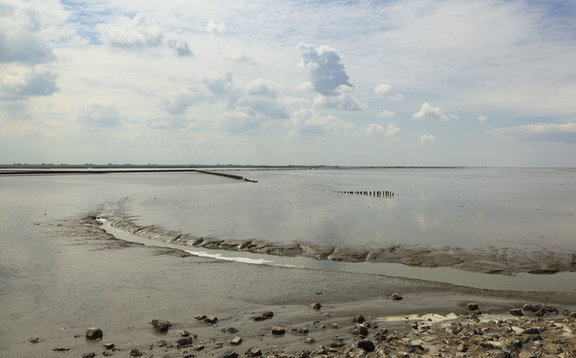
Commissioned by: Programma Rijke Waddenzee

Contents
Summary 4
1 Introduction 5
2 Fish Targets 8
Introduction 8
Trilateral Fish Targets as a basis for the Swimway Action Programme 9
3 Birds and Habitats Directive 11
Introduction 11
Denmark 11
Germany 15
Netherlands 17
General conclusion on the BHD 23
4 Water Framework Directive 26
Introduction 26
Denmark 26
Germany 27
Netherlands 29
General conclusion on the WFD 32
5 Marine Strategy Framework Directive 34
Introduction 34
Denmark 35
Germany 36
Netherlands 37
General conclusion on the MSFD 38
6 EU Eel Directive 39
Introduction 39
Denmark 39
Germany 39
The Netherlands 40
General conclusion on the ED 41
7 Fisheries Policy 42
7.1 Introduction 42
7.2 Denmark 43
7.3 Germany 44
7.4 The Netherlands 44
7.5 General conclusion 45
8 Ballast Water Management Convention 46
Introduction 46
Denmark 46
Germany 46
Netherlands 47
General conclusion on the BWMC Convention 48
9 Other regulations and agreements 49
Alien Species Regulation 49
Maritime Spatial Planning Directive 49
Convention on International Trade of Endangered Species (CITES) 49
Oslo-Paris Convention (OSPAR) 50
Convention on Migratory Species (CMS) 50
UNESCO World Heritage 51
10 Conclusion and next steps 52
Do European regulations help fish ? 52
Relevance of European law for the flagship and fleet species designated in the Swimway Action Programme 53
Trilateral fish targets supported by European law? 54
Next steps 56
Citations 61
Appendix I – Abbreviations & acronyms 63
Appendix II – List of typical wadden sea species 64
Colophon 65

Summary
Many marine and estuarine fish species depend on the Wadden Sea at some point in their life cycle. In recent decades, the populations of many fish species have declined in the Wadden Sea due to largely unknown reasons. As fish are an important part of the Wadden Sea ecosystem, in May 2018, at the Trilateral Governmental Conference on the Protection of the Wadden Sea at Leeuwarden, the three Wadden Sea countries declared to further develop the Trilateral Wadden Sea Swimway Vision, aiming to achieve the trilateral fish targets for the Wadden Sea (as laid down in QSR 2009, Wadden Sea Plan 2010). The Swimway Vision is described in a so called Swimway Action Programme (Swimway, 2019). This programme contains - among others - actions suitable to improve knowledge on relevant processes, optimise population monitoring, adjust policies and develop, realise and evaluate measures to reach the trilateral fish targets.
This policy review shows in what way current European legislation and its implementation enable the realisation of the trilateral fish targets.
Of the directives, conventions and legislation described, the Habitats Directive contains specific and concrete measures for habitats and a small group of fish species occurring in the Wadden Sea. Fish species may benefit from the measures aimed at preserving and restoring habitats, but the effect thereof is difficult to estimate. It can be observed, however, that the designation of N2000 areas provides the possibility to limit or even exclude certain (potential) threatening human activities.
The Water Framework Directive (WFD) applies to the 1-mile coastal zone. Here too, targets for specific fish species are often lacking, but much attention is paid to water quality and the removal of barriers, particularly for diadromous fish. With this, the WFD can indeed contribute to the trilateral fish targets.
The Eel directive has a clear and specific purpose. The measures aimed at removing physical barriers will also help other migrating fish species.
The Marine Strategy Framework Directive, the Alien Species Regulation, the Ballast Water Management Convention and the EU Common Fisheries Policy contribute partly to to a mid-to long term improvement of fish populations.
This report concludes that that although the current link between the trilateral fish targets and the reviewed policies is not strong, there is enough scope within the policy frameworks to enable the inclusion of the targets as well as the SWIMWAY flagship and fleet species in future iterations of the management plans, including research and monitoring. This is true for the Habitats Directive and N2000 management plans, as well as the Water Framework Directive and Marine Strategy Framework Directive. There is also scope to collaborate between the countries to work on an Single Integrated Management Plan, as envisaged in the UNESCO World Heritage Strategy. An approach is suggested on how to close the plan-do-check-act policy cycle, supported by the SWIMWAY Programme.

Introduction
Many marine and estuarine fish species depend on the Wadden Sea at some point in their life cycle. In recent decades, the populations of many fish species have declined in the Wadden Sea due to largely unknown reasons. As fish are an important part of the Wadden Sea ecosystem, the three Wadden Sea countries, Denmark, Germany and the Netherlands, declared at the Trilateral Governmental Conference on the Protection of the Wadden Sea, Leeuwarden 2018, to further develop the Trilateral Wadden Sea Swimway Vision, aiming to achieve the trilateral fish targets for the Wadden Sea (as laid down in QSR 2009, Wadden Sea Plan 2010).
The Swimway Vision is part of the Leeuwarden 2018 Wadden Sea Declaration as Annex 3.The Swimway Vision is described in an action programme, the so called Swimway Action Programme (Swimway, 2019). This programme is based on four pillars: research and monitoring; policy; measures; stakeholder involvement, communication and education. The policy pillar describes: “Policy objectives for fish in the Wadden Sea are formulated at the European, trilateral, national and regional levels. Within the Vision it is aimed for making an inventory of existing policies and regulations relevant to the Trilateral Fish Targets at the European, trilateral, national and regional level and to analyse their contribution to the realisation of the these targets. Following the analysis the need for additional actions could be identified. “
The policy overview, presented in this report, is therefore an important part of the Swimway Action Programme. It shows in what way the current European legislation and the way this is implemented in national policy. It also gives an overview of how the current directives and measures support the trilateral Fish Targets, and the scope of the legislation to include the Fish Targets. The report contains:
- An analysis of European legislation relevant for the implementation of the fish targets in Denmark, Germany and the Netherlands;
- An assessment of the effectiveness of these EU legislation and policies in helping to implement the trilateral fish targets.
Specific regional and national legislation has not been addressed in this report and should be addressed in the future.

The Trilateral Wadden Sea Plan (WSP, 2010) is the common policy and management plan for the protection and sustainable management of the Wadden Sea. It is also the common management plan for the Wadden Sea World Heritage Site. A unique and basic feature of the Wadden Sea Plan is that it aims at achieving the full scale of habitats, which belong to a natural and dynamic Wadden Sea. These include the habitats below the water surface. Each of these habitats, for which common trilateral targets have been adopted, needs a certain quality (natural dynamics, absence of anthropogenic disturbance, absence of pollution), which can be reached by proper management of the area. In the WSP (2010) the following trilateral fish targets have been formulated:
- Viable stocks of populations and a natural reproduction of typical Wadden Sea fish species;
- Occurrence and abundance of fish species according to the natural dynamics in (a)biotic conditions;
- Favourable living conditions for endangered fish species;
- Maintenance of the diversity of natural habitats to provide substratum for spawning and nursery functions for juvenile fish;
- Maintaining and restoring the possibilities for the passage of migrating fish between the Wadden Sea and inland waters.
The Wadden Sea Quality Status Report 2017 (QSR 2017) is written by independent experts from the three Wadden Sea countries. The Chapter on fish (Tulp et al. 2017) describes the status and trends of fish in the Wadden Sea based on several fish monitoring programmes. The QSR 2017 concludes concerning the aforementioned trilateral fish targets the following: “these targets were not formulated in a testable way, which makes it impossible to evaluate them quantitatively”. Furthermore, the formulations are not all easy to comprehend, allowing multiple interpretations. To facilitate an objective evaluation in the future, the QSR 2017 proposes to restructure and reformulate the targets from the WSP as follows:
There should be no human-induced bottlenecks in the Wadden Sea for fish populations or their ecosystem functions. Maintain or improve:
- Robust and viable populations of estuarine resident fish species;
- The nursery function of the Wadden Sea and estuaries;
- The quality and quantity of typical Wadden Sea habitats;
- Passageways for fish migrating between the Wadden Sea and inland waters;
- Conservation of endangered fish species.

The targets of the QSR 2017 have been incorporated in the Swimway Action Programme (Swimway, 2019). The overall target as proposed in the QSR 2017 (“There should be no human-induced bottlenecks in the Wadden Sea for fish populations or their ecosystem functions.”) however, is not mentioned in the Swimway Action Programme. Because the targets need to be read and interpreted in the light of the overall target, it will be used in this study.
The next chapter compares the trilateral fish targets with the elaboration of these targets in the QSR 2017 /Swimway Action Programme.
The chapters 3-9 present an overview of the relevant European legislation related to the trilateral fish targets and (if applicable) their implementation in Danish, German and Dutch legislation. The Birds and Habitats Directive and the Water Framework Directive aim directly at the improvement of the biotic and abiotic quality of habitats and water systems. The Marine Framework Strategy Directive aims amongst others at the protection of marine biodiversity, as it contains the explicit regulatory objective that "biodiversity is maintained by 2020", as the cornerstone for achieving Good Environmental Status (GES). Furthermore the Common Fisheries Policy, the Eel Directive, the Ballast Water Management Convention, the Aliens Species Regulation, the Maritime Spatial Planning Directive and CITES are reviewed in respect of their relevance to fish conservation in de Wadden Sea. For its globally unique geological and ecological values the Wadden Sea is listed by UNESCO as World Heritage (CWSS, 2016). It was not possible to achieve the same level of detail in the three countries for each of these frameworks.
Chapter 10 describes in what way the standing policy supports the realisation of the trilateral fish targets. It also addresses the gaps in the policies and suggests what is needed to fill these gaps. Conclusions and recommendations can also be found in this chapter.
A list of abbreviations and acronyms is given in Appendix I.

Fish Targets

Introduction
Fish are recognised as being an important part of the Wadden Sea ecosystem. The three Wadden Sea nations (the Netherlands, Germany and Denmark) cooperate on the conservation of fish in the context of the Trilateral Wadden Sea Cooperation supported and coordinated by the Common Wadden Sea Secretariat (CWSS) in Wilhelmshaven. So far, the common policies and targets for the management within the boundaries of the conservation area of the Wadden Sea are laid down in the Wadden Sea Plan, the joint management plan for the TWSC. The competent authorities in Denmark, The Netherlands and Germany with the Länder Schleswig-Holstein, Hamburg and Lower Saxony are responsible for the implementation of the WSP on a regional/local level.
To get an overview of the current situation of natural assets (species, habitats, biotopes), the management, and human activities in the Wadden Sea, so-called Quality Status reports are produced regularly by external experts, including recommendations for future policies. Part of it are chapters on the status of fish populations in the QSR (Vorberg et al., 2004; Jager et al., 2009; Tulp et al., 2017). Derived from the findings in the QSR, trilateral fish targets were formulated in the WSP (2010) and these were included in the QSR 2017 in an updated adapted, testable, formulation. Finally, the updated trilateral fish targets were embedded in the Swimway Vision, and elaborated in the Swimway Action Programme (Swimway, 2019).
The updated trilateral fish targets were formulated in reference to the overall target: “There should be no human-induced bottlenecks in the Wadden Sea for fish populations or their ecosystem functions.”
Tulp et al. (2017) defined the following recommendations for management:
- Stronger support from national governments for fish research. Compared to other more visible and ‘charismatic’ groups such as birds, research on fish is heavily underrepresented and mainly focussed on surveys (rather than research on mechanisms) and on commercial (demersal) species;
- Consider that the Wadden Sea is an important (and perhaps critical) area within the entire chain of areas that fish need to complete their life cycle;
- Long-lasting trilateral projects are needed to catch up with this backlog;
- Facilitate integrated monitoring of fish as part of the food web. Fish is an important component of the food web as food for birds and sea mammals and as predator of benthos and lower trophic levels;
- Management of the Wadden Sea should be at (inter)national levels instead of provinces;
- Exploring the possibilities of citizen science (as currently in practise in daily emptying of the NIOZ fyke) or cooperation with fishermen could enhance research effort;
- Map quality and quantity of typical Wadden Sea habitats (saltmarshes, shellfish reefs, seagrass beds, mudflats, sandflats) to reconcile conservation with other stakes (spatial planning).

Trilateral Fish Targets as a basis for the Swimway Action Programme
The Wadden Sea fish populations are composed of a diverse species mix, with 163 recorded fish species. The functions that the Wadden Sea fulfils for those species may differ, with some species such as plaice using the Wadden Sea as a nursery area, whilst for others such as smelt or eel it is a migratory route between the sea and freshwater. In order to address this, the Swimway Action Programme has identified five groups, or guilds, based on the life style and functionality of the Wadden Sea for the species. This is based on occurrence patterns, feeding and reproduction behaviour, an approach which was used by Elliott et al. (2007) to increase the understanding of the use of estuaries by fishes. Each group is represented by one characteristic species (‘flagship’) and a number of related species (‘fleet’) as shown in Table 1 (Swimway, 2019). These species are the foundation for the work on the Swimway Action Programme and this review.
Life cycle | Flagship | Fleet
Pelagic marine juvenile | Herring | Sprat, anchovy, horse mackerel, seabass
Demersal marine juvenile | Plaice | Sole, dab
Wadden Sea residents | Eelpout | Gobies, sandeel, sea snail, rock gunnel, mullets
Diadromous species | Smelt | Twaite shad, salmon, sea trout, houting, eel
Marine adventitious | Tope | Thornback ray, dogfish
Table 1 Flagship and fleet species for five functional life cycle groups according to occurrence patterns, feeding and reproduction behaviour (Swimway, 2019).
The trilateral fish targets were adopted in 2010 (WSP 2010). The Ministerial Declaration of 2014 stated that countries should implement the Fish Targets. See Swimway action Programme: “At the ministerial conference in 2014 Denmark, Germany and the Netherlands agreed to “Acknowledge the importance of fish for the Wadden Sea ecosystem and therefore instruct the WSB to work on the further implementation of the Trilateral Fish Targets of the Wadden Sea Plan” (Tønder Declaration 2014, no. 28). The three countries agreed to implement the Trilateral Fish Targets through a Wadden Sea Swimway Vision (including an Action Programme 2018-2024).” (Swimway, 2019)
The QSR 2017 shows an update of these trilaterally adopted targets in the QSR 2017. In the Swimway Action Programme (Swimway, 2019), an approach is described by which the Targets could be implemented. An essential step towards developing more specific objectives for fish is addressing the knowledge gaps on the functioning of the Wadden Sea ecosystem for fish and the key processes driving the fish populations. In order to do this the Swimway Action Programme aims - among others - at identifying population bottlenecks and the translation of this knowledge into effective management and conservation measures. One of the pillars of the Swimway Action Programme is this policy overview.
The QSR 2017 states that the updated trilateral fish targets (incorporated in the Swimway Action Programme) should “facilitate an objective evaluation in the future”. In the table below, the Trilateral Fish Targets and the corresponding updated trilateral fish targets as formulated in the Swimway Action Programme are listed and remarks are made based on the comparison of both.

Trilateral Fish Targets (WSP 2010) | Updated Trilateral Fish Targets (QSR2017) | Remarks
Viable stocks of populations and a natural reproduction of typical Wadden Sea fish species. | Maintain or improve:  Robust and viable populations of estuarine resident fish species. | Typical fish communities in the Wadden Sea include as also juvenile fish of marine species, marine seasonal visitors, diadromous species and even freshwater species that are indicative of an undisturbed estuarine gradient
Occurrence and abundance of fish species according to the natural dynamics in (a)biotic conditions. | Maintain or improve:  Conservation of endangered fish species | The trilateral target was formulated more widely, included all fish species occurring in the Wadden Sea, not only those that are endangered
Favourable living conditions for endangered fish species. | Maintain or improve:  The quality and quantity of typical Wadden Sea habitats. | It is not only the habitats but also water quality (physical and chemical)
Maintenance of the diversity of natural habitats to provide substratum for spawning and nursery functions for juvenile fish. | Maintain or improve:  The nursery function of the Wadden Sea and estuaries. | Nursery function (in Swimway) is more limited than the Trilateral target, which includes spawning and nursery function
Maintaining and restoring the possibilities for the passage of migrating fish between the Wadden Sea and inland waters. | Maintain or improve:  Passageways for fish migrating between the Wadden Sea and inland waters. | Both targets are similar

Table 2 Summary of the Wadden Sea fish targets: adopted in the WSP 2010 and rephrased in the QSR 2017 ) and a comparison of both.
Based on the comparison in the Table 2 above, we can conclude that the trilateral fish targets as adopted in the WSP 2010 and the updated trilateral fish targets in the QSR 2017 are comparable and not contradicting. This means that the policy review will encompass both the WSP 2010 and the QSR 2017 by assessing these targets.

Birds and Habitats Directive

Introduction
The Habitats Directive (HD, Council Directive 92/43/EEC) promotes the maintenance of biodiversity, taking economic, social, cultural and regional requirements into account. Together with the Birds Directive (BD), the Habitats Directive forms the cornerstone of Europe's nature conservation policy by establishing an EU wide Natura 2000 ecological network of protected areas, safeguarded against potentially damaging developments.
The HD aims at the conservation of a wide range of rare, threatened or endemic animal and plant species. Around two hundred rare and characteristic habitat types are also targeted for conservation in their own right and described in Annex I of the HD. For these, typical species also belong to the characteristics of the site in an ecosystem aspect. For the protection of these habitats Special Areas of Conservation (SAC’s) should be installed. Annex II of the HD contains a list of animal and plant species of community interest whose conservation requires the designation of SAC’s. Annex IV contains a list of animal and plant species of community interest in need of strict protection - both include fish species.
The Birds Directive aims at the protection of (all) European bird species. The protection of Special Protection Areas (SPA’s) as stated in the Birds Directive has been incorporated in the Habitats Directive since June 10th 1994. As it focuses on the protection of birds, fish could benefit indirectly if, e.g., human activities are restricted or limited within the designated areas, or conversely the predation pressure on fish could increase with an increase in piscivorous birds such as terns.

Denmark
The Habitats Directive is implemented in the Danish national law as a part of Environmental Targets Act (Miljømålsloven) and Nature Protection Act (Naturbeskyttelsesloven). The Danish government is responsible for designating Natura 2000 sites in Denmark and designated in 1998, the Danish habitat areas covered by the HD. Thus, most of the Danish Wadden Sea is covered by Natura 2000 sites. To meet the BD and HD requirements, a basis analysis of each Natura 2000 site is carried out every sixth year, providing the data needed in order to plan the upcoming six years. The next analysis will be done in 2020.
The Danish Wadden Sea includes four habitat areas (H78, H86, H90 and H239), which contain several relevant habitat types in Annex I. The Danish Wadden Sea contains seven fish species included in Annex II. Only houting is listed in Annex IV.

HD Element | H78  Ribe Å, Tved Å and Varde Å west of Varde | H86  Brede Å | H90  Vidå with inflow, Rucbøl Sø and Magisterkogen  F57 Vadehavet | H239  Alslev Ådal
Habitat types
1110 Sandbanks which are slightly covered by seawater all the time.
1130 Estuaries.
1140 Mudflats and sandflats not covered by seawater at low tide.
1150 Lagune
1160 Large shallow inlets and bays.
1170 Reefs.
1310 Salicorna and other annuals colonizing mud and sand.
1320 Spartina swards.
1330 Atlantic salt meadows.
3150 Nutritious Lake
3260 Streams
Species
1095 Sea Lamprey (Petromyzon marinus)
1096 Brook Lamprey (Lampetra planeri)
1099 River Lamprey (Lampetra fluviatilis)
1103 Twaite shad (Alosa fallax)
1106 Salmon (Salmo Salar)
1113 Houting (Coregonus oxyrinchus)
1145 Weatherfish (Misgurnus fossilis)

Table 3: Habitat and species elements in relevant Danish Wadden Sea areas. Red=absent, green=present
On a national scale, a consolidation act pursuant to the Nature Conservation Law focuses on conservation of specific animals and plants: Statutory Order on the Protection of certain Animal and species and the care of injured wild-life (Bekendtgørelse om fredning af visse dyre- og plantearter og pleje af tilskadekommet vildt). The act prohibits all kinds of capture and killing of species covered by the Annex IV.
The HD is likewise a part of the Statutory Order on protection and wildlife sanctuary in the Wadden Sea, focussing directly on conservation (Bekendtgørelse om fredning og vildtreservat I Vadehavet). The aim of this act is to promote sustainable management of the Wadden Sea and to ensure fulfilment of Denmark’s international obligations in relation to the Habitats Directive, the Birds Directive and the Ramsar Convention. The act provides strict regulations prohibiting commercial fishing for shellfish and fish. Dispensation can be given in a few smaller areas for exploratory fishing; however, this has not been the case for some 14 years, now leaving the inner part of the Danish Wadden Sea rather pristine compared with the German and Dutch parts of the area. Water sport activities are also under strict regulation, and water activities are only allowed in specific areas during a specific time of the year. In some areas the public is not allowed access at all at any time during the year. The act is currently under revision and is expected to be even stricter in the future.
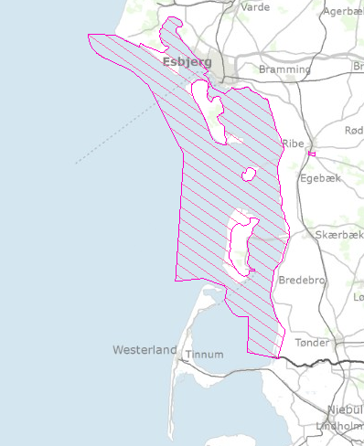

Figure 1. The area protected by Statutory order on protection and wild-life sanctuary in The Wadden Sea.

The Danish Wadden Sea is also a designated national park called “Nationalpark Vadehavet”, which opened in 2010. The general legislation behind national parks in Denmark does not introduce any new binding formal management – and/or protection regimes. A board appointed by the Minister of Environment leads the national park. The board consists of stakeholders from organisations with different interests in the Wadden Sea. The Wadden Sea national park is the biggest in Denmark and extends to four different municipalities; Esbjerg, Fanø, Tønder and Varde.

Issues with the conservation states of habitat types and species
The Ministry of Environment controls the Natura 2000 sites and determines the assessed status of HD elements. The majority of the H86 areas are determined to be in a moderate to a good condition. The other habitats were not yet assessed. A general system for assessing the state of the marine nature types has not yet been developed, but especially nutrient loads and anthropogenic activities are expected to have an impact. Nutrient load is among several stressors that are not included in the basis analysis. Such stressors are expected to have an impact on both species and the state of the habitats.
The basis analysis evaluates some possible threats to the habitat types present in the Wadden Sea. Among these are direct impacts from agriculture, invasive species and fisheries. The pacific oyster (Crassostrea gigas) is considered a permanent species in the Wadden Sea, and some scientists regard the pacific oyster and other shellfish as coexisting. It is not legal to perform commercial fishing for the pacific oyster in the Danish part of the Wadden Sea, but for private use, you can collect them applying manual collection only. An issue predicted and feared is the Signal Crayfish, which is an invasive species that carries crayfish plague. The Ministry of Environment and Food Security is currently making a guideline on how to handle the Signal Crayfish and how to prevent it from spreading further, and minimize the risk of Crayfish plague.
Despite the tight restrictions on fisheries in the inner Danish Wadden Sea, there are still fishing activities in the outer (North Sea) part of the Wadden Sea and in the adjacent marine area (see Figure 2). It is especially the bottom trawling fishery activities that is expected to affect the habitats and species (Naturstyrelsen, Miljøministeriet, 2013).

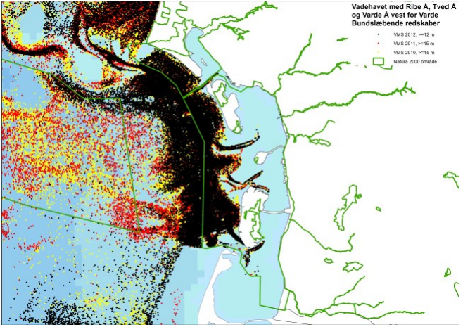

Figure 2. VMS data of fishing vessel with bottom trawling equipment (Naturstyrelsen, Miljøministeriet, 2013).

Based on criteria for favourable conservation status, the only fish found in the Danish Wadden Sea with a favourable status is the brook lamprey (Lampetra planeri). The difficulties of monitoring fish species, and the fact that there is no general Danish monitoring programme directed towards non-commercial species might be an issue in relation to the conservation state. The brook lamprey is an example hereof. It is habituated in shallow, muddy and slowly flowing water, which makes detection by electrofishing difficult. Other species such as salmon have a limited distribution in Denmark due to its high demands for habitat quality. The conservation status of salmon is unfavourable, as is the status of the European weatherfish (Misgurnus fossilis). The houting (Coregonus oxyrhinchus) is of high concern in the Wadden Sea. The breeding and thus survival of the houting is dependent on having access to the larger streams that flow into the Wadden Sea. The poor swimming skills puts a limit to its movement, and if a stream provides fish ladders or other obstacles, the conservation state of the houting can be affected. According to the assessment of conservation status, the houting is uncertain. The population has been declining throughout the past century, and in order for the species to be in a favourable state, it needs to be increasing (Søgaard et. al, 2007).
Climate change is another factor that is suspected to have a negative impact on the marine life in the Wadden Sea. Through higher water temperature the reproductive capacity of sessile species such as shellfish might be impacted negatively and some mobile marine species might migrate to cooler waters.

Conclusion
The conservation of fish species, as such, is limited to those species mentioned explicitly, such as the sea and river lamprey, salmon, houting and Twaite shad. Marine species other than those mentioned will primarily be affected indirectly through the different laws and acts that are based on the directives. The fish populations in the Wadden Sea depend to a high degree on the quality of the habitat types, which is why conservation and management hereof is important. For the inner Danish Wadden Sea the national law already provides strict regulations on human activities such as fisheries.
Although the underwater inner Danish Wadden Sea is the best protected part of the Wadden Sea in general, de facto prohibiting fishery there during the last 14 years, revision of the Statutory Order, may still lead to enable fishery, in case specific biological conditions were met. In this connection recent knowledge of i.a. biotopes and food web interconnectivity is being taken into consideration. In connection with the preparation of the revised Statutory Order, a basic political decision has been made by the government revoking the possibility of again issuing licences for blue mussel and cockle fishery in the inner parts of the Danish Wadden Sea.

Germany
The Habitats Directive was implemented into German national law as part of the “Bundesnaturschutzgesetz” in 1998 and in the respective laws of the Länder. The governments of the federal states are responsible for designating Natura2000 sites in the German coastal seas (up to 12 nm from the coast baseline), the federal government implements the Natura2000 sites in the German exclusive economic zone (EEZ). The Wadden Sea is therefore covered by Natura2000 sites of the federal states Niedersachsen, Hamburg and Schleswig-Holstein. The WSP is the Natura2000 management plan for the Länder and therefore no specific Management Plan (MP) exists. The German Wadden Sea is also protected and managed as National Park, split into three administrative entities (Niedersachsen, Hamburg and Schleswig-Holstein) run by the aforementioned federal states. The main legal basis for National Parks in Germany is given by the “Bundesnaturschutzgesetz”, basically defining them as areas where nature should be undisturbed for most of its area. Conservation targets for each of the SACs (and SPAs) have been defined, either as part of the respective national park laws (LS, HH) or as part of a declaration by the state Ministry for the Environment (SH).
According to the types and species of the Habitat Directive (HD) the relevant elements for each federal state, are listed in Table 4.

HD element | Niedersachsen | Hamburg | Schleswig-Holstein
Habitat types
1110 Sandbanks which are slightly covered by seawater all the time | Yes | Yes | Yes
1130 Estuaries | Yes | Yes | Yes
1140 Mudflats and sandflats not covered by seawater at low tide | Yes | Yes | Yes
1160 Large shallow inlets and bays | Yes | Yes | Yes
1170 Reefs | Yes | No | Yes
1310 Salicorna and other annuals colonizing mud and sand | Yes | Yes | Yes
1320 Spartina swards | Yes | Yes | Yes
1330 Atlantic salt meadows | Yes | Yes | Yes
Species
Sturgeon Acipenser sturio | Yes | Yes | Yes
Houting Coregonus maraena | Yes | Yes | No
Houting Coregonus oxyrhynchus | ? | ? | No
Sea lamprey Petromyzon marinus | Yes | Yes | Yes
River lamprey Lampetra fluviatilis | Yes | Yes | Yes
Twaite shad Alosa fallax | Yes | Yes | Yes
Allis shad Alosa alosa |  |  | No

Table 4. Relevant HD elements for the three federal states

Issues with the conservation state of habitat types and species
The assessed status of HD elements differs between the federal states. Results from Schleswig-Holstein from 2019 show that in the Atlantic region of Schleswig-Holstein, the conservation status of 6 habitat types (relevant HD elements, see Table 4) has been assessed as “favourable”. For 1 habitat type the conservation status has been assessed as “unfavourable – bad” (one habitat type was not assessed). In the same region, the conservation status of 5 species (relevant HD elements, see Table 4) has been assessed as “unfavourable – inadequate” or “unfavourable - bad”.
The main reasons for the unfavourable assessment outcomes of habitat types were diffuse and direct substance inputs (nitrogen, nutrients, biocides, pesticides) and disturbances of hydrological regimes. For fish species, the main reason of unfavourable conservation statuses could be related to the lack of connectivity in freshwater systems i.e. the obstruction of migration pathways.
The HD directive does not provide jurisdictional means to implement measures which are directly designated to protect the marine fish species listed in Table 4 (apart from the diadromous species). A major shortcoming of the HD is the fact that there are no species-specific measures for marine fish species, other than the diadromous species. A number of species are considered to be associated with the habitat types mentioned above (e.g. H1110) and are designated to be ‘characteristic’ of these habitat types. In the QSR (Jager et al., 2009) a list of priority Wadden Sea species has been made. See Appendix II for an overview of these species.
Fisheries within the German Wadden Sea are regulated through legal regulations as well as management measures of the Natura2000 sites. Fishing on brown shrimp Crangon crangon with small beam trawls of max. 10m-beam width is allowed in wide parts of the national parks (i.e. also within the Natura2000 sites). There is also blue mussel production in the national parks of Schleswig-Holstein and Lower Saxony.
Other human activities exerting pressure on the fish communities of the German Wadden Sea are not as widespread as fishing, but include shipping, eutrophication, dredging of shipping lanes and sludge deposition from river deepening (Elbe, Weser, Ems) (BLANO 2018).

Proposed solutions
More environmental-friendly beam trawling techniques for shrimp along with designation of no-take zones may contribute to improving the conservation state of the HD habitats 1110, 1160, 1170 and 1130. The increased use of spat collectors in the blue mussel seedling fisheries instead of dredging for seed mussels might improve the conservation state of HD habitats 1140, 1160 and 1170, accompanying studies (e.g. on species communities on collectors) are recommended to make an assessment possible. The conservation of the six listed fish species (sturgeon, river lamprey, sea lamprey, allis shad and twait shad) needs to occur mostly in freshwater systems by allowing for unhindered migrations and suitable spawning and nursery habitats in inland rivers.

Netherlands
The Birds and Habitats Directive are fully implemented in the Nature conservation act (Natuurbeschermingswet, Wnb). The Nature Conservation Act protects Natura 2000-sites (area conservation, with the qualifying habitats and species for which the site is designated). The part of the Nature Conservation Act that protects species listed in Annex IV of the Habitats Directive (species conservation) is relevant for this study, but the only marine fish species listed on Annex IV are the Houting and Sturgeon, which are very rare and seldom present in the Wadden Sea.
With respect to the area conservation chapter of the Nature Conservation Act, the Wadden Sea is designated as a SPA and SAC. In the Netherlands, the term Natura 2000-site is commonly used to describe both a SAC and a SPA.
Three fish species, as listed in Annex II of the Habitats Directive, have been assigned as conservation targets in the Natura 2000-area Wadden Sea. These are:
- S1095 Sea lamprey (Petromyzon marinus);
- S1099 River lamprey (Lampetra fluviatilis) and;
- S1103 Twaite shad (Alosa fallax).
A large number of habitats have been assigned a conservation status in the Wadden Sea Natura 2000-site, of which three are relevant for the protection of fish in the Natura 2000-area Wadden Sea. Those habitats are:
- H1110A (permanently covered sand flats);
- H1140A (tidal flats) and;
- H1130 (estuaries).
For each of these habitat types, selected fish species have been listed as elements that contribute to the quality of the habitat (typical fish species).
Typical fish species of H1110A (permanently covered sand flats)
For H1110A these are: Hooknose Agonus cataphractus, Fivebearded rockling Ciliata mustela, Herring Clupea harengus, Dab Limanda limanda, Sea snail Liparis liparis , Bullrout Myoxocephalus scorpius, Butterfish Pholis gunnellus, Flounder Platichthys flesus, Plaice Pleuronectes platessa and Eelpout Zoarces viviparus (Profielendocument H111A permanent overstroomde zandbanken (getijdengebied), versie 2014).

Typical fish species of H1140A (tidal flats)
For H1140A these are: Plaice Pleuronectes platessa, Flounder Platichthys flesus, Mullet Mugil labrosus (Profielendocument H1140 bij eb droogvallende slikwadden en zandplaten, versie 2008).
Typical fish species of H1130 (estuaries)
For H1130 these are: Anchovy Engraulis encrasicolus, Flounder Platichthys flesus, Pipefish Syngnathus acus and Syngnathus rostellatus, Hooknose Agonus cataphractus, Whiting Merlangius merlangus and Bullrout Myoxocephalus scorpius (Profielendocument H1130 estuaria, versie 2008).

Occurrence | Counts | Species | %
(Extremely) rare | 1-3 | 74 | 49,3
Fairly common | 4-6 | 26 | 17,3
Common | 7-9 | 50 | 33,3
Total |  | 150 | 100
Table 5 Occurrence of fish species in the Wadden Sea as derived from the species list in Annex I (version December 2008)

Altogether, these fish species comprise about 10% of the total of 150 fish species that have been recorded as occurring in the Wadden Sea (Jager et al., 2009; see “Table 5”).
Natura 2000 Management Plan
The Dutch Natura 2000 Management Plan of the Wadden Sea 2016-2022 (I&M 2016) contains the conservation measures needed to reach the favourable conservation state of all qualifying habitats and species of the Wadden Sea. Because only a limited number of fish species is a qualifying Natura 2000 species (Sea lamprey, river lamprey and Twaite shad) most of the fish species will have no conservation measures specifically targeting these species. This means most fish species have to profit from conservation measures aimed at the conservation of the marine habitats. Other measures in the management plan concern knowledge development, which may lead to more effective measures in the future.

The Management plan describes the following conservation measures relevant for the above mentioned habitats and species:
H1110A Permanently covered sand flats
In the Wadden Sea, habitat type "permanently covered sand flats" can be found in trenches and permanently flooded plains. These areas are often indicated as the "sublittoral". The channels can be found throughout the Dutch Wadden Sea, from the small gullies between the tidal flats to the wide tidal inlets between the islands. The permanently flooded plains lie mainly north of the Afsluitdijk, as a remnant of the former Zuiderzee. On the flooded plains the current velocities are lower than in the channels and in many places on the flooded plains, the water is so deep that the effect of wave action on the soil is small, so that the soil is fine sandy to muddy in many places. Because of this, the bottom fauna in the shallower water surfaces of the western Wadden Sea is richer than in the channels. Locally, hard substrates such as shell banks and areas with peat, boulder clay or stones are still present. In addition, also hard substrates are formed by organisms in the form of oyster beds and mussel beds. It is the habitat for algae, shellfish, tube worms, sea urchins, shrimp, crabs and fish.
Before the Natura 2000 management plan came into effect, the mechanical cockle dredging in the Netherlands was ended. This may have had a positive impact on the sea bed (less disturbance) of the sub littoral (H1110A). This is an example of the effectiveness of the Habitats Directive, as the mechanical shellfish fishery was ended by court ruling based on the Habitats Directive.
Issues with the conservation state
The state of conservation of "permanently flooded sandbanks" in the Wadden Sea has been assessed as moderately unfavourable. This assessment is mainly based on the limited occurrence of sublittoral mussel beds in mainly older stages of development and at the strongly reduced total biomass of fish and the reduced bottom life community and nursery function / growing area for fish. The unfavourable assessment can also be the result of various forms of soil agitation. Changes in natural factors (climate change) and the closure of estuaria and bays like the Zuiderzee, Amstelmeer and Lauwerszee in the last century may also play a role. It is suspected that climate change, through the occurrence of warmer winters (higher sea water temperature), has a negative impact on the breeding of shellfish and results in certain fish species migrating from the Wadden Sea to the North Sea in an earlier stage. The beam trawling in the North Sea may have a negative impact on the composition of the fish populations in the Wadden Sea, but this effect is unclear. There is also a limited gradient in salinity, as a result of which there is limited fish migration and locally slightly impoverished fauna at freshwater discharge points.
Proposed solutions
An improvement in the quality of "permanently flooded sandbanks" (with sublittoral mussel beds in older stages) can possibly be achieved by continuing the phasing out of mussel seed fishing from the bottom (transition process via spat collectors (MZIs in Dutch) and/or other innovative methods), as well as by (further) making the shrimp fishing more sustainable (reduction of bycatch, smaller area for seabed fishery and protection of benthic communities). Opportunities for the development of multi-annual sublittoral mussel beds are present in the western Wadden Sea, because mussel spat falls naturally in this part of the Wadden Sea. The experiments with the development of the mussel beds have positively contributed to the necessary knowledge on the development of mussel beds. Research into the causes of the fish biomass decline in the Wadden Sea is needed. Monitoring the development of fish stocks and conducting more research may help to understand processes that cause decline in fish abundance until the next management plan period.
H1140A Tidal flats
The Wadden Sea is the most important area in the Netherlands for this habitat type, which is also referred to as the "littoral" or the tidal area between high and low water. It is a very dynamic habitat type of which the exact location and the surface area change annually due to erosion and sedimentation processes. In addition to the rich bottom fauna, littoral (dry-falling) mussel beds and seagrass (fields) are of great importance for foraging birds. On many mussel beds nowadays also the Pacific oyster (Crassostrea gigas) is present. This species is an introduced species established in the entire Dutch Wadden region between 1983 and 1999. It often occurs in mixed beds with blue mussels (Mytilus edulis), which appear to develop well in oyster beds. The mussel and oyster beds (including mixed forms) make up no more than 1.5 - 3 percent of the tidal flats.
Recent research shows the importance of mussel beds to be greater than suspected, due to the impact of the banks on the surrounding mudflats (with more sludge deposition). The drifting area therefore largely consists of mudflats of sand and sludge, often with a rich benthic life underneath (amongst others: cockles, knife heads, soft-shell clams, worms).
Issues with the conservation state
At the moment, the areal extent of sublittoral mussel beds and the associated living communities is insufficient. Although the soil agitation has been reduced, the natural restoration of the littoral mussel beds in the western Wadden Sea is so far still lagging behind that in the eastern Wadden Sea. Recent monitoring (2006-2011), however, shows there is a (slightly) increased establishment of mussels on Japanese oyster beds. How the symbiosis between oyster and mussel beds develops is still uncertain. Climate change might have an adverse effect on the further recovery of the littoral mussel beds. The higher seawater temperature is suspected to be detrimental to the breeding of shellfish, including mussels, and it may cause an increase of prawns, which predate on juvenile mussels. Furthermore, there are too few seagrass meadows for a good quality of the habitat type. The sublittoral sea grass morphs have altogether disappeared from the Dutch Wadden Sea and the current conditions seem unfavourable for recolonisation. The sea grasses that are still present are the littoral form of Zostera marina and the small eel grass Zostera nana.
Proposed solutions
Experiments with stimulating development of seagrass fields (and Ruppia fields) can contribute to a positive development of the quality of the habitat type tidal flats. However, the success of restoration of sea grass fields is uncertain at this moment and it is unsure if and when it will have a positive impact on the fish populations in the Wadden Sea.
In projects such as “Mosselwad” and “Waddensleutels” research is carried out (with field tests) on the influences of hydrodynamics and climate change on opportunities for and threats to mussel beds. Based on these studies the conclusion can be drawn that little else is possible in this natural system than protecting (young) mussel beds from human activities. In the long term, mussel beds may then possibly develop into older stable structures that can maintain themselves better. Moreover, more natural salinity gradients are desired by adapting the management of fresh water discharge points. Furthermore, research into sediment and sludge management in the Wadden Sea, by Rijkswaterstaat as a WFD measure, is important (knowledge building).
H1130 Estuaries
This habitat type comprises both the littoral and sub littoral parts of the Ems-Dollard Estuary. The Natura 2000 Management plan of the Wadden Sea does not contain any information on this habitat type, because it is only a qualifying habitat type in the Natura 2000 site “Eems-Dollard”. This will become part of the N2000 Management plan Wadden Sea. Germany and the Neherlands agreed on a joint integrated management plan for this area.
S1095 Sea lamprey (Petromyzon marinus), S1099 River lamprey (Lampetra fluviatilis) and S1103 Twaite shad (Alosa fallax)
These three fish species are anadromous, which means that these species migrate from the marine environment to inland waters to spawn there. An important part of their life cycle is at sea and the Wadden Sea and in particular the Wadden Sea estuaries are of great importance for these species.
Issues with the conservation state
The national trend data for the Sea lamprey are unclear, the data of the River lamprey shows an upward trend. In the past few decades there seems to be a positive one trend for the Twaite shad. The presence of barriers in the form of dams and locks, hamper the migration of these fish to the rivers and vice versa. Furthermore, the presence and quality of upstream spawning grounds for the Lampreys (and the Twaite shad) may be insufficient. In the Natura 2000 management plans of, among others, the Drentsche Aa and Gelderse Poort, both areas with conservation objectives for river and / or sea lamprey, suitable spawning grounds must be provided. Regarding the Twaite shad, it is likely that the conditions (light current, sufficiently good water quality for supply of eggs, the presence of tides) in the spawning grounds located in Germany are insufficient. There is a high degree of turbidity in the Ems and the water is sometimes anoxic, and the river has been channelized to a large extent with little remaining spawning habitat. Within the Wadden Sea (including Ems Dollard) there is no spawning or nursery area for the Twaite shad. Furthermore, in the current situation there are hardly any suitable and accessible estuaries for the Twaite shad in the Netherlands. (There is evidence of successful Twaite shad reproduction in the Scheldt estuary). Juvenile Twaite shads are sometimes encountered in the Dutch coastal waters and in the Wadden Sea, but it is not known from which spawning sites these individuals originate.
Proposed solutions
For an increase in the population of the Lampreys an unobstructed migration from the Wadden Sea to the inland spawning areas is needed, together with an improvement of the habitat quality of the spawning areas. To facilitate the migration of the Twaite shad on the Ems river, the suspended sediment concentration in the water needs to be lowered. These measures will be added to the management plan after the designation of the Ems-Dollard as a Special Area of Conservation.
Conclusion
The fish populations of the Wadden Sea depend on good habitat quality. The Natura 2000 management plan of the Wadden Sea should lead to a favourable conservation status of habitat types H1110 A, H1140A and (in the future, after the Ems-Dollard has been designated as a SAC) H1130. This should lead to a better habitat quality for the fish populations. However, looking at the sixty measures proposed in the Wadden Sea Natura 2000-management plan (see management plan table 8.6), it must be concluded that it contains hardly any measures from which the fish populations will benefit directly. Only the following measures might (in time) have a positive impact on fish populations:
- change from mussel seed fisheries to MZI’s (an installation used to harvest mussel seeds without disturbance of the seabed);
- change to a more sustainable way of shrimp fisheries (less bycatch of fish, less disturbance of the seabed);
- restoration of sea grass fields (success very uncertain)
- knowledge development on the development of mussel beds
- knowledge development on the increased turbidity and reduction methods.
The management plan contains no explicit measures to enhance the water quality, enlarge the abundance of food for fish, reduce the turbidity, etc. It seems as if fish, as an important part of these habitat types, have been overlooked, or at least have received little attention.

General conclusion on the BHD
The Birds and Habitats Directives provide very limited protection for marine fish species in general. The Nature 2000 sites are designated to conserve habitats, but not specific fish species, except the limited number of fish species for which specific conservation targets have been set (fish species of Annex II). Conservation measures aimed at these species are however scarce. Although a number of species are considered to be ‘characteristic’ to each habitat, it is not possible to determine whether the indirect protection by the designation of these habitats, suffices for the fish species.
The number of fish species for which Annex IV requires protective measures is limited (e.g. sturgeon, houting).
The comparison between the three countries in Table 6 shows that the designation of habitats differs. This is partly due to physical differences and partly caused by a different designation policy: the Danish Wadden Sea encompasses two fresh water habitats (3150 and 3260) and two fresh water fish species (1096 and 1145).
Habitat | DK | GER | NL
Sandbanks (1110)
Estuaries (1130)
Mudflats and sandflats not covered by seawater at low tide (1140)
Lagune (1150)
Large shallow inlets and bays (1160)
Reefs (1170)
Salicornia and other annual plants colonizing mud and sand (1310)
Spartina meadows (1320)
Atlantic salt meadows (1330)
Nutritious Lake (3150)
Streams (3260)

Table 6 Comparison Habitats designation Relevant HD elements for the three federal states

 | DK | GER | NL
1095 Sea Lamprey Petromyzon marinus
1096 Brook Lamprey Lampetra planeri
1099 River Lamprey Lampetra fluviatilis
1103 Twaite shad Alosa fallax
Alosa alosa
1106 Salmon Salmo Salar
1113 Houting Coregonus oxyrinchus
1145 Weatherfish Misgurnus fossilis
Sturgeon Acipenser sturio

Table 7 Comparison of protected HD fish species per country

The Danish “Statutory order on protection and wild-life sanctuary in The Wadden Sea” makes it possible to protect the entire Danish Wadden Sea area as commercial fishing, in general, is not allowed. Only one dispensation is given to perform exploratory fishing during the last 12 years.
The German designated Natura2000 sites restrict human activities to limited amounts, many activities such as dredging, pile driving, coastal flood and defence measures, are prohibited or have to undergo a licensing procedure (e.g. shrimp trawling and dredging for blue mussel spat) including an appropriate assessment according to HD.
The Dutch Natura 2000 management plan regulates current (economical) activities in the Natura 2000-site, restoration projects, management activities, but hardly contains measures with a direct positive impact on fish populations.

Fish targets | Denmark | Germany | Netherlands
Viable stocks of populations and a natural reproduction of typical Wadden Sea fish species |  |  | Increase in habitat quality (H1110A) with regards to completeness of fish community
Occurrence and abundance of fish species according to the natural dynamics in (a)biotic conditions
Favourable living conditions for endangered fish species |  | Sturgeon (Acipenser sturio) is mentioned as HD element as all three federal states
Maintenance of the diversity of natural habitats to provide substratum for spawning and nursery functions for juvenile fish | Eleven habitat types have been identified across the area, including potential spawning and nursery grounds such as salt meadows (H1330), Salicornia (H1310) and Spartina swords (H1320) | Eight habitat types have been identified, including potential spawning and nursery grounds such as large shallow inlets and bays (H1160), reefs (H1170), salt meadows (H1330), Salicornia (H1310) and Spartina swords (H1320) | Increase in habitat quality H1110A with regards to nursery function  Increase in habitat quality H1140A with regards to sublittoral mussel beds and seagrass fields
Maintaining and restoring the possibilities for the passage of migrating fish between the Wadden Sea and inland waters | Five migratory fish species are included:  H1095 sea lamprey (Petromyzon marinus);  H1099 river lamprey (Lampetra fluviatilis); H1103 Twaite shad (Alosa fallax); H1106 Salmon (Salmo salar); H1113 houting (Coregonus oxyrinchus)  Twaite shad, salmon and houting are SWIMWAY flagship species | Six migratory fish species are included:  sturgeon (Acipenser sturio); houting (Coregonus maraena); sea lamprey (Petromyzon marinus); river lamprey (Lampetra fluviatilis); Twaite shad (Alosa fallax)  houting (Coregonus oxyrynchus) and Allis shad (Alosa alosa) are not included for Schleswig-Holstein and for the other two federal states it is unclear | Increase in population size of H1103 Twaite shad (Alosa fallax), H1095 sea lamprey (Petromyzon marinus) and H1099 river lamprey (Lampetra fluviatilis).  Twaite shad is a SWIMWAY flagship species  Increase in habitat quality H1110A and H1130 with regards to fish migration

Table 8. Overview of how the Birds and Habitats Directive might support the trilateral Fish Targets in Denmark, Germany and the Netherlands. The Birds Directive protects all European bird species and an increase in numbers of piscivorous birds, such as terns, might increase the predation pressure on fish.

Water Framework Directive

Introduction
The Water Framework Directive (WFD), which was introduced in 2000, commits the EU member states to achieve good qualitative and quantitative status of all water bodies, including marine waters up to one nautical mile from shore. The quality status of water bodies is assessed based on the hydro morphological, physical-chemical and biological quality (fish, benthic invertebrates, aquatic flora). The aim is to reach the good ecological status in case of natural water bodies and a good ecological potential in case of heavily modified water bodies.

Denmark
The WFD was implemented in Denmark in 2002 within the Water Planning Act (Lov om Vandplanlægning). Denmark is divided in river basin units and these are further divided into head-water-catchments. The law also ensures that a basis analysis of each river basin unit is prepared. As for transitional waters, lakes and streams the ecological status has a biological quality element that describes fish fauna. This is not the case for the coastal waters. Here, the ecological state depends on factors such as eel grass, chlorophyll a, benthic fauna and pollutants. In Figure 3 the state of the Danish Wadden Sea is shown, though not all quality elements have been assessed. The map indicates that no coastal area in the Wadden Sea is in good ecological condition.

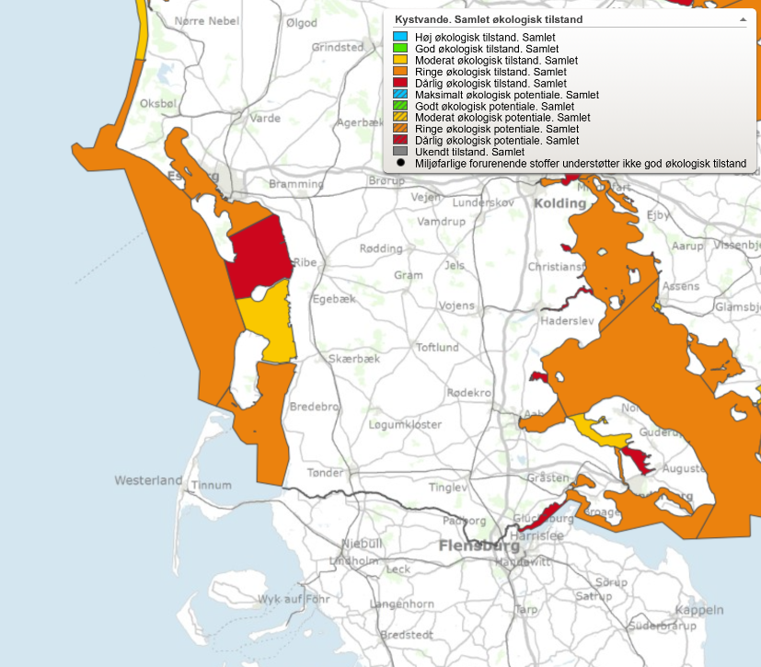
Figure 3. Overall ecological status of Water bodies in the Danish Wadden Sea. Yellow: Moderate condition, Orange: Poor condition, Red: Bad condition (Source: Miljøstyrelsen, N.D.).

The creeks Vidå, Bred å, Ribe å, Kongeå, Sneum å and Varde å are connected to the Danish part of the Wadden Sea. The ecological state here depends as mentioned on fish fauna among others. A population’s density and composition should be almost equal to that of an untouched population in order to be in a good condition. Of course, it is likely that actions taken to improve the state of the streams will also influence the coastal community. The plan for the Wadden Sea from 2009-2015 included aims such as reducing the nitrogen emission to the environment in the catchment area and improving the physical conditions of water bodies. For the coastal areas specifically a reduction of nutrients was required (Naturstyrelsen, 2011). Such measures should improve the living conditions for fish too.

Germany
The WFD was implemented in Germany within the “Wasserhaushaltsgesetz” in 2002 and within the individual water acts of the respective states. Though the WFD includes coastal waters up to 1 nm seawards from the coastal baseline, in these coastal waters fish are not assessed as biological quality components by the WFD. Fish are, however, a relevant biological quality component in transitional waters, rivers and streams and hence the WFD is the major policy to address the conservation issues of diadromous fish considered under the Habitats Directive such as lampreys, salmonids and shads.
The German WFD assessment of 2017 indicates that no coastal water body is in good ecological condition, varying from poor (yellow) to bad (red). Eutrophication was identified as the predominant anthropogenic pressure and affected microphytes, macrophytes and benthic organism more heavily along the coast of Hamburg, Niedersachsen and Bremen than the Wadden Sea of Schleswig-Holstein.
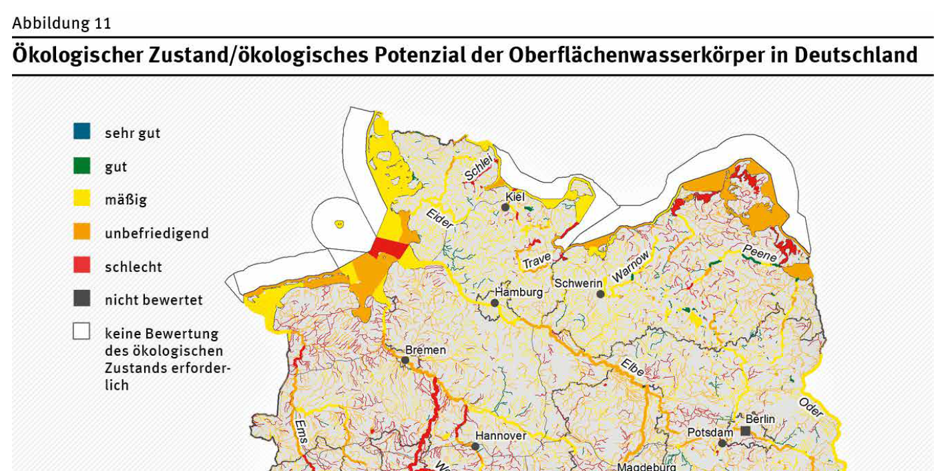Figure 4. Assessment results according to the Water Framework Directive in coastal and transitional waters of Germany. Source: Umweltbundesamt (www.umweltbundesamt.de).
In Germany, the river basin units Eider, Elbe, Ems and Weser are connected to the Wadden Sea area. The most important measures of the management plans for these river basin units with regards to the Wadden Sea fish fauna are measures to ensure the connectivity between sea, estuaries, rivers and streams, e.g. fishways for up- and downstream migrations e.g. in Geesthacht (Elbe) or Bremen (Weser).
The measures of the WFD eventually may lead to a reduction of nutrient inputs and improve the connectivity between marine and freshwater habitats. In case a further reduction of nutrients is achieved, this should further improve the habitat quality of nursery and spawning habitats in the Wadden Sea. The longitudinal migration of diadromous fish towards spawning and nursery ground in rivers and estuaries might also further improve when fishways are extended or maintained.

Netherlands
The Dutch Wadden Sea has the typology Coastal Water (“Beschut polyhalien kustwater” K2). Whereas the estuaries (type: Transitional water) have fish as a biological quality element that should be evaluated for its species composition and abundance, fish is not evaluated in coastal waters in the WFD. Therefore, Wadden Sea fish are not evaluated in the scope of the Water Framework Directive in the Netherlands.
In the Netherlands, the government translates the WFD into national policy, regulations and tools, based on the Dutch Water Act. The WFD targets are implemented in the “river basin unit management plans “ (Stroomgebiedplannen). The Wadden Sea lies within the river basin unit Rhine for the most part, only the Ems and Dollard lie within the river basin unit Ems (figure 5). However, the Stroomgebiedbeheerplan contains no measures specifically for the Wadden Sea, let alone any measures specifically concerning the fish populations of the Wadden Sea.
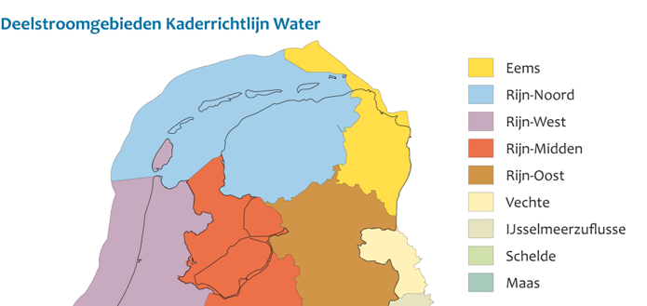
Figure 5. River Basin areas (deelstroomgebieden ).

Based on the Stroomgebiedbeheerplan Rhine, a number of projects from which the Wadden Sea fish may benefit have been and will be carried out for. These are described in the “Factsheet: NL81_1 Waddenzee” (2015). This factsheet describes the measures carried out until that time, and the intended measures for the period 2015-2021. The measures already carried out are:
- RWS_x2433-b - Pilot planting of Seagrass
- RWS_x2434-b - Pilot restoration of littoral mussel banks
- RWS_x2458a-b – Study on the behaviour of suspended sediment in the Wadden Sea
The measures to be carried out after 2015 are:
- RWS_Y2002 – Large scale seeding of Sea grass
- RWS_Y9015 - Vispassages Texel Krassekeet en Dijkmanshuizen
- RWS_x2458a-c – Research sludge household Waddenzee i.c.m. Deltaprogramma Wadden
- RWS_W1020 - Study standard exceeding specific pollutants
The factsheet describes the biological and chemical situation. The biological parameters score as follows:
- Macrofauna: average
- Water flora: insufficient
- Fish: not relevant
The factsheet describes the state of specific pollutants exceeding the standard: Arsenic, Benzo(a)antracene, benzo(a)pyrene, benzo(b)fluoranthene, benzo(ghi)perylene, Mercury, TBT, fluoranthene.
The factsheet states the final assessment of the Wadden Sea as follows:
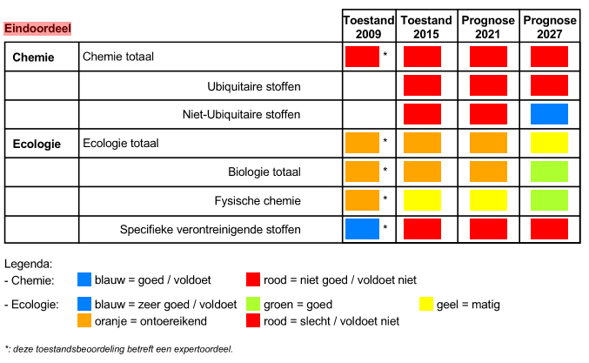
Stroomgebiedbeheerplan Eems 2016-2021
The Ems-Dollard estuary lies within the “stroomgebied” Eems, see the figure below.
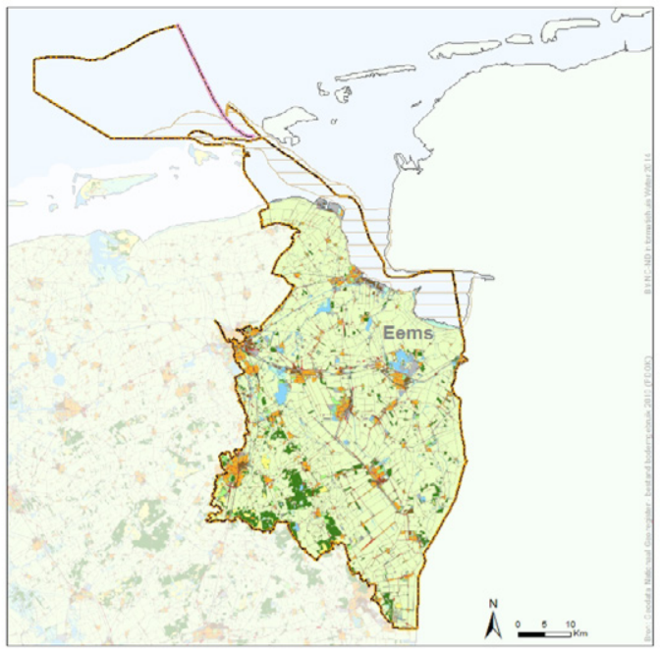

Figure 6. River basin unit Ems.

For the river basin unit Eems factsheet: NL81_2 Eems-Dollard (2015) describes the measures carried out until that time, and the intended measures for the period 2015-2021. The measures already carried out are:
- Fish passibility sluis Nieuw-Statenzijl
- Research salt marsh erosion
- Research sludge household Eems-Dollard
The measures to be carried out after 2015 are:
- Research source specific pollutants
- Research sludge household Eems
- RWS_W1020 - Study standard exceeding specific pollutants
The factsheet describes the biological and chemical situation. The biological parameters score as follows:
- Macrofauna: average
- Water flora: average
- Fish: average
- Phytoplankton: good
The factsheet describes the state of specific pollutants exceeding the standard: Arsenic Benzo(a)antracene, Chryseen, Cobalt, Copper, Silver.

The factsheet states the final assessment of the Wadden Sea in the river basin unit Ems as follows:
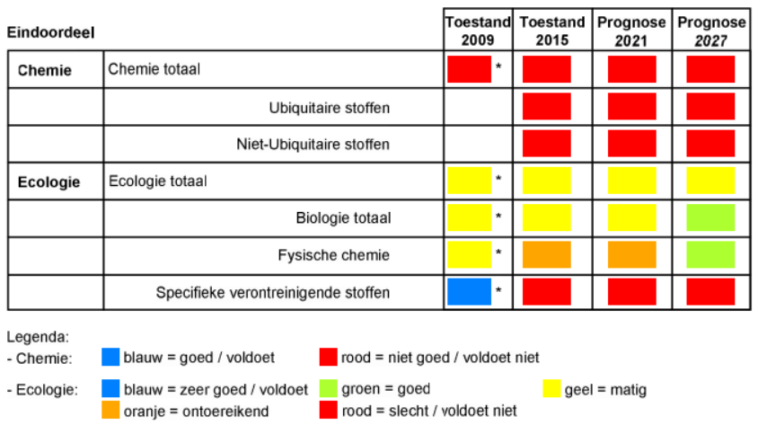

The Dutch WFD measures aim mainly at reducing nutrient and pollutant inputs into the Wadden Sea and removing barriers for diadromous fish. The aims of planting of seagrass and restoration of mussel beds might benefit fish as potential habitats. The measures aiming at reducing nutrient and pollutant inputs might improve the water quality, but at this time no part of the Wadden Sea is in a good ecological condition. Most parts of the Dutch Wadden Sea are designated as “Coastal Waters”, without fish as ecological parameters.
A number of WFD measures might benefit fish in due time, if the measures are successful. However, the measures carried out or proposed until this moment are only small scope projects and research projects which may or may not lead to specific measures which will benefit fish. The most relevant measure which may have a positive effect in the long term is the improvement of the water quality, which is an overall goal of the WFD.
Because the river basin unit Rijn has the topology “Coastal Waters”, fish are not part of the biological parameters to be evaluated. That means that for the largest part of the Dutch Wadden Sea the Stroomgebiedsplan does not encompass improvement of fish and fish habitats. For the river basin unit Ems fish are part of the biological parameters, and the current status is “average”. However, the Dutch implementation of the WFD in the Ems estuary contains hardly any measures to enhance the habitat quality and living conditions of fish, except a number of measures to facilitate the migration of diadromous fish species.

General conclusion on the WFD
The first nautical mile from the coast of the Wadden Sea (coastal waters) falls under the regime of the WFD. In 2015, the ecological condition of this Wadden Sea area was assessed as moderate to poor in the three Wadden countries.
Fish are a relevant biological quality component in transitional waters, rivers and streams. In neither of the three countries the Water Framework Directive contains specific measures for fish for this part of the Wadden area. Nevertheless, the three countries have included measures for the entire river basin, such as improving water quality and connectivity. Both goals may ultimately benefit fish in the Wadden Sea. The significance, pace, and scope of this potential contribution has not been identified in the context of this study.

Marine Strategy Framework Directive

Introduction
The aim of the European Union's ambitious Marine Strategy Framework Directive (MSFD) is to protect the marine environment across Europe more effectively. The Marine Strategy Framework Directive was adopted on 17 June 2008.
The Marine Strategy Framework Directive aims to achieve Good Environmental Status (GES) of the EU's marine waters by 2020 and to protect the resource base upon which marine-related economic and social activities depend. It is the first EU legislative instrument related to the protection of marine biodiversity, as it contains the explicit regulatory objective that "biodiversity is maintained by 2020", as the cornerstone for achieving GES.
In a legislative framework, the MSFD enshrines the ecosystem approach to the management of human activities having an impact on the marine environment, integrating the concepts of environmental protection and sustainable use.
Of the eleven descriptors for describing ‘Good Environmental Status’, four are relevant for the Fish Targets:
D1 Biodiversity: Biological diversity is maintained. The quality and occurrence of habitats and the distribution and abundance of species are in line with prevailing physiographic, geographic and climatic conditions.
D3 Commercial fish stocks: Populations of all commercially exploited fish and shellfish are within safe biological limits, exhibiting a population age and size distribution that is indicative of a healthy stock.
D4 Food web: All elements of the marine food webs, to the extent that they are known, occur at normal abundance and diversity and levels capable of ensuring the long-term abundance of the species and the retention of their full reproductive capacity.
D6 Soil floor integrity: Sea-floor integrity is at a level that ensures that the structure and functions of the ecosystems are safeguarded and benthic ecosystems, in particular, are not adversely affected.
To this end, the Member States develop a marine strategy for their marine waters in accordance with the plan of action set out by the MSFD in respect of each of the marine regions or sub-regions concerned. Member States sharing a marine region or sub-region cooperate to ensure that, within each such region or sub-region, their marine strategies and the measures required to achieve the objectives of the MSFD are coherent and coordinated.
This kind of co-operation Cooperation is already taking place through these Regional Sea Conventions. Since 1978, Denmark, Germany and the Netherlands have been cooperating to protect the Wadden Sea as an ecological entity. The Guiding Principle of the “Trilateral Cooperation on the Protection of the Wadden Sea”, in short Trilateral Wadden Sea Cooperation (TWSC), is “to achieve, as far as possible, a natural and sustainable ecosystem in which natural processes proceed in an undisturbed way”.
In addition to this, because the MSFD follows an adaptive management approach, the Marine Strategies must be kept up-to-date and reviewed every 6 years.
The Wadden Sea falls under the obligation of the Oslo-Paris Convention (OSPAR).

Denmark
The MSFD was implemented in Denmark as part of the Danish Marine Strategy (Danmarks Havstrategi) in 2011. As a result of this, Denmark’s Marine Strategy was published in 2012 comprising three reports: "Initial Analysis", "Environmental Targets" and "Socio-Economic Analysis". The "Initial Analysis" provided an overview of the status of Danish marine areas including which factors are contributing to the situation that not all Danish marine areas have good environmental status. The most important factors were identified as nutrient loads and contaminants dangerous to the environment, as well as fisheries of certain stocks and sea floor impacts due to fishing with bottom towed gear.
The environmental target report identified targets for the environmental status of Danish marine areas, and it described what would be considered a good environmental status. The environmental targets either describe the threshold to be crossed in order to go from 'not good' environmental status to ‘good’ environmental status, or they describe sub-targets to lead progress towards good environmental status. In autumn 2014, a monitoring programme under Denmark's Marine Strategy was published to ensure ongoing assessments of the environmental status in relation to the environmental targets set in the environmental target report for the Marine Strategy. In 2017, this strategy was followed up by a programme of measures. The programme of measures includes specific initiatives on the basis of the environmental targets laid down the environmental target report.
The programme of measures was prepared in the period 2014-2016 by a cross-ministerial cooperation between participants from the Danish Energy Agency, the Danish Maritime Authority, the Danish AgriFish Agency and the Danish Environmental Protection Agency. Furthermore, the Ministry for Defence was regularly informed about the programme.
A significant part of the programme of measures consists of various existing measures under other legislation. The cross-ministerial co-operation reviewed all relevant existing initiatives that have already been launched for the Danish marine environment. Subsequently, a gap analysis has assessed the contribution of the individual measures to achieving the environmental targets, as well as the need for further measures for each environmental target. In situations where the existing initiatives are assessed to be insufficient to reach the environmental targets, new initiatives have been proposed. The cut-off between existing and new measures is 1 January 2015, and new measures are defined as measures adopted after this date.
Furthermore, supplementary initiatives have been included, which, for example through additional knowledge from research or monitoring, will provide the knowledge necessary to enable the launch of initiatives to achieve the environmental targets or which will in other ways support achievement of the environmental targets.
In 2019 the 2nd generation marine strategy has been started. The strategy will be prepared in three parts over the coming years.
The first part is intended to provide an overview of the state of the sea and its effects and at the same time set environmental goals aimed at a good environmental condition.
The second part is to ensure an updated monitoring program in 2020 that takes into account new knowledge and new monitoring methods.
In 2021, the environmental targets will be followed up with the third and final part of the strategy, which is an action program that will include the measures to be taken to achieve or maintain the good state of the sea.

Germany
The Marine Strategy Framework Directive was implemented in Germany as part of the “Wasserhaushaltsgesetz” in 2011. The implementation of the MSFD is tightly coupled to the implementation of the Habitats Directive and the Birds Directive (e.g. by incorporating the SPAs and SACs as Marine protected areas) and the Water Framework Directive, but adds several new aspects to the conservation and management of marine ecosystems, such as the assessment and management of litter, noise pelagic habitats and function of food webs.
In 2012, as a first step, the EU Member States, and thus also Germany, carried out an initial assessment of their marine waters, determined a set of characteristics for good environmental status and established environmental targets. The environmental targets bridge the gap between the current and the good environmental status respectively with a view to meeting the overall objective of the MSFD, i.e. to achieve or maintain good environmental status in the marine environment by the year 2020 at the latest. The initial assessment and the environmental targets were reviewed and updated in 2018. The environmental targets form the basis for the development of measures.
In Germany, measures of the WFD, the BD and HD or the EU Common Fisheries Policy are included in the programme of measures (POM) as so called “existing measures”. New measures are additional measures to achieve and maintain GES, which do not build on existing implementation processes regarding existing EU legislation or international agreements or those that go beyond what is already required under these. The German POM contains 31 new measures for the 2016–2021 period. They focus on pressure sources at sea and include the following aspects:
- Reduction of pollutant inputs, including shipborne emissions and discharges.
- Protection of marine biodiversity, e.g. by means of spatial measures for the protection of marine species and habitats.
- Reduction of litter inputs through a combination of measures relating to product design, waste management, removal actions and public awareness- raising.
- Reduction of underwater noise through the development and application of noise mitigation measures, supported by noise mapping, a noise registry and biological threshold values.

The good environmental status is determined by 10 qualitative descriptors (Annex 1 MSFD) to which assessment, targets and measures refer.
The conservation of fish populations and diversity is addressed in Descriptor 1 of the MSFD (“Biological diversity is maintained. The quality and occurrence of habitats and the distribution and abundance of species are in line with prevailing physiographic, geographic and climatic conditions”). Germany lists in the initial assessment 2018 32 fish-species as relevant for the MSFD, of which nine species achieve good environmental status (GES), 15 species are not at GES and 8 species could not be assessed due to gaps in data availability (BLANO 2018). The assessment of the population status of these 32 fish species was based on the assessments of the HD, assessments of commercial stocks by the International Council for the Exploration of the Sea (ICES) or the German Red List (Thiel et al. 2013).
However, the good environmental status of several criteria is not yet specific enough to allow the formulation of concise management objectives (such as ‘healthy’ age structures in fish populations or proportion of trophic guilds according to prevailing environmental conditions in food webs).
Of the species listed in Table 4, only plaice, eelpout and lump sucker are included within the German MSFD assessment. However, the German MSFD assessment included also two elasmobranchs, thornback ray Raja clavata and spurdog Squalus acanthias, which were, based on survey data from the beginning of the 20th century, widely distributed throughout the German Bight including the Wadden Sea (Fock 2014; Fock et al. 2014).
So the MSFD led to a first comprehensive assessment of marine fish species and the impact of benthic disturbances and other anthropogenic pressures like migration barriers, fishery or ow habitat quality. This may possibly lead to more concrete measures.

Netherlands
The MSFD is implemented in 2010 via the Waterbesluit of the Waterwet (Water Act). The Waterbesluit calls for a National Water Plan (Nationaal waterplan) which describes the measures that should be taken to reach the GES. The Waterbesluit also calls for a Regional Water plan, which should contain a more detailed and specific implementation on the level of the provinces, and a Management plan of national waters on the level of the water bodies managed by the national government. The national and regional water plans and the management plan have a scope which is much broader than the MSFD, with the Water Act including regulation of traffic, etc.
The national government (Rijkswaterstaat) is responsible for the management of the Wadden Sea. The national management plan (Beheerplan Rijkswateren 2016 – 2021) contains amongst others measures for the Wadden Sea. The targets are:
- Guaranteeing agreed water safety with coastline care, research and monitoring.
- Investing in water quality: implementation of WFD measures and the Natura 2000 management plan.
- Guaranteeing the accessibility of the islands for ferries.
- Widening the navigation channel from Eemshaven to the North Sea.
The Beheerplan Rijkswateren refers to the WFD and N2000 and does not contain additional relevant policy. It is uncertain if a direct implementation of the MSFD could lead to more effective measures than those already based on the WFD and Habitats Directive.

General conclusion on the MSFD
The MSFD differs from the specific approach of the HD and WFD as it is based on an ecosystem approach to the management of human activities having an impact on the marine environment, integrating the concepts of environmental protection and sustainable use.
The MSFD second generation plans in Denmark will certainly have an impact in the Danish Wadden Sea, since the Danish WFD-implementation does not encompass marine fish in general. The directions in the MSFD thus obliges the implementation of “fish-measures” until the coast line although the first sea mile of marine water is covered by the WFD. The second generation MSFD plans thus i.a. implement a general fish monitoring programme in the Danish Wadden Sea and sets up targets for fish in general.
The MSFD is tightly coupled to the Habitats Directive, the Water Framework Directive and the Birds Directive, and adds several new aspects to the conservation and management of marine ecosystems, such as the assessment and management of litter, noise, pelagic habitats and function of food web.
In Germany the MSFD led to a first comprehensive assessment of marine fish species and the impact of benthic disturbances and other anthropogenic pressures like migration barriers, fishery or ow habitat quality. This may possibly lead to more concrete measures.
In the Netherlands the implementation of this Directive through concrete measures for the Wadden Sea in general and the fishing targets in particular, is restricted to the HD and WFD.

EU Eel Directive

Introduction
European eel Anguilla anguilla is classified on the IUCN red list as “critically endangered”. Since the early 1980s, a steady and almost continent wide decline in the recruitment of glass eel has been observed to less than 90 % of the recruitment levels observed in the 1960s. The decline in recruitment has led also to a decline in older life stages, namely yellow eel (resident in freshwater systems) and silver eel (migrating to sea).
The European Eel Directive (EC 1100/2007) aims at restoring the eel populations. It does so by obliging the individual member states to develop and implement national eel management plans including measures to restore the eel populations.
The Wadden Sea is considered an important habitat for this migratory species and eel has been designated as one of the flagship species for diadromous species in the Swimway approach.

Denmark
In Denmark the Eel Directive is implemented by the Ministry of Food, Agriculture and Fisheries, December 2008 (now called Ministry of Environment and Food Safety). The most recent Danish Eel management plan is from 2008.
In order to ensure that eel recovery measures are effective and equitable, Danish authority identified a series of measures to be taken and areas to be covered with respect to securing the recovering of the European eel stock. Following the adoption of Council Regulation in 2007, Danish fisheries authorities set up an eel management plan task force in order to initiate preparatory work required in connection with the adaptation of and compliance with the Council Regulation. The task force comprised fisheries management experts, legislators and eel scientists from the Technical University of Denmark. The task force will continue its work in the on-going process of monitoring, evaluating and adjusting the measures described in this plan.
The Danish Eel Management plan incorporates the introduction of a framework for effectively managing an extensive reduction in fishing effort, management measures for mitigating structural eel mortality, improving habitat conditions and re-establishing eel stocks. The Plan also includes a number of initiatives, management tools and development projects aimed at strengthening the quality and quantity of eel data. Stakeholder engagement and an open transparent process features the conduction if this plan.

Germany
In Germany the Eel Directive is implemented by the federal states across nine eel management units (EMU). The most recent assessment from 2018 indicates a sufficient overall migration rate of silver eels (> 40% compared to reference conditions) (Brämick and Fladung 2018). However, for the EMUs affiliated with the Wadden Sea (Eider, Elbe, Ems, Weser) the migration rate of silver eels was considerably lower (between 7 to 37% of reference conditions).
The restoration of eel in Germany focuses on stocking programs as natural recruitment by glass eels is at very low levels (Brämick and Fladung 2018). The implementation of measures to enhance longitudinal connectivity are limited and could be further improved especially in the tributaries of the rivers Elbe, Weser and Ems. The reduction of turbine inflicted mortality on silver eels remains a technical challenge.

The Netherlands
The Dutch Eel Management Plan (Aalbeheerplan) was implemented in 2009, and was evaluated in 2018 (van de Wolfshaar et al., 2018).
In the Netherlands, the pristine biomass of silver eel in fresh waters is assessed at 10.400 tons. This implies that 4.160 tons of silver eel should be allowed to migrate annually to the spawning areas, presuming location in the Sargasso Sea. It is estimated that in the years 2014-2016, the Dutch annual escapes were 1.795 tons of silver eel. Therefore, the objectives were not met.
In the evaluation of the Dutch Eel plan (van de Wolfshaar, 2018), the anthropogenic eel mortality was also analysed. Since 2007, there was a clear reduction in anthropogenic mortality. Up to 2007 it was 81%, with a reduction to 49% in the time period 2014-2016. This was mainly due to the catch reductions in the commercial and recreational fisheries. The mortality of migrating silver eel by barriers (pumps, hydropower stations, sluices) was reduced from 20 % to 18 %, which seems like a small improvement but required high investments by the government and regional authorities (waterschappen).
There has been increasing public awareness for removing fish migration barriers (for upstream migration) but as yet, less attention is paid to the seaward migration of fish (such as silver eel).
Along the Wadden Sea mainland coast, at least 11 sites have been identified which provide barriers for upstream eel migration from the Wadden Sea to inland waters. Several management measures are being implemented in line with EMPs, for example easing of barriers. The influence of these measures, however, will take time to determine as they have only very recently been implemented and very much focus on the freshwater component of the eel's life-history. Arguably the most widely practised measure is restocking; however, there remains a great deal of debate as to whether this benefits eel spawning stocks and thus enhanced future recruitment. Measures that apply to silver eels, such as fisheries management, and/or trap and transport programmes, can theoretically have an almost immediate effect on the potential spawning stock, although when carried out in isolation, their benefit is significantly reduced (IUCN website: www.iucn.org).
Not only the eel will benefit from the removal of fish migration barriers, also other diadromous species (both anadromous and catadromous) will benefit.

General conclusion on the ED
The Eel Directive will further improve the migration pathways of diadromous fish into tributaries adjacent to the Wadden Sea. Due to the life cycle of eel as catadromous fish, the ED has the potential to improve the connectivity of down-stream migrations.
The eel directive has been implemented in all three countries. The success of the measures differs slightly from country to country, but in general a positive trend in numbers is observed.

Fisheries Policy

7.1 Introduction
The EU Common Fisheries Policy (CFP) aims to ensure that fishing and aquaculture are environmentally, economically and socially sustainable and that they provide a source of healthy food for EU citizens. Its goal is to foster a dynamic fishing industry and ensure a fair standard of living for fishing communities. Although it is important to maximise catches, there have to be limits. The CFP ensures that fishing practices do not harm the ability of fish populations to reproduce. The current policy stipulates that between 2015 and 2020 catch limits should be sustainable and maintain fish stocks in the long term. The CFP is based on the precautionary principle which recognises the impact of human activity on all components of the ecosystem. It seeks to make fishing fleets more selective in what they catch, and to phase out the practice of discarding unwanted fish.
The CFP regulates the access to fishing grounds within national waters of the member states including coastal seas (3 to 12 nm) and the exclusive economic zones (EEZ, 12 to 200 nm). Generally, all EU member states have access to all coastal seas and EEZs of other member states. However, inside the territorial waters i.e. the 12 nm zone, member states have the right to restrict fishing access for foreign vessels, details of these restrictions are listed in Annex I of the CFP regulation (2013/1380/EU).
Important stocks of commercially exploited species, which are also predominant members of the Wadden Sea Fish community, are managed through the CFP. Such species are whiting Merlangius merlangus, plaice Pleuronectes platessa, sprat Sprattus sprattus and herring Clupea harengus. The regulation of fishing activities through catch quotas and spatial measures (see plaice box and Natura2000 sites) will also affect early life stages of these species, which rely on the Wadden Sea as spawning and nursery areas. Hence the sustainable management of commercially exploited fish species supports their abundance in the Wadden Sea area.
In 1989 the CFP inaugurated the plaice box, an area in which the fishing with large beam trawls towed by vessels with more than 300 hp engines was prohibited (Beare et al. 2013; Kjaersgaard and Frost 2008) (Figure 7). The impacts of the plaice box on the development of the plaice stocks remained ambiguous, as environmental changes were acting in concordance with the changes in the fishing regime (Beare et al. 2013; Dulvy et al. 2008). Though the plaice stocks did not increase substantially directly after the implementation of the plaice box, it is now at an all-time high.
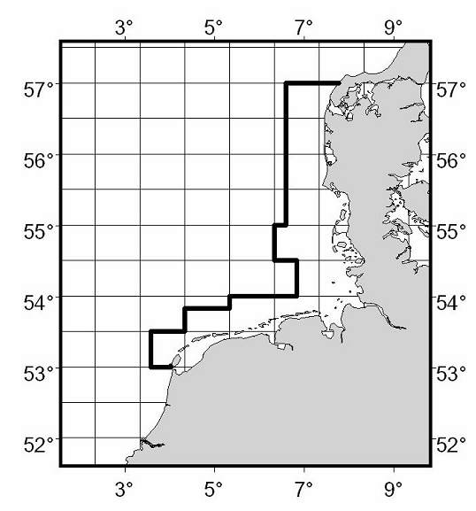
Figure 7. The plaice box, a spatial measure to exclude fishing vessels with more than 221 kW (300 hp) engine power. Source: www.ices.dk.

Only the fisheries covered by the CFP which are relevant for the Wadden Sea are described in this report. All countries have restricted fishing additionally to the CFP, e.g. Denmark has since 2007 designated areas closed for fisheries. Since then there has only being given one dispensation to do exploratory fishing. Schleswig-Holstein has a small no-take zone between the islands of Sylt and Föhr.

7.2 Denmark

In Denmark, the common fisheries policy in the Wadden Sea has been implemented in the Statutory order on protection and wild-life sanctuary in The Wadden Sea (Bekendtgørelse om fredning og vildtreservat i Vadehavet), which aims to promote sustainable management of the Wadden Sea. The newest version is from 2007. There has been very little commercial fishing inside the Wadden Sea in the last 25 years, and there hasn’t been given permission for commercial fishing or fishing with machinery since 2007. It is possible in the present version to apply for a dispensation to get license to exploratory fishing – however only one applicant - from the Technical University of Denmark – has been accepted. The Statutory Order is currently under revision. On the outer part of the Wadden Sea (at the border of the protected area) towards the North Sea, shrimp fishing is allowed.
The Common Fisheries Policy is also implemented in general in the national Fisheries Act (Fiskeriloven) which focusses specifically on fisheries and conservation in the Wadden Sea. The act Statutory order on particular regulations for fishery and conservation Zones in The Wadden Sea and certain South Western rivers and streams ( Bekendtgørelse om særlige fiskeriregler og fredningsbælter i Vadehavet og i visse sydjyske vandløb) prohibits fishing with rod and string in the streams that are connected to the Wadden Sea in parts of the year. Furthermore, an area of 500 m from several creeks and streams are protected. It also puts restrictions on what types of fishing gears are allowed in the Wadden Sea. Restrictions on fisheries is very relevant for the state of the fish in the Wadden Sea.
Further there is another statutory order connected to the general Fisheries Act specifically concerning the fishery of blue mussels in the WS concerning the formal regulations in connection with licensing.

7.3 Germany
Like stated before not all forms of fisheries going on in Germany under the umbrella of the CFP are described in the chapter.
In Schleswig-Holstein, cockle fishing as well as razor clam fishing is prohibited under the National Park Act. Surf clam fishing is no more permitted since 2017, but has in fact not been carried out since 1997.
The fisheries and cultivation of blue mussels is restricted to licensed operators which have to follow a co-operative management plan between the license holders and the federal state governments of Niedersachsen and Schleswig-Holstein (see section on Habitats Directive). Shrimp fishing is allowed in all three parts of the national park apart from a small no-take zone between the islands of Sylt and Föhr. However, there have been issues with enforcing this no-take zone and violations have been reported.

7.4 The Netherlands
In the Netherlands, the common fisheries policy has been implemented in the Fish Law (Visserijwet 1963) with a follow-up in the Sea and Coast Fisheries Act (Reglement zee- en kustvisserij 1977, valid from 01-01-2015 up to date) and translated into a regulation on Fish (Uitvoeringsregeling Visserij). Fish species can be included in the Fisheries Act with a minimum size and / or closed seasons. All fishing activities have to have a license according to this law, but the actual management of the fishery falls under the HD/N2000, not the CFP, according to the ‘Wet Natuurbescherming’ (Wnb).
For the shrimp fisheries and mussel fishery this license if given by national government. Other forms of fishery such as manual shellfish (cockles and Pacific oyster) fisheries and passive gear (e.g. nets, fykes) are covered by licenses given by regional government.

7.5 General conclusion
The CFP is mainly used to regulate fisheries, to ensure that the commercial fish population is maintained at a certain reproductive level to “produce” enough fish. Measures regarding fishing methods, bycatch reduction and reducing environmental impacts may also support the (ecological) fish targets. The CFP has the potential to further improve and maintain the stock status of commercially exploited fish species which occur in the Wadden Sea, such as plaice, sole, whiting and herring. However, apart from a small area in Denmark, the CFP is not implemented in the Wadden Sea and cannot contribute directly to the fish targets. The CFP does explicitly refer to the Habitats Directive and the MSFD and allows for spatial conservation measures for fish spawning and nursery habitats, but these are not in the Wadden Sea.

Ballast Water Management Convention

Introduction
The International Convention for the Control and Management of Ships' Ballast Water and Sediments (BWM Convention, which came into force on September 8th, 2017) requires ships to manage their ballast water to remove, render harmless, or avoid the uptake or discharge of aquatic organisms and pathogens within ballast water and sediments. One example of an invasive species in the Wadden Sea is the comb jelly (Mnemiopsis leidyi), which travelled in ship’s ballast water. An example for a fish species that is mentioned on the website of imo.org is the round goby Neogobius melanostomus. Furthermore, there is a record of Atlantic croaker.
The Ballast Water Management Convention aims to prevent new introduction of invasive alien species via ballast water. It will not prevent further growth of populations of alien species already present. And unfortunately there are also a number of other pathways for such species than by ballast water.

Denmark
The implementation of the BWMC is under the responsibility of the Danish Maritime Authority (Søfartsstyrelsen). The purpose of the ballast water management convention is to prevent the introduction of invasive species from ships’ ballast water.
The concept of “Same Risk Area”, developed in Denmark, has now been approved by the IMO, and it has been decided that it can be used already now. This means that, rather than making a risk assessment per ship route, you can make a risk assessment for minor sea areas (following an agreement by the authorities of all the countries affected); this would be considerably easier to handle for both ship owners and the authorities.
The implementation of BWMC in DK has led to the fist e-DNA program being introduced on an operational basis in the country.

Germany
The implementation of the BWMC is under the responsibility of the Federal Maritime and Hydrographic Agency (Bundesamt für Seeschifffahrt und Hydrographie, BSH). This agency has a strong focus on technical applications and hence is responsible for the approval of ballast water treatment systems of vessels, which intend to reduce the amount if viable organisms in discharged ballast water. The BSH has licensed several ballast water management systems so far. By 2024, all vessels have to fulfil the quality criteria of ballast water management.
A national monitoring initiative (rapid assessment survey, RAS) of non-native species is conducted along eleven sampling sites in harbours and marinas along the German North Sea coast. This monitoring program covers sampling of pontoons, harbour walls and rocky substrates. As a result of a joint harmonized procedure between HELCOM and OSPAR to fulfil the monitoring obligations of the Ballast Water Management Convention, the German RAS programme has been extended by monitoring of settlement panels (eRAS).
So far, 101 non-native species have been recorded in the German North Sea, of which the round goby Neogobius melanostomus has been recorded as the only established invasive fish species. The round goby is a highly adaptable and invasive fish species. It competes for food and habitat with native fishes including commercially important species, and preys on their eggs and young. It spawns multiple times per season and survives in poor water quality. The ctenophore Mnemiopsis leydii is also an introduced species with high impact potential for Wadden Sea fish species.
With regard to non-native invasive species the German legislation is focussing on reducing the introduction of new species, either from ballast water or biofouling. Within the MSFD an introduction rate of less than three species per six years is considered as compliant to a good environmental status.

Netherlands
The Ballast Water Management Convention is implemented in the Dutch Act on the prevention of pollution by ships (Wet voorkoming verontreiniging door schepen). This law does not only regulate the use of ballast water, but also a.o. the use of anti-fouling. It contains a complete implementation of the BWMC with no additional regulation concerning ballast water. The Dutch Human Environment and Transport Inspectorate) of the Ministry of Infrastructure and Water Management is responsible for enforcing this law in the Netherlands.
The round goby was recorded in the NIOZ fyke monitoring in the western Dutch Wadden Sea in 2015 and may have been transported by ballast water or it may have migrated via the Danube-Rhine canal. The round goby has already established its stomping grounds in the south of the Netherlands and in Lake IJssel. It is a freshwater goby, which can also live in brackish waters, so it could have been expected that it would one day also appear in the Wadden Sea. However, researchers didn’t come across it until 2019. It can therefore be surmised that since 2015, an extra fish species is present in the Wadden Sea.
The Atlantic croaker or ‘knorrepos’ in Dutch (Micropogonias undulatus), was recorded in 2003 in the Wadden Sea, but there are no further reports.

General conclusion on the BWMC Convention
The BWMC is implemented in the three countries. This leads to measures that may delay or prevent the introduction of alien species in the Wadden area. It is difficult to predict the influences of the Ballast Water Management Convention and other prevention measures on the fish fauna of the Wadden Sea. The introduction of a single non-native species can alter the structure and function of an entire ecosystem within short time frames. But the implementation of the Ballast Water Management Convention along with local measures to reduce the introduction of non-native species presumably reduces the risk of catastrophic invasions.

Other regulations and agreements

Alien Species Regulation
- Regulation (EU) 1143/2014 on invasive alien species (the IAS Regulation) entered into force on 1 January 2015, fulfilling Action 16 of Target 5 of the EU 2020 Biodiversity Strategy. The core of the IAS Regulation is the list of Invasive Alien Species of Union concern.
- This issue has been prioritized in the Leeuwarden Declaration 2018, and a strategy to that effect is under implementation. A comprehensive list of Alien Species in the Wadden Sea Area have been developed and is maintained on a regular basis.

Maritime Spatial Planning Directive
- The Maritime Spatial Planning Directive to marine waters of Member States, does not apply to coastal waters or parts thereof. The relevance for this policy analysis is low even though specific issues connected to the MSPD (I.a. power lines from the North Sea wind farms and shipping traffic both in the construction phase as well as the operation phase from the wind farms) may be relevant impact issues on fish.

Convention on International Trade of Endangered Species (CITES)
The Convention on International Trade in Endangered Species of Wild Fauna and Flora (CITES), regulates international trade in endangered species through a licensing system based on non-detriment findings (NDFs), in which the scientific evidence is presented to prove that trade does not impact on the wild population. National trade and trade between EU countries does not have to follow this system. The list of protected species in CITES comprises sturgeons (a.o. Atlantic sturgeon Acipenser sturio), eel (Anguilla anguilla), Syngnathid fishes (a.o., Hippocampus spp.). Sea horse species occur occasionally in the (German) Wadden Sea. There are three shark species (porbeagle, thresher shark and basking shark) in the North Sea on the CITES list, but these are generally offshore and are not relevant for the Wadden Sea.
While sturgeon has been extirpated in the Wadden Sea, syngnathids and eel are living in the area. For these species CITES is only relevant if they are transported outside the EU.

Oslo-Paris Convention (OSPAR)
The Oslo-Paris convention (OSPAR) is the mechanism by which 15 Governments & the EU cooperate to protect the marine environment of the North-East Atlantic. OSPAR started in 1972 with the Oslo Convention against dumping and was broadened to cover land-based sources of marine pollution and the offshore industry by the Paris Convention of 1974. These two conventions were unified, up-dated and extended by the 1992 OSPAR Convention. The new annex on biodiversity and ecosystems was adopted in 1998 to cover non-polluting human activities that can adversely affect the sea. The fifteen Governments are Belgium, Denmark, Finland, France, Germany, Iceland, Ireland, Luxembourg, The Netherlands, Norway, Portugal, Spain, Sweden, Switzerland and United Kingdom.
Work to implement the OSPAR Convention and its strategies is taken forward through the adoption of decisions, which are legally binding on the Contracting Parties, recommendations and other agreements. OSPAR has a list of Threatened and/or Declining Species and Habitats for which the Contracting Parties agree management measures. For the Wadden Sea the relevant species are: sturgeon (Acipenser sturio), allis shad (Alosa, alosa), European eel (Anguilla anguilla), houting (Coregonus lavaretus oxyrinchus), cod, (Gadus morhua), long-snouted seahorse (Hippocampus guttulatus), short-snouted seahorse (Hippocampus hippocampus), sea lamprey (Petromyzon marinus), salmon (Salmo salar) and thornback ray (Raja clavata)

Convention on Migratory Species (CMS)
As an environmental treaty of the United Nations, the Convention on Migratory Species (CMS) provides a global platform for the conservation and sustainable use of migratory animals and their habitats. CMS brings together the States through which migratory animals pass, the Range States, and lays the legal foundation for internationally coordinated conservation measures throughout a migratory range.
As the only global convention specializing in the conservation of migratory species, their habitats and migration routes, CMS complements and co-operates with a number of other international organizations, NGOs and partners in the media as well as in the corporate sector.
Migratory species threatened with extinction are listed on Appendix I of the Convention. CMS Parties strive towards strictly protecting these animals, conserving or restoring the places where they live, mitigating obstacles to migration and controlling other factors that might endanger them. Besides establishing obligations for each State joining the Convention, CMS promotes concerted action among the Range States of many of these species.
Migratory species that need or would significantly benefit from international co-operation are listed in Appendix II of the Convention. For this reason, the Convention encourages the Range States to conclude global or regional agreements.

Three species relevant for the Wadden Sea are on the CMS list. These are Atlantic sturgeon (Acipenser sturio – Appendix I), the European eel (Anguilla anguilla – Appendix II) and the tope (Geleorhinus galeus – Appendix II).

UNESCO World Heritage
In 2009, the Wadden Sea was inscribed on UNESCO’s World Heritage List in recognition of the ‘Outstanding Universal Value’ of the area and the progress made in protecting and managing it for more than a generation. The World Heritage status is the highest possible award for a natural site and recognition and acknowledgement of its outstanding global importance. Thus, the Wadden Sea is on the same footing as other World Heritage properties such as the Great Barrier Reef and the Grand Canyon. The inscription into the World Heritage List means that the Wadden Sea carries outstanding universal value and must be preserved for the benefit of present and future generations. With the extension of the Dutch German Wadden Sea World Heritage Site (inscribed in 2009) with further areas in Germany and the Danish part of the Wadden Sea in 2014, the entire Wadden Sea is now on the World Heritage List (CWSS, 2016).
As part of the nomination, the World Heritage Committee requests that the State Parties of Denmark, Germany and the Netherlands develop a single integrated management plan (SIMP) for the entire area and harmonise management practices (CWSS, 2016). Implementation of the trilateral Fish Targets could be included in these processes.

Conclusion and next steps

Do European regulations help fish ?

Of the directives, conventions and legislation described, in particular the Natura 2000 Management Plans based on the Birds and Habitats Directive contain specific and concrete measures for habitats and a small group of fish species in the Wadden Sea. The Natura2000 measures focus mainly on the qualifying habitats and some focal species. It seems to overlook the importance of measures aimed at other relevant species which use these habitats and underestimates the importance of fish as a crucial part of the Wadden Sea ecosystem. Nonetheless, fish species are characteristic for marine habitats and as such can be considered in management plans when specific measures are defined to improve subtidal habitats. It is possible to include them and their function in the food web in the conservation objectives for the sites.
Fish species may benefit from the measures aimed at preserving and restoring habitats, but only if the specific needs of fish species are taken into account when developing management measures for the restoration of marine habitats. Measures to improve fish migration are implemented through policy directives such as the HD/N2000, WFD and ED, but for other species the specific needs of fish species are still poorly understood and there are few specific restoration measures and those in place are not always monitored adequately. It can be observed, however, that the designation of Natura2000 areas provides the possibility to limit or even exclude certain (potential) threatening human activities. The three countries deal with this differently.
The WFD applies to the coastal zone in Denmark and Germany. In the Netherlands it is only in the transitional waters such as the River Ems that objectives for fish are addressed. Much attention is paid to water quality and the removal of barriers in rivers and estuaries leading into the Wadden Sea, particularly for diadromous fish. However, the effectiveness of these measures is largely unknown.
The Eel directive has a clear and specific purpose. The measures aimed at removing physical barriers will also help other migrating fish species and a small positive trend has been noticed.
The Marine Strategy Framework Directive is based on an integrated ecosystem approach and is mainly aimed at the marine zone outside the coastal waters. It can however also support fish communities in the Wadden Sea, because the MSFD's scope can also be applied in the coastal zone (including the Wadden Sea) for issues that are not addressed by the Birds and Habitats Directive or the Water Framework Directive.
The Alien Species Regulation, the Ballast Water Management Convention and the Common Fisheries Politics are relevant for this policy review, and may contribute in an indirect way or in the long term to improvement of fish species through the regulation of invasive species and mechanisms such as quota of commercial species which use the Wadden Sea during part of their life-cycle. CITES, OSPAR and CMS are relevant for some of the SWIMWAY flagship and fleet species. The UNESCO World Heritage is important from the point of view of integrated and harmonised management.
It should be noted that national legislation that could contribute to achieving favourable living conditions for fish in the Wadden Sea, is not systematically analysed in this review. Therefore the conclusions and proposed next steps mainly apply to the European regulations, as these provide a common basis for the trilateral Swimway Vision.

Relevance of European law for the flagship and fleet species designated in the Swimway Action Programme

The flagship and fleet species are each covered by different laws and regulations, which reflect their conservation status. See Table 9 for an overview of the policy frameworks in which the species are explicitly mentioned. Most of the species are covered by one or more frameworks, which gives scope for future work.
Life style | Flagship or fleet | Species | Relevant policy framework – for all three countries
Pelagic marine juvenile | Flagship | Herring | BHD (habitat), MSFD
 | Fleet | Sprat | WFD (transitional waters)
 |  | Anchovy | BHD (habitat), WFD (transitional waters)
 |  | Horse mackerel | -
 |  | Seabass | -
Demersal marine juvenile | Flagship | Plaice | BHD (habitat)
 | Fleet | Sole | BHD (habitat)
 |  | Dab | BHD (habitat)
Wadden Sea residents | Flagship | Eelpout | BHD (habitat)
 | Fleet | Gobies | WFD (transitional waters)
 |  | Sandeel | WFD (transitional waters)
 |  | Sea snail | BHD (habitat)
 |  | Rock gunnel | WFD (transitional waters)
 |  | Mullets | BHD (habitat)
Diadromous species | Flagship | Smelt | WFD (transitional waters)
 | Fleet | Twaite shad | BHD (species)
 |  | Salmon | WFD (transitional waters)
 |  | Sea trout | WFD (transitional waters)
 |  | Houting | BHD, WFD (transitional waters)
 |  | Eel | ED
Marine adventitious | Flagship | Tope | MSFD (NL - North Sea only)
 | Fleet | Thornback ray | MSFD (NL - North Sea only)
 |  | Dogfish | MSFD (NL - North Sea only)
Table 9 Overview of policy frameworks relevant for the flagship and fleet species. Unless mentioned, these apply to all three countries. See Appendix I for a list of acronyms.

Trilateral fish targets supported by European law?

Another question is to what extent the trilateral fish targets are supported by European legislation. A short conclusion per targets follows hereafter.
- Viable stocks of populations and a natural reproduction of typical Wadden Sea fish species.
The definition of typical Wadden Sea fish is not consistent enough in the described regulations and policies to develop measures to enhance viable stock of Wadden Sea fish species. However, the Habitat Directive does list ‘characteristic’ species for each of the habitats which could give a framework for measures. It might also be possible for the countries to include the above mentioned flagship and fleet species in the Habitat descriptions more explicitly. For commercial fish species managed with a quota, the CFP provides the basis for measures regarding viable stocks. These may also include some species of the typical Wadden Sea fish communities, such as plaice and herring but does not cover all relevant species, especially not those that are of no commercial interest. As it is not as it is not implemented in the Wadden Sea it is of limited value.
2. Occurrence and abundance of fish species according to the natural dynamics in (a)biotic conditions.
The MSFD might be used to improve the natural dynamics in (a) biotic conditions, implementation of this framework has still some more potential in the three countries, based on their view that the HD and WFD requirements provide sufficient protection.
3. Favourable living conditions for endangered fish species.
The HD does not cover all endangered Wadden Sea fish species. The designated habitats (reefs, shallow large bays, estuaries, salt marshes and sand banks) are not sufficiently targeted for supporting favouring endangered fish species. Measures based on the HD and WFD regarding habitats will contribute to favourable living conditions for fish, such as reduced rates of mortality from fishing of adequate levels of food supply, unpolluted water and negative impacts of human activities. The focus of these measures however is not aimed at endangered fish species, though they would contribute to the living conditions.
The policies relevant for endangered fish species are the Eel Directive, CITES, OSPAR and CMS. A number of the flagship and fleet species are listed on these conventions and there is scope for measures for improving living conditions.
4. Maintenance of the diversity of natural habitats to provide substratum for spawning and nursery functions for juvenile fish.
Measures to restore, conserve and maintain the diversity of natural habitats, such as eelgrass, oyster- and blue mussel banks are part of the N2000 management plans. Additionally the MSFD provides a basis for a more integrated approach, it`s a possibility that still offers a lot more scope.
5. Maintaining and restoring the possibilities for the passage of migrating fish between the Wadden Sea and inland waters.
Both the WFD and the Eel Directive contain measures to mitigate barriers between the inland fresh water systems and the Wadden Sea.

Target | Relevant existing policy | Gaps
Viable stocks of populations and a natural reproduction of typical Wadden Sea fish species. | CFP, HD, MSFD | No conservation measures for non-commercial fish species (e.g. hook nose, gobies, etc.) and locally extirpated species (e.g. thornback ray, sturgeon, spurdog, houting, etc.).
Occurrence and abundance of fish species according to the natural dynamics in (a)biotic conditions. | HD, WFD, MSFD | No policy currently implements measures for non-commercial fish species (e.g. hook nose, gobies, etc.) and rare or locally extirpated species (e.g. thornback ray, sturgeon, spurdog)
Favourable living conditions for endangered fish species. | HD, WFD, MSFD, ED | No policy currently implements measures for rare or locally extirpated species (e.g. thornback ray, sturgeon, spurdog, etc.).
Maintenance of the diversity of natural habitats to provide substratum for spawning and nursery functions for juvenile fish. | HD, CFP, MSFD | Knowledge about spawning and nursery habitats is limited. Potential areas could be protected under HD or part of the HD management plans, CFP and/or MSFD.
Maintaining and restoring the possibilities for the passage of migrating fish between the Wadden Sea and inland waters. | WFD, ED | Knowledge on migration success differs by river basin and species. Further improvements on marine freshwater connectivity are necessary.
Table. 10. Trilateral fish targets and their relation to relevant existing policies and gaps.

Next steps

Proper implementation of the trilateral fish targets in European regulation will require more effort and collaboration at all relevant levels of legislation, especially national and regional. For the European level several ways to achieve this are suggested. Two parallel approaches are presented:
- Knowledge based approach
- Policy approach
Both approaches may be combined and should be elaborated parallel.

Knowledge based approach
The knowledge based or rational approach should build on what is already known to start improving the situation for fish and enable the implementation of current fish policy for the Wadden Sea with regard to the Fish Targets. Emphasis on more research, monitoring and expertise, will - in this approach – lead to better targeted policy and measures. Therefore the trilateral fish targets should become SMART, causes of decline better known, and measures more specific defined. This is the approach that has been developed in the Swimway Action Programme in order to address the Fish Targets. The Swimway Action Programme states that “.. the only way to arrive at sensible measures aimed at improving the situation for fish is to view the function of the Wadden Sea within the whole life cycle of a fish species. To understand population dynamics, investing in quantifying the rates that drive population developments, such as births, deaths, immigration and emigration (demographic or vital rates) is needed.” Research on predator-prey relationships, eco-physiology, species-habitat interactions and connectivity was identified as being needed to understand this. Research programmes are already being carried out and new insights into the factors influencing fish population dynamics will feed into the process over time. The following actions are identified as being a way to link into policy.

- Define Smart targets
The trilateral fish targets are formulated at a generic and abstract level. This is partly due to lack of knowledge, as mentioned in the Swimway Action Programme (Swimway, 2019), which concludes “The main benefit arising from the Swimway research will be the identification of population bottlenecks and the translation of this knowledge into effective management and conservation measures. Closing these knowledge gaps will help to improve effective conservation”. It would therefore be very helpful to make the trilateral fish targets SMART by defining quantitative sub-targets for given species and habitats. The Report from the 2019 Swimway conference has developed this principal further (Dänhardt, 2019). The author proposes a four step approach: 1) formulate generic, overarching goals everybody can agree on; 2) specify these into more specific SMART targets; 3) develop a technical implementation plan; and 4) take immediate action to protect fish while specifying the targets. This means that there does not have to be any delay with implementing the targets.

- Focus on typical Wadden Sea species
The focus on fish species and communities which are (or were) typical for the Wadden Sea, also with respect to historic knowledge of local or regional extinction, is essential when addressing the Fish Targets. The QSR has a list of priority species which are used in analyses (Tulp et al., 2017) and in Appendix II there is a list of ‘typical’ fish species. The trilateral Swimway Wadden Sea Action Programme 2019 identifies 23 flagship and fleet species within five ecological groups of fish species (ecological guilds) which share similar behaviour and ecological demands within each guild (Swimway, 2019). This approach has been described earlier in the document and will help to focus research and conservation efforts. The current policy frameworks give enough scope to include these species. As the sturgeon is covered by a number of policy directives (HD, OSPAR, CMS, CITES) it might be good to include this in the list of fleet species, even though it has disappeared from the region, as there might be ample leverage to develop management measures which would benefit other diadromous species.
- Identify threats and/or causes of declines in fish populations
The ecological requirements of many species are known to a limited extent and the associated threats as mentioned in the trilateral fish targets are quite generic. This calls for research specifically aimed at pinpointing the bottlenecks for the achievement of the trilateral fish targets. Research into the underlying causes of the decline of fish populations will contribute to development of targeted and knowledge based proposals regarding the implementation of the current policies aiming to resolve bottlenecks. Now that these bottlenecks are insufficiently known, it is difficult to assess to what extent the existing implementation of the policy is effective. These gaps in knowledge will be addressed in the SWIMWAY Programme.
- Make better use of available knowledge and expertise
A lot of knowledge is already available. By inviting experts to share their insights, by collecting and combining this knowledge and by developing collective views, a lot of questions and gaps mentioned above may receive a satisfying answer. Although it may be hard to determine which specific measures will benefit fish populations without a deeper analysis, it may be worthwhile to check what is already known and whether that can lead to appropriate measures. Identification of areas of importance for relevant processes in species’ life cycles i.e. spawning or nursery habitats and considering potential spatial measures to improve the status of extirpated, threatened or declining species.
Existing knowledge may be of great value already to provide clear recommendations for a better implementation of the existing legislative framework and trilateral declarations and the Wadden Sea Plan. At the Swimway conference in 2019 recommendation were made to improve exchange of knowledge and it is recommended to develop a framework for this.

Policy approach
Although implementation of policy should preferably be based on scientific knowledge, thorough research as described above takes time and requires sufficient funds. And next to that, available insights and existing knowledge about the Wadden Sea, may be sufficient to be able to formulate adjustments of the implementation aiming to a better support of the trilateral fish targets.
- Make better use of the existing legislative framework, including the trilateral declarations and the Wadden Sea Plan.
The link between the trilateral fish targets and existing European regulations could be established, but the full potential of the regulations is currently not used by either member state. The CFP and the MSFD for example both could be used to establish spatial management measures to protect threatened and valuable fish species in the Wadden Sea. However, currently no country seems to makes full use of this potential. Despite the partly required, complex coordination, there are important options for protection. It is recommended to elaborate specific proposals for the three Wadden Sea countries how to make better use of the existing legislative framework, including the trilateral declarations and the Wadden Sea Plan. The Wadden Sea World Heritage Management Plan (so called SIMP for single integrated management plan), which is requested by WHC for the Wadden Sea World Heritage and currently in preparation, may prove to be a useful vehicle for this purpose.
In the “fit for purpose review”, the European Commission recommended to achieve more integration between the Natura2000 (HD & BD), WFD and other directives. This aim may also benefit the trilateral fish targets. This is in line with and contribute to the development of the SIMP, as it is aimed for by the trilateral cooperation and which is also a requirement for the Wadden Sea World Heritage.
The national HD and WFD plans have to be evaluated and adapted every six years. This might provide an opportunity to enhance the attention for the Wadden Sea fish populations. Lobby to improve these plans by the trilateral partners at the national level (regarding e.g. the implementation of the EU directives in national legislation) is needed. A first step would be for the three countries to collaborate to include the flagship and fleet species more explicitly in the national management and monitoring plans. This will mean a more comprehensive approach to including species from the different ecological groups.

- Focus on national implementation
In this review the national policies and regulations have not been analysed. Proposals for implementation of the national and regional Wadden Sea policy will likely be a feasible way to implement the trilateral fish targets successfully. Supplementary to this review of European legislation, an analysis of the national and regional policies on fish of the three Wadden Sea countries, is recommended.
The linkages and interactions between the above recommendations are shown in the following figure (Figure 8) which should be read as an adaptive process whereby our knowledge of species population dynamics and the effectiveness of measures to address the Fish Targets improves over time.
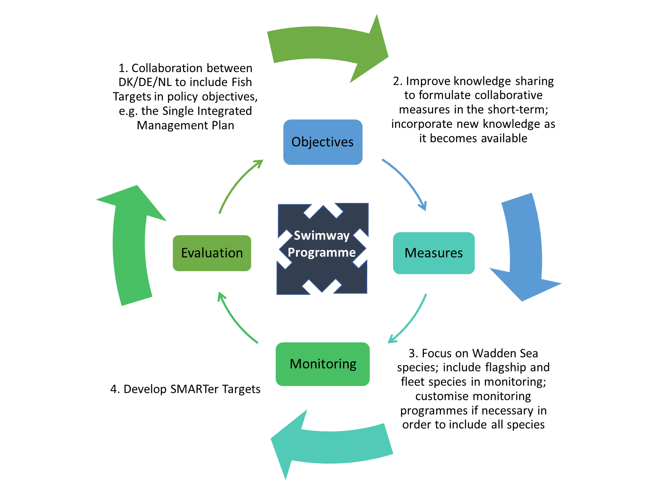
Figure 8. How the policy and knowledge approaches to address the Fish Targets could interact over time within the plan-do-check-act policy cycle.

Citations
Addison, J., Gaudian, G., Knapman, P., 2017. MSC sustainable fisheries certification, In Publilc Certification Report. p. 428. Acoura.
Anonymous, 2017. Kurzbewertung des Bewirtschaftungsplans Miesmuschelfischerei im Nationalpark "Niedersächsisches Wattenmweer", p. 38. COFAD GmbH, Weilheim.
Beare, D., Rijnsdorp, A.D., Blaesberg, M., Damm, U., Egekvist, J., Fock, H., Kloppmann, M., Röckmann, C., Schroeder, A., Schulze, T., Tulp, I., Ulrich, C., van Hal, R., van Kooten, T., Verweij, M., 2013. Evaluating the effect of fishery closures: Lessons learnt from the Plaice Box. Journal of Sea Research 84, 49-60.
BLANO, 2018. Zustand der deutschen Nordseegewässer 2018, In Umsetzung der Meeresstrategie-Rahmenrichtlinie. p. 191. Umweltbundesamt, Bonn.
Brämick, U., Fladung, E., 2018. Umsetzungsbericht 2018 zu den Aalbewirtschaftungsplänen der deutscheln Länder 2008, p. 62. Institut für Binnenfischerei e.V. , Potsdam-Sacrow.
Buschbaum, C., Lackschewitz, D., Reise, K., 2012. Nonnative macrobenthos in the Wadden Sea ecosystem. Ocean & Coastal Management 68, 89-101.
CWSS (Common Wadden Sea Secretariat), 2016. Report on the State of Conservation of the World Heritage property “The Wadden Sea (N1314)”. Wilhelmshaven, Germany. 170 pp.
Dänhardt, A. (2019) SWIMWAYs: Understanding connectivity within the life cycles of coastal fish. Conference report, 24-26 September 2019, Hamburg, Germany. Jesteburg/ Lüllau, 105 pages. Common Wadden Sea Secretariat, Wilhelmshaven, Germany.
Davenport, J., 1985. Synopsis of biological data on the lumpsucker Cyclopterus lumpus (Linnaeus, 1758). FAO fisheries synopsis no. 47.
Dulvy, N.K., Rogers, S.I., Jennings, S., Stelzenmüller, V., Dye, S.R., Skjoldal, H.R., 2008. Climate change and deepening of the North Sea fish assemblage: a biotic indicator of warming seas. Journal of Applied Ecology 45, 1029-1039.
Fock, H.O., 2014. Patterns of extirpation. I. Changes in habitat use by thornback rays Raja clavata in the German Bight for 1902-1908, 1930-1932, and 1991-2009. Endangered Species Research 25, 197-207.
Fock, H.O., Probst, W.N., Schaber, M., 2014. Patterns of extirpation. II. The role of connectivity in the decline and recovery of elasmobranch populations in the German Bight as inferred from survey data. Endangered Species Research 25, 209-223.
I&M 2016 Natura 2000-beheerplan Waddenzee 2016-2022. Ministerie van Infrastructuur en Milieu, Rijkswaterstaat Noord Nederland. Juni 2016.
Jager, Z., Bolle, L., Dänhardt, A., Diederichs, B., Neudecker, T., Scholle, J., Vorberg, R., 2009. Thematic QSR Report No. 14: Tidal Area - Fish, in: Marencic, H., de Vlas, J. (Eds.), Quality Status Report 2009. WaddenSea Ecosystem No. 25. Common Wadden Sea Secretariat, Trilateral Monitoring and Assessment Group, Wilhelmshaven, Germany.
Kjaersgaard, J., Frost, H., 2008. Effort allocation and marine protected areas: is the North Sea Plaice Box a management compromise? ICES Journal of Marine Science 65, 1203-1215.
Naturstyrelsen, Miljøministeriet, 2013. Natura 2000-basisanalyse 2015-2021 for Vadehavet - Vadehavet med Ribe Å, Tved Å og Varde Å, H86 Brede Å, H90 Vidå med tilløb, Rudbøl Sø og Magisterkogen og F57 Vadehavet, Natura 2000- område nr. 89, Habitatområde H78, H86 og H90, Fuglebeskyttelsesområde F57.
Naturstyrelsen, 2011. Vandplan 2010-2015, Vadehavet, Hovedvandopland 1.10 Vanddistrikt: Jylland og Fyn.
Miljøstyrelsen, N.D. MiljøGIS for Vandområdeplanerne 2015-2021. http://miljoegis.mim.dk/spatialmap? profile=vandrammedirektiv2-bek-2019
Polte, P. & H. Asmus (2006). Intertidal sea grass beds (Zostera noltii) as spawning grounds for transient fishes in the Wadden Sea. Mar. Ecol. Prog. Ser. 312: 235-243.
Søgaard, B., Skov, F., Ejrnæs, R., Pihl, S., Fredshavn, J., Nielsen, K.E., Clausen, P., Laursen, K., Bregnballe, T., Madsen, J, Baatrup-Pedersen, A., Søndergaard, M., Lauridsen, T.L., Aude, E., Nygaard, B., Møller, P.F., Riis-Nielsen, T., & Buttenschøn, R.M., 2007. Criteria for favourable conservation status in Denmark. Natural habitat types and species covered by the EEC Habitats Directive and birds covered by the EEC Birds Directive. National Environmental Research Institute, University of Aarhus. 92 pp. – NERI Technical report No. 647. http://www.dmu.dk/Pub/FR647.pdf
SWIMWAY 2019. Trilateral Wadden Sea Swimway Vision Action Programme. Common Wadden Sea Secretariat, Wilhelmshaven, Germany.
Tulp, I., L.J. Bolle, A. Dänhardt, P. de Vries, H. Haslob, N. Jepsen, J. Scholle, & van der Veer, H.W., 2017. Fish. In: Wadden Sea Quality Status Report 2017. Eds.: Kloepper S. et al., Common Wadden Sea Secretariat, Wilhelmshaven, Germany. Last updated 21.12.2017. Downloaded 20.02.2019. qsr.waddensea-worldheritage.org/reports/fish
Ulleweit, J., Stransky, C., Panten, K., 2010. Discards and discarding practices in German fisheries in the north Sea and Northeast Atlantic during 2002-2008. Journal of Applied Ichthyology 26, 54-66.
van de Wolfshaar, K.E., Griffioen, A.B., Winter, H.V., Tien, N.S., Gerla, D., van Keeken, O. and van der Hammen, T. 2018. Evaluation of the Dutch Eel Management Plan 2018: Status of the eel population in 2005-2016. CVO report: 18.009, 83 pp.
Walker, P. 2015. Wadden Sea Fish Haven. Development agenda for fish in the Wadden Sea. https://rijkewaddenzee.nl/wp-content/uploads/2016/03/FishStrategyWalkerPRWwebsiteDEF.pdf

Appendix I – Abbreviations & acronyms
BD | Birds Directive
BHD | EU Birds and Habitat Directive
BWMC | International Convention for the Control and Management of Ships’ Ballast Water and Sediments
CFP | EU Common Fisheries Policy
CITES | Convention on International Trade of Endangered Species
CMS | UN Convention on Migratory Species
CWSS | Common Wadden Sea Secretariat
ED | EU Eel Directive
EEZ | Exclusive Economic Zone
EMU | Eel Management Units
GES | Good Environmental Status
HD | EU Habitat Directive
HELCOM | Helsinki Commission - Baltic Marine Environment Protection Commission
IAS | Invasive Alien Species Regulation
ICES | International Council for the Exploration of the Sea
IUCN | International Union for Conservation of Nature
MP | Management Plan
MSFD | EU Marine Strategy Framework Directive
MSPD | Maritime Spatial Planning Directive
N2000 | Natura 2000
OSPAR | Oslo-Paris Convention
POM | Programme of Measures
QSR | Quality Status Report
SAC | Special Areas of Conservation
SIMP | Single Integrated Management Plan
SMART | Specific - Measurable - Achievable - Realistic -Timely
SPA | Special Protection Areas
UNESCO | United Nations Educational, Scientific and Cultural Organisation
WFD | EU Water Framework Directive
WSP | Trilateral Wadden Sea Plan

Appendix II – List of typical wadden sea species
Besides the designated Flagship and Fleet species, typical Wadden Sea fish species have been selected from the QSR and N2000. Upper fourteen = priority species selected for spatial and temporal analyses by Bolle et al., 2009 and used in the QSR (Jager et al., 2009). Last seven species also mentioned in N2000 species as related to one of the major habitats designated for the Wadden Sea (H1110). Species marked with * are designated species for N2000 for the Wadden Sea. Species in bold type = in both QSR and N2000. Guild: CA = diadromous; ER = estuarine resident; MJ = marine juvenile; MS = marine seasonal. Sensitivity to driving forces: CC = climate change; FM = fishing mortality; HD = habitat degradation; LP = local pressures; NE = nutrient enrichment. Source: Walker (2015).
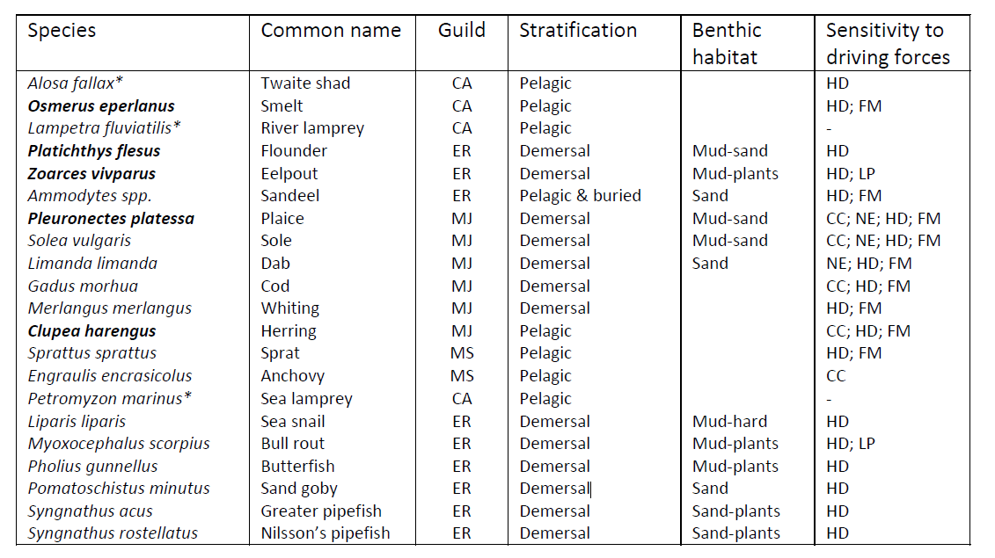

Colophon

Title: | Policy review Swimway Wadden Sea
Author(s): | B.J.H. Koolstra MSc, Dr. Z. Jager, Dr. N Probst, M. Buitenkamp MSc and other authors.
Commissioner: | Commom Wadden Sea Secretariat
Report number: | 2019-017-03
Version: | 0.6
Date: | June 2020
Status: | Draft
Citation: | Policy review Swimway Wadden Sea, Review of international and European policies and legislations. Report number
© Reproduction of parts of this report or re-use of data from this report is permitted with acknowledgment of the source

Leeuwarden Declaration 2018, WSB
Bolle et al. (2009) and Jager et al (2009) reported of 150 species including 13 freshwater species.
The Natura 2000-network comprises both the SAC and SPA areas.
N2000 >Plan 2016-2021 “N89 - Wadden Sea”: https://mst.dk/media/130303/n89_f53_n2000plan_2016-21.pdf,
Last amended by Article 1 of the Order of 4 March 2020
https://www.schleswig-holstein.de/DE/Fachinhalte/N/natura2000/NZP_09_Monitoring.html
Synonym: Japanese oyster, Miyagi oyster
"Directive 2000/60/EC of the European Parliament and of the Council establishing a framework for the Community action in the field of water policy
https://www.gewaesser-bewertung.de/files/170829_uba_fachbroschure_wasse_rwirtschaft_mit_anderung_bf.pdf
https://www.gewaesser-bewertung.de/files/170829_uba_fachbroschure_wasse_rwirtschaft_mit_anderung_bf.pdf
https://www.noordzeeloket.nl/en/policy/europese/besluitvorming/
See http://publicaties.minienm.nl/download-bijlage/99755/printversie-bprw-2016-2021-zonder-links-tcm21-72095.pdf from page 174 onwards.
https://www.sustainableeelgroup.org/
https://ec.europa.eu/fisheries/cfp_en
Probst, oral communication.
http://www.imo.org/en/MediaCentre/PressBriefings/Pages/21-BWM-EIF.aspx
www.neobiota-plattform.de/listen/.
www.imo.org
https://www.nioz.nl/en/expertise/wadden-delta-centre/news-media/fyke-stories/catch-of-a-round-goby
www.nioz.nl
http://ec.europa.eu/environment/nature/invasivealien/index_en.htm
https://www.eea.europa.eu/policy-documents/directive-2014-89-eu-maritime
https://www.cites.org/
http://ec.europa.eu/environment/cites/legislation_en.htm
https://www.ospar.org/about
https://www.ospar.org/work-areas/bdc/species-habitats/list-of-threatened-declining-species-habitats
https://www.cms.int/
https://www.waddensea-worldheritage.org/one-wadden-sea-one-global-heritage
https://www.waddensea-worldheritage.org/node/973
https://www.waddensea-worldheritage.org/node/973
Personal message from M. Buitenkamp following consultation with the Dutch Ministry of Agriculture, Nature and Food Quality

